
2015 ASEE MODEL DESIGN COMPETITION
Sponsored by the Two Year College Division of ASEE

Date: June 3, 2014

Dear Colleague,

On behalf of the American Society for Engineering Education (ASEE) - Two Year College Division (TYCD), we invite you to encourage the submission of student design projects for the 17th Annual ASEE Lower Division MODEL DESIGN COMPETITION. This event will be held in conjunction with the 2015 ASEE Annual Convention, Seattle, Washington, June 14 - 17, 2015. This competition is open to 1st and 2nd year students at two and four year colleges and universities.

In this year’s competition student teams will design and build an autonomous robot that can catch as many colored fish cutouts and deposit them in corresponding colored fish tanks. The robot must adhere to the rules of the model design competition (attached). An Exhibition session is included as part of the competition.

The main reason for this competition is for students to gain a better understanding of the design process from start to finish. Designing and building something from an idea is probably why they chose engineering in the first place. Use this design competition as a platform to reinforce their ideas and have some engineering fun! We hope to see you and your students' entries in Indianapolis.

Please find enclosed the guidelines and registration forms for this event. The interest and registration forms are on the back of this letter.

Sincerely,

Paul E. Gordy
Phone: 757-822-7175
Fax: 757-427-0327
Email: pgordy@tcc.edu

John Wadach
Phone: 585-292-2488
Email: jwadach@monroecc.edu

Results from the
16th Annual ASEE Model Design Competition
June 16, 2014 - Indianapolis, Indiana

The recent competition in Indianapolis required teams to design and build an autonomous robot that could complete 5 laps around an Indy style oval track in the least amount of time. In the first two trials the track contained no obstacles to avoid but in trials 3 and 4 foam obstacles were added in random locations.

19 teams competed and the results were as follows:

1st Place: Cedarville University, Team Zoom-Zoom

2nd Place: Monroe Community College, Team The Burnouts

3rd Place: Monroe Community College, Team Astromechs

For complete results, including scores, pictures, videos, and more, visit the competition websites at
http://www.tcc.edu/faculty/webpages/pgordy/ASEE/index.html and at https://www.facebook.com/MCCELC .

Consider bringing a team from your college to next year’s competition on June 15, 2015 in Seattle, Washington. For more information or a copy of next year’s rules, please contact Paul Gordy, pgordy@tcc.edu,
757-822-7175) or John Wadach, Jwadach@monroecc.edu, 585-292-2488).
2015 ASEE TYCD MODEL DESIGN COMPETITION RULES (Revised 9-15-14)
Seattle, Washington
June 15, 2015

The 17th Annual American Society for Engineering Education (ASEE) Two-Year College Division (TYCD), Model Design Competition will be held Monday, June 15, 2015 in conjunction with the ASEE Annual Convention in Seattle, Washington.

Event Name: Fishing Derby

Objective:

To design and build an autonomous robot that can collect as many colored fish cutouts and then deposit them in corresponding colored fish tanks. Robots will have a maximum time of 120 seconds in each of their four allotted trials. The robot must begin within an 8” X 12” X 10” high size limit but may expand to any size during a trial. An Exhibit Session will precede the robot trials.

Track Specifications:
Figure 1: Isometric View of the Track showing Red, Yellow, Green, and Blue Fish Cutouts
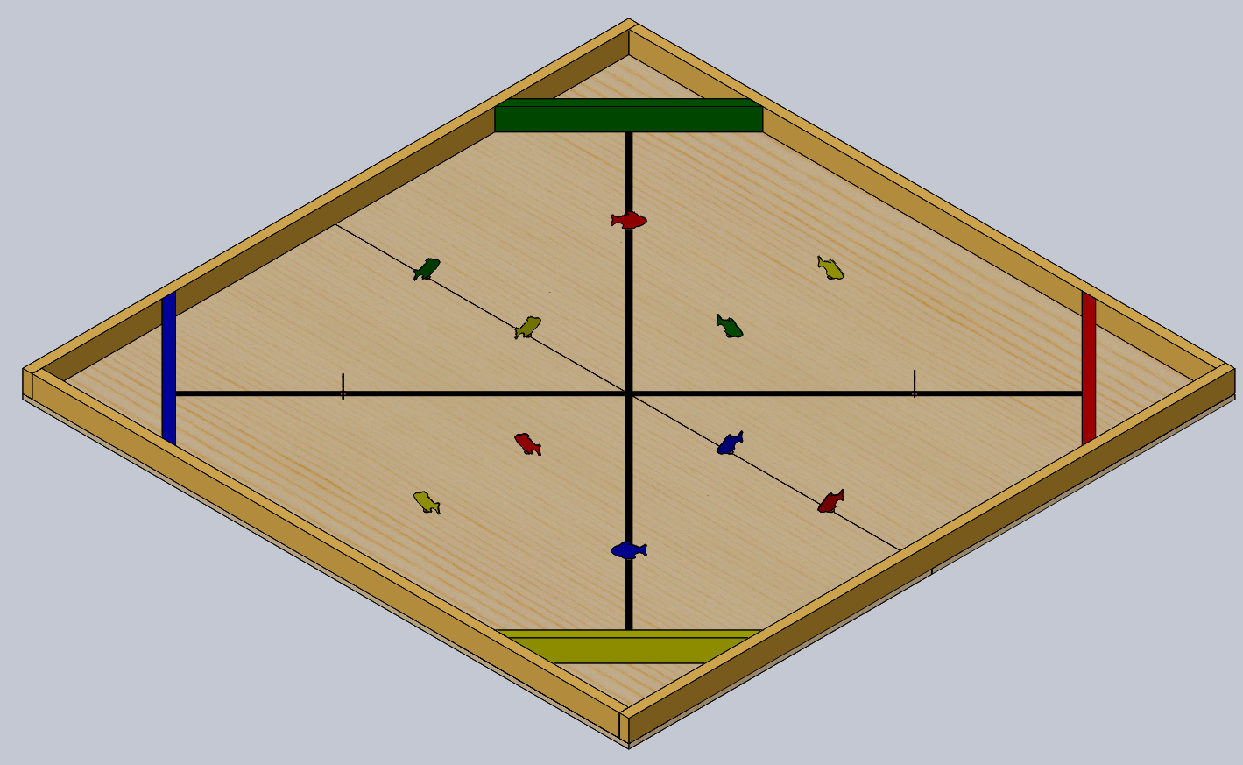
Figure 2: Top View of the Track
(Sheet scale may not be accurate due to document magnification)
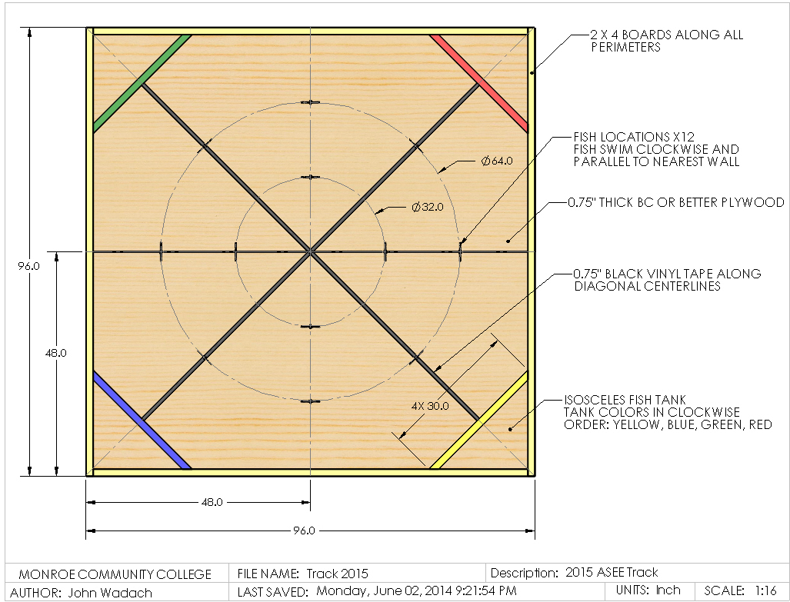

Figure 3: Fish Cut Outs (red shown, other colors are green, blue, and yellow)
(Sheet scale may not be accurate due to document magnification)

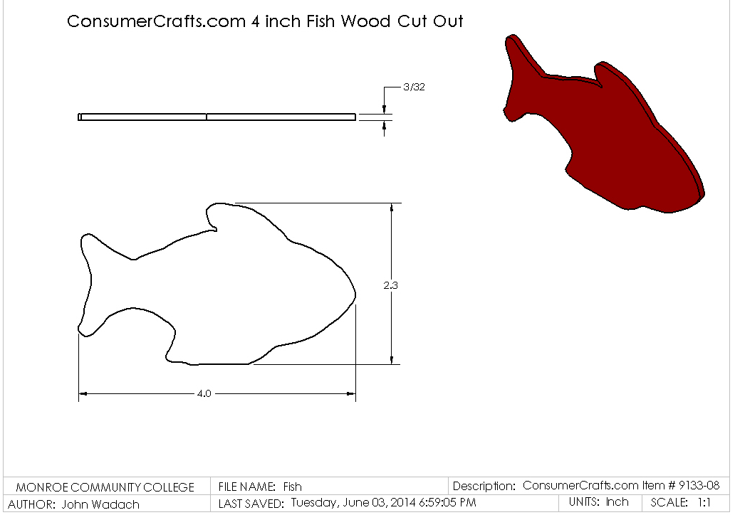
Figure 4: Fish Cut Out Mounted to a Black Game Piece Stand (red fish shown, other color fish are green, blue, and yellow)

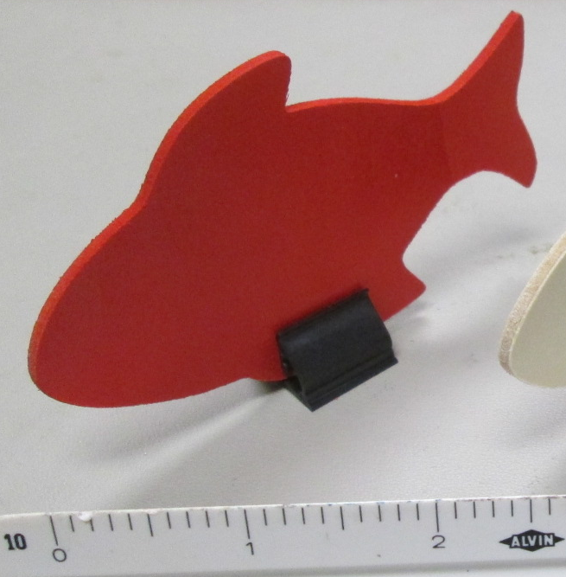

Figure 5: Corner Boards (board colors are red, green, blue, and yellow)
(Sheet scale may not be accurate due to document magnification)
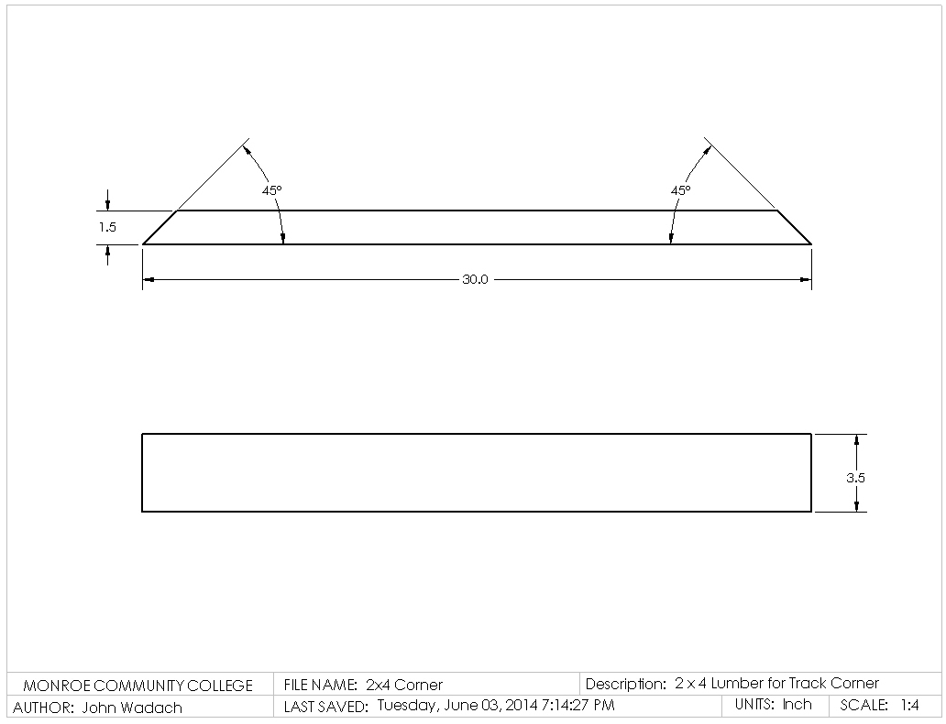

Required Materials:

1. Two 4’ X 8’ X 3/4” sheet BC grade or better grade plywood.

2. Four 2” x 4” x 96” Boards (2 for track perimeter, 2 for substructure)

3. Nine 2” x 4” x 93” Boards (2 for track perimeter, 7 for substructure)

4. One 2” x 4” x 120” Board to be cut into four 30” corner boards with 45° mitered ends

5. One Roll of 3/4” Wide Black Vinyl Tape

6. Twelve 4 inch Wood Fish Cutouts, part number 9133-08 from ConsumerCrafts.com
Cut and Paste link: http://www.consumercrafts.com/store/search?s=9133-08&p=1&ps=20

7. Twelve Black Game Stands with Inward Clasping Style, part number rolGGAM008 from greathallgames.com
Cut and Paste Link: http://www.greathallgames.com/aacc/atokbags/aOtherParts.htm#crd

8. Four Cans of Rust-Oleum Painter’s Touch 2X Gloss Spray Paint in the following colors:
Apple Red, Deep Blue, Sun Yellow, and Meadow Green.

9. One Box of 2.5” or 3.0” Wood Screws for substructure framing

10. One Box of FastenMaster HeadLok 4-1/2 in. Heavy Duty Flathead Fastener

11. One Box of 1.5” Finishing Nails for attaching the plywood to the substructure and perimeter boards to the plywood.

12. One container of light pine colored Sandable Wood Filler.

13. One package of 150 grit sandpaper

14. One package of tack cloths

Construction Procedures:

1. Construct an 8’ x 8’ substructure using 2” x 4” boards spaced 16” on-center.

2. After the substructure is square, fasten the 3/4” thick plywood using 1.5” finishing nails. Set the nails and fill the holes with putty. Once the putty has dried, sand it flat.

3. Draw light construction lines on the plywood as shown in figure 2 to locate the centerlines and the 32” and 64” diameter circles.

4. Apply the 3/4” wide black vinyl tape to the plywood. Be sure not to stretch the tape during application or else the tape will lose adherence to the track over time.

5. Attach the perimeter boards to the track using the HeadLok 4-1/2 in. screws.

6. Paint one corner boards and 3 fish cutouts with each of the four colors of Rust-Oleum. Apply a minimum of two coats to each surface of the boards and cutouts.

7. Attached the corner boards to the track to form isosceles triangles in each corner of the track.

8. Sand off any stray marks on the plywood and then dust the plywood with tack cloths.

9. Insert each Fish Cutout into a black Game Stand as shown in figure 4 and place the Fish Cutout-Game Stand assemblies in the locations shown in figure 2. The fish will be placed in a random color pattern at the start of each trial after a team has placed their robot on the track.
Robot Specifications:

Allowable Energy Sources:
Any energy source is allowed as long as it is completely contained within the robot and does not create or emit any gaseous, liquid, or solid emissions. Energy sources must not present any safety hazards to participants or spectators.

Maximum Robot Size:

The robot must fit inside a box with vertical sides having inside dimensions of 8.0” X 12.0” and have a maximum height of 10.0”. The robot may expand to any size after the start of a trial.

Components, Fabrication, and Cost:
Team members using materials which are commonly available to the general public must perform all fabrication. Use of commercially available vehicles, robots, or entire kits such as RC cars, Legos, K-nex, Fischer-Technics, Parallax or erector sets may not be used. The use of Lego Mindstorm microcontroller bricks are prohibited. Individual components from these cars, robots, or kits (except the Mindstrorm Brick) may be integrated into a team’s robot as long as the majority of the robot’s components are not from the same car, robot, or kit source. The cost of purchasing all components must not exceed $400.

Robot Time Trial Rules:

- It is the responsibility of the team to inspect the condition of the track before starting their robot to be certain that everything is in order. Once a team presses or pulls the start mechanism, the run counts as an official trial and may not be done over.
- The order of testing will be determined by random draw.
- While the preceding team is on the track for a trial, the on-deck team must have their robot on the on-deck table ready to run immediately after the previous team completes their trial. Each team will have one minute to begin a trial after being called.
- All teams will be called for a trial in a current round before any teams begin the next round of testing.
- Robot sizes will be tested with the measuring box prior to each team’s first run and in subsequent runs if requested by the judges. Team members will be responsible for placing the measuring box over their robots. If a robot fails to meet the size constraint the judges will assess a penalty proportional to the severity of the violation.
- The Fish Cutout-Game Stand assemblies will be placed in a random color pattern after a team has placed their robot on the track. After the Fish Cutouts are in place, a team may only activate a single mechanism to start the trial as described in rule 9.
- The robot may start in any location as long as the robot is neither touching a fish cutout nor has any part above any portion of a fish cutout.
- The robot may extend beyond the perimeter of the track during the trial as long as the robot is fully supported by the plywood track surface or the perimeter boards.

- The time for a trial will begin when the judge gives the team the command to start. Once this start command is given, a team may only activate a single switch or mechanism to start the robot. This switch or mechanism may not have multiple ways in which it can be activated for the purpose of communicating the configuration of the fish cutouts to the robot. Once the robot begins to move in any way, team members may not touch the robot or communicate with it with any remote control device.

- If a robot fails to move once the judge’s start command is given, the team members may work on their robot to get it moving but the time will continue to run from the time when the start command was given. If the robot has not moved within 120 seconds of the start command, a score of zero will be assigned for that trial.
- A trial will end when any of the following actions occur:
a. The robot becomes disabled or shows no evidence of being able to deposit additional fish cutouts into the corner fish tanks.
b. The robot deposits all 12 fish into corner fish tanks.
c. 120 seconds elapses from the start command.

10) Teams may make changes or repairs to their robots between trials but they must be ready within one minute of being called to the track.

11) Teams may not make practice runs during the Exhibit Session or after the start of the Robot Time Trials.

Robot Time Trial Scoring:

Robots will earn points by depositing only the Fish Cutout, or both the Fish Cutout and the Card Stand, into the corner fish tanks. Parts from the robot may also be deposited into the tanks without penalty.

- 5 Points will be awarded for each fish cutout that is deposited into a fish tank with a different color corner board as the fish cutout. All portions of the fish cutout must be inside the three vertical inside surfaces of a fish tank to score.
- 10 Points will be awarded for each fish cutout that is deposited into a fish tank with the same color corner board as the fish cutout. All portions of the fish cutout must be inside the three vertical inside surfaces of a fish tank to score.
- If a robot deposits all 12 fish cutouts into matching colored corner fish tanks and thus earns 120 points (a perfect run) a time bonus will be added using the formula below.
Time Bonus for Perfect Run = (120 – Time in seconds to complete the perfect run)

Exhibit Session Scoring:

A maximum score of 120 points may be earned in the Exhibit Session. Scoring details are described on the next page.
Overall Scoring:
The overall score for a team will be equal to the sum of the scores for the Poster Session and the four Robot Time Trials. A team will be disqualified from the competition if they fail to participate in the entire Poster Session.

Overall Score = Sum of the Points from all four Robot Time Trials + Exhibition Session Point Total

Exhibit Session:
Prior to the Robot Time Trials, each team must participate in an exhibit session where they will create a booth to promote their project to judges, other students, and conference attendees. Each team will be supplied with a 6’ long table, a tripod display frame, and electrical power. The entire session is scheduled to last approximately 2 hours during the grand opening of the Exhibition Hall on Monday, June 15th.

All participants must be present during the entire exhibit session. Teams may use posters, written documents, physical prototypes, multimedia displays, and other visual aids at their booths. In addition, each team’s robot must remain on display at their booth for the entire duration of the exhibit session. Team members may neither work on, nor test their robots during this session. The number of entries from a given school will be limited by the available space during the exhibit session.

Students from each team are required to visit the exhibits from all other schools. A captain from each school will score each team from other schools on a scale from 0-20 (20 being best) based upon the criteria that the judges will use. Each school will designate a single captain even if that school has multiple teams. The captains’ score will be computed by deleting the highest and lowest scores from the captains and then computing the average of the remaining scores.

The judges will visit each booth for approximately 10 minutes depending on the number of teams competing. During this visit, team members will guide the judges through their display for the first five minutes. In the second 5 minute period, the judges will ask the team questions. Each judge will score teams on a scale of 0 to 20 (20 being best) on the first five items below. The score in each category will be computed by deleting the highest and lowest scores from the judges, and then computing the average of the remaining scores.

1. Design Evolution:
Guide the judges through the design process that your team followed from the initial ideas to the final solution. Describe your rationale for making design decisions.

2. Robot Operation:
Discuss how your robot works.

3. Fabrication Methods:
Explain how you fabricated your robot.

4. Design Analysis:
Convince the judges that your design is optimal based upon its performance, cost, and environmental impact.

5. Exhibit Quality:
Your exhibit quality will be judged on the following items: team and exhibit appearance, technical expertise displayed, communication skills, and effectiveness of visual aids.

6. Captain Scoring:
The score from the captains will be added to the judges’ scores from the five categories above.
Rule Interpretation Questions:

Prior to the date of the competition direct your inquiries to:

John Wadach
Monroe Community College
1000 E. Henrietta Road
Rochester, NY 14623
Phone: 585-292-2488
Email: jwadach@monroecc.edu

On the date of the competition:

The judges will interpret the intent of the rules and make all decisions. If the judges determine that a team is in violation of the intent of any rule or specification, they will deduct points in proportion to the severity of the violation. All decisions by the judges are final and may not be appealed. Teams have shown respect for the judges, participants, and spectators in the past, and this positive attitude is expected from each participant this year.

Competition Registration Questions:

Questions related to registering for the competition should be directed to:

Paul Gordy
Tidewater Community College
1700 College Crescent
Virginia Beach, VA 23453
Phone: 757-822-7175
Email: pgordy@tcc.edu

Please find the entry forms on pages 11 and 12. The Interest Form should be received no later than April 1, 2015. A Registration Form for each model design team must be received no later than June 1, 2015.
PROJECT TEAM / ENTRY LIMITATIONS:

Each team must have at least one faculty advisor and at least 2 student members but no more than 10 student members. Each team member must primarily be enrolled in freshmen or sophomore level classes. The number of entries from each school will be limited by the space available in the Exhibit Session. If a school has more than one entry then each team must represent a unique solution to the design problem. Multiple copies of the same solution are prohibited.

ASEE ANNUAL CONVENTION PASSES:

It is not required that student team members or faculty advisors be registered for the ASEE Annual Convention. Passes will be provided for all team members and advisors so that they can enter the conference area and exhibition area on the day of the competition. Details for obtaining passes will be made available a couple of weeks prior to the competition.

COMPETITION TIMELINE:

The specific time and location of the Exhibit Session and Robot Testing will be sent to all teams and published in the ASEE Final Program and Proceedings booklet. The overall format of the competition is given below.

Morning: Exhibit Session

Afternoon: Robot Testing Session and Awards

PRACTICE SESSION:

It is expected that two tracks will be ready for teams to practice on by Sunday morning, June 14th. Teams should be considerate and only use the tracks for brief periods if other teams are waiting to use the tracks.

On the day of the competition the tracks will be available in the Exhibition Hall for teams to practice on prior to and following the Exhibit Session. No practice runs may be made during the Exhibit Session or after the Robot Time Trials have begun.

AWARDS:

First, second, and third-place teams will receive plaques.

SUNY TYESA COMPETITION

The State University of New York Two Year Engineering Science Association (SUNY TYESA) will host a design-build competition on at the end of April 2015. SUNY TYESA will use the same rules and project as the 2015 ASEE Design Competition. Teams interested in participating in the SUNY TYESA competition should contact Mark Courtney mcourtne@sunydutchess.edu or visit the SUNY TYESA website at: tyesa.org

2015 ASEE Model Design Competition Registration Form

Name of college/university: _______________________________________________________________

Team Name: ________________________________________________________________________

Name of faculty advisor(s): _______________________________________________________________

Mailing Address: _______________________________________________________________________

Phone: ______________________________________ Fax: _____________________________________

Email (print clearly): _____________________________________________________________________

Student team captain: ____________________________________________________________________

Other student team members:

1. __________________________ 2. __________________________ 3. __________________________

4. __________________________ 5. __________________________ 6. __________________________

7. __________________________ 8. __________________________ 9. __________________________

Which students/advisors need badges for the convention center? (Badges are needed if you are not registered for the convention).
Circle one: All need badges None need badges Only those listed below need badges

Will your team require electrical power at your Exhibition Table? Circle one: YES NO

Please submit this form to : Paul E. Gordy
Tidewater Community College
1700 College Crescent
Virginia Beach, VA 23453
Phone: 757-822-7175
Fax: 757-822-7334
Email: PGordy@tcc.edu

Return one copy of this form for each team entered by
June 1, 2015 (by US mail , fax, or email)
2015 ASEE Model Design Competition Interest Form

Name of college/university: _______________________________________________________________

Name of faculty advisor(s): _______________________________________________________________

Mailing Address: _______________________________________________________________________

Phone: ______________________________________ Fax: _____________________________________

Email (print clearly): _____________________________________________________________________

Number of model entries desired : _________________

Please submit this form to: Paul E. Gordy
Tidewater Community College
1700 College Crescent
Virginia Beach, VA 23453
Phone: 757-822-7175
Fax: 757-822-7334
Email: PGordy@tcc.edu

Return this form by April 1, 2015 (by US mail , fax, or email)

