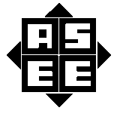
2011 ASEE MODEL DESIGN COMPETITION
Sponsored by the Two Year College Division of ASEE

Date: June 11, 2010

Dear Colleague,

On behalf of the American Society for Engineering Education (ASEE) - Two Year College Division (TYCD), we invite you to encourage the submission of student design projects for the 13th Annual ASEE Lower Division MODEL DESIGN COMPETITION. This event will be held in conjunction with the 2011 ASEE Annual Convention, Vancouver, British Columbia, June 26 - June 29, 2011. This competition is open to 1st and 2nd year students at four and two year colleges and universities.

In this year’s competition student teams will design and build a “tree” harvesting robot capable of collecting six red colored dowels without moving the six green dowels positioned around a route defined by a black tape line. The robots must adhere to the rules of the model design competition (attached). A new exhibit session is included as part of the competition.

The main reason for this competition is for students to gain a better understanding of the design process from start to finish. Designing and building something from an idea is probably why they chose engineering in the first place. Use this design competition as a platform to reinforce their ideas and have some engineering fun! We hope to see you and your students' entries in Vancouver.

Please find enclosed the guidelines and registration forms for this event. The interest and registration forms are on the back of this letter.

Sincerely,

Paul E. Gordy
Phone: 757-822-7175
Fax: 757-427-0327
Email: pgordy@tcc.edu

John Wadach
Phone: 585-292-2488
Email: jwadach@monroecc.edu

Results from the
12th Annual ASEE Model Design Competition
June 21, 2010 - Louisville, Kentucky

The ASEE Model Design Competition is a design/build competition for freshmen & sophomore engineering students at 2-year and 4-year colleges. The competition is held each year during the ASEE Annual Convention. The competition typically involves building an autonomous, battery-powered vehicle to navigate some sort of challenging track to complete a prescribed task. The recent competition in Louisville required robots to play a form of baseball in which the robots had to shoot ping-pong balls into three outfield targets and then round the bases of an 8’ X 8’ track. Scoring for the competition was based on the number of balls shot into the targets, the time to complete the task, and the points earned in the presentation phase of the competition.

20 teams competed and the results were as follows:

1st Place – Change-Up, Monroe Community College
2nd Place – Blue Bomber, Tidewater Community College
3rd Place – King Crab, Monroe Community College

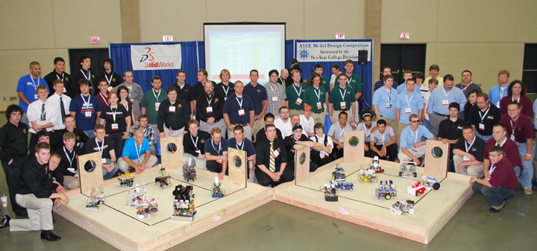

For complete results, including scores, pictures, videos, and more, visit the competition website at
http://www.tcc.edu/faculty/webpages/pgordy/ASEE/index.html

Consider bringing a team from your college to next year’s competition on June 28, 2009 in Vancouver, British Columbia. For more information or a copy of next year’s rules, please contact Paul Gordy (Pgordy@tcc.edu, 757-822-7175) or John Wadach, Jwadach@monroecc.edu, 585-292-2488).
2011 ASEE TYCD MODEL DESIGN COMPETITION RULES
Vancouver, British Columbia, Canada
July 28, 2011

The American Society for Engineering Education (ASEE) Two-Year College Division (TYCD), Model Design Competition will be held Monday, June 27, 2011 in conjunction with the ASEE Annual Convention in Vancouver, British Columbia, Canada.
.

Event Name: Sustainable Forester

Objective:

To design and build an autonomous robot that is capable of harvesting six red dowel rods representing dead trees, while not moving the six green dowels that represent live trees. The colored dowels will be placed in a random color pattern prior to each run. Teams have a maximum of 120 seconds to complete the task.

Track Specifications:
Figure 1: Isometric View of Track with Red and Green Dowels in a Sample Random Color Pattern

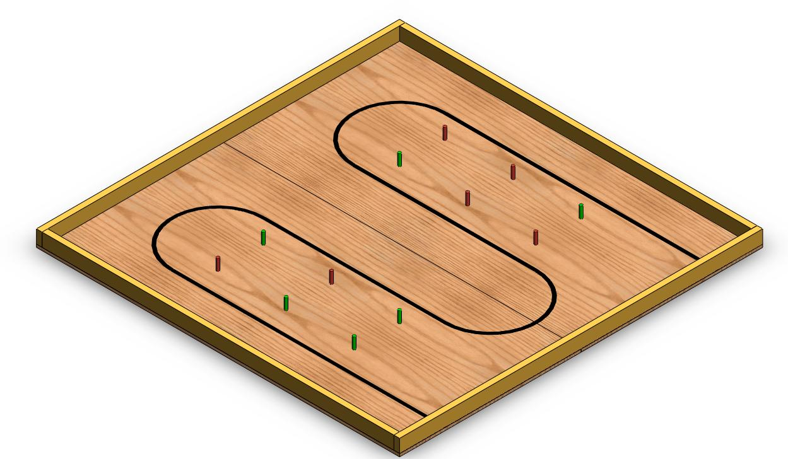

Figure 2: Top View of Plywood with Dimensions in Inches
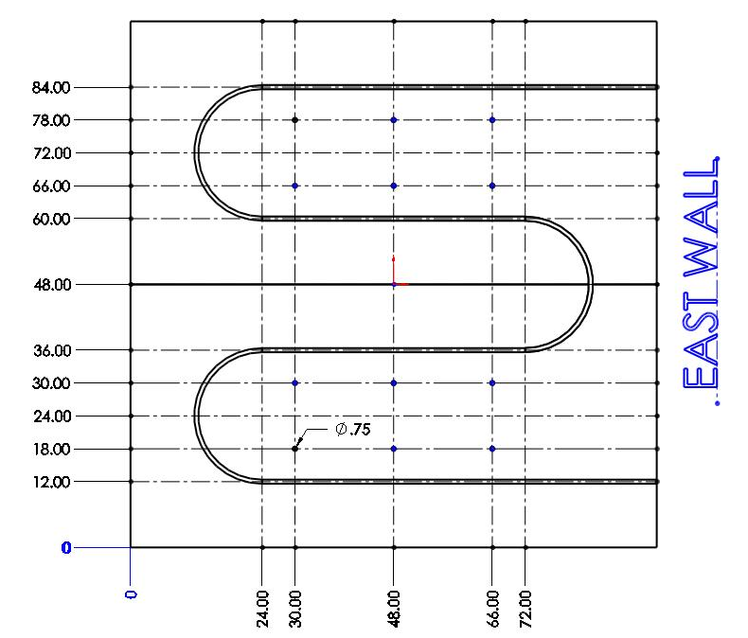
+Y

+X
Notes:

- All dimensions are in inches with the origin (0,0) located in the southwest corner of the plywood.
- All dimensions are measured from the origin.
- Dimensions to the centerline of the tape lines are shown.
- The three arcs have radii of 12.00 inches.
- The (X,Y) coordinates of the three arc centers are: (24.00, 24.00) , (24.00, 72.00) , (72.00, 48.00)
- The joint between the two plywood sheets runs from west to east at Y = 48.00 in.
- Dowel locations are indicated by circles having diameters of 0.75” centered on the intersections of the construction lines at ( 30.00,18.00) , ( 30.00,30.00) , ( 30.00,66.00) , ( 30.00,78.00) ,
( 48.00,18.00) , (48.00,30.00) , (48.00,66.00) , (48.00,78.00) ,
( 66.00,18.00) , (66.00,30.00) , (66.00,66.00) , (66.00,78.00) .

Track Materials:

1. Two 4’ X 8’ X ¾” sheets BC or better grade plywood.

2. Two 2” X 4” X 96” boards (actual dimensions 1.5” X 3.5” X 96’’).

3. Two 2” X 4” X 93” boards (actual dimensions 1.5” X 3.5” X 93’’).

4. One 12oz can of Rust-Oleum Gloss Apple Red Painter’s Touch spray paint. Home Depot model number 249124.

5. One 12oz can of Rust-Oleum Gloss Meadow Green Painter’s Touch spray paint. Home Depot model number 249100.

6. Six hardwood dowels with diameters of 0.75” and heights of 3.00” with top, bottom, and sides painted with two coats of Rust-Oleum Gloss Apple Red Painter’s Touch spray paint according the product directions.

7. Six hardwood dowels with diameters of 0.75” and heights of 3.00” with top, bottom, and sides painted with two coats of Rust-Oleum Gloss Meadow Green Painter’s Touch spray paint according the product directions.

8. One roll of ¾” wide black vinyl electrical tape.

9. Fasteners or adhesive.

10. 2”x4” boards for constructing a substructure to maintain flatness of the plywood.

Construction Procedures:

1. Place the two sheets of plywood on a flat surface to form the 8’ X 8’ base for the track.

2. Draw light construction lines as shown in figure 2 to locate the centers of the dowels and centerlines of the electrical tape.

3. Draw dark ¾” diameter circles in the locations where dowels will be placed (see page 4, note 7).

4. Apply the 3/4'” wide black vinyl electrical tape so that the centerline of the tape is coincident with the appropriate centerlines.

5. Cut two 2 X 4 boards to a length of 93”.

6. Fasten two 96” and two 93” 2 X 4 boards along the perimeter of the track so that the outside edge of the 2 X 4 boards are coincident with the outside edge of the plywood.

7. To provide for maximum flatness, a 2”x4” substructure should be constructed and attached to the track.

Vehicle Specifications:

Allowable Energy Sources:
Any energy source is allowed as long as it is completely contained within the robot and does not create or emit any gaseous, liquid, or solid emissions. Energy sources must not present any safety hazards to participants or spectators.

Maximum Robot Size:

At the start of a trial, the robot must fit inside a box with vertical sides having inside dimensions of 8.0” X 12.0” and have a maximum height of 10.0”. After the start of the trial, the robot may expand to any size and shape.

Components, Fabrication, and Cost:
Team members using materials which are commonly available to the general public must perform all fabrication. Use of commercially available vehicles, robots, or entire kits such as RC cars, Legos, K-nex, Fischer-Technics, Parallax or erector sets may not be used. The use of Lego Mindstorm microcontroller bricks are prohibited. Individual components from these cars, robots or kits (except the Mindstrorm Brick) may be integrated into a team’s robot as long as the majority of the robot’s components are not from the same car, robot, or kit source. The cost of purchasing all components must not exceed $450.
Robot Testing:

- It is the responsibility of the team to inspect the condition of the track and placement of dowels before starting their robot to be certain that everything is in order. Once a team presses or pulls the start mechanism, the run counts as an official trial and may not be done over.
- The order of testing will be determined by random draw.
- While the preceding team is on the track for a trial, the on-deck team must have their robot on the on-deck table ready to run immediately after the previous team completes their trial. Each team will have one minute to begin a trial after being called.
- All teams will be called for a trial in a current round before any teams begin the next round of testing.
- Robot size will be tested with the measuring box prior to each team’s first run and in subsequent runs if requested by the judges.
- A robot must start so that it is touching the east wall of the track. The robot may start anywhere along the east wall.
- After a team’s robot is ready in the starting position, the judges will randomly draw dowels from a container and place them on the track to create a random color sequence. Team members may not touch their robot while the judges are setting up the dowels.
- After the dowels are set up, a judge will give the team the commands READY – GO. On the GO command a team may press or pull only one button, lever, string, or other starting mechanism on the robot. Energy from the team member’s body may not be used to propel the robot or cause components to move on the robot. This starting signal may in no way be used to communicate to the robot the positions of the red and green dowels.
- After the starting mechanism is pressed or pulled, team members may not touch their robot until the trial is over.
- The robot must be capable of completing the tasks without any input from the team. Team members may not operate radio, infrared, ultrasonic, electrical, or other remote controls at any time.

- The robot may operate for a maximum of 120 seconds after the judge gives the command to start.

- Each team will be allowed to make four trials.

13) Teams may make changes or repairs to their robots between trials but they must be ready within one minute of being called to the track.

14) Teams may not make practice runs during the exhibit session or after the start of the robot testing session.

Robot Scoring:

Robots will earn points as described below.

- 5 Points will be awarded for each Red Dowel that is knocked down and not onboard the robot when it touches the east wall to end a trial.
- 10 Points will be awarded for each Red Dowel that is collected from the track and onboard the robot when it touches the east wall to end a trial.
- A sustainability bonus will be added to a robot’s score using the formula below. The minimum sustainability bonus score is zero.
Sustainability Bonus = 5*(Number of Red Dowels Knocked Down or Collected –
Number of Green Dowels that are Knocked Down or Lifted Off the track)
- A time bonus will be added to robots that complete a perfect run. A perfect run is defined as one in which a robot neither knocks down nor lifts any green dowels, and successfully collects all six red dowels and is in possession of them when it touches the east wall to end the trial. The time bonus formula is given below.

Time Bonus = (120 – time in seconds to complete the perfect run) / 3

Exhibit Session:

Prior to the testing of the vehicles, each team must participate in an exhibit session where they will create a booth to promote their project to judges, other students, and conference attendees. Each team will be supplied with a 6’ long table, room for tripod displays behind the table, and electrical power. The entire session is scheduled to last approximately 3 hours during the grand opening of the Exhibition Hall on Monday, June 27th.

All participants must be present during the entire exhibit session. Teams may use posters, written documents, physical prototypes, multimedia displays, and other visual aids at their booths. In addition, each team’s robot must remain on display at their booth for the entire duration of the exhibit session. Team members may neither work on, nor test their robots during this session. The number of entries from a given school will be limited by the available space during the exhibit session.

Students from each team are required to visit the exhibits from all other schools. A captain from each school will score each team from other schools on a scale from 0-20 (20 being best) based upon the criteria that the judges will use. Each school will designate a single captain even if that school has multiple teams. The captains’ score will be computed by deleting the highest and lowest scores from the captains and then computing the average of the remaining scores.

Teams are encouraged to participate in an optional T-shirt exchange during this session where captains exchange one of their school T-shirts with the captain from each of the other participating schools.

The judges will visit each booth for approximately 5-10 minutes depending on the number of teams competing. During this visit, team members should interact with the judges to address each item listed below. Each judge will score teams on a scale of 0 to 20 with 20 being best on the first five items below. The score in each category will be computed by deleting the highest and lowest scores from the judges and then computing the average of the remaining scores.

1. Design Evolution:
Guide the judges through the design process that your team followed from the initial ideas to the final solution.

2. Robot Operation:
Discuss how your robot works.

3. Fabrication Methods:
Explain how you fabricated your robot.

4. Design Analysis:
Convince the judges that your design is optimal based upon its performance, cost, and environmental impact.

5. Exhibit Quality:
Your exhibit quality will be judges on the following items: team and exhibit appearance, technical expertise displayed, communication skills, and effectiveness of visual aids.

6. Captain Scoring:
The score from the captains will be added to the scores from the five categories above.
Overall Scoring:
The overall score for a team will be equal to the sum of the scores for the Exhibition Session and the four robot testing trials. A team will be disqualified from the competition if they fail to participate in the entire Exhibition Session.

Overall Score = Sum of the Points from Robot Testing + Exhibition Session Point Total

Rule Interpretation Questions:

Prior to the date of the competition direct your inquiries to:

John Wadach
Monroe Community College
1000 E. Henrietta Road
Rochester, NY 14623
Phone: 585-292-2488
Email: jwadach@monroecc.edu

On the date of the competition:

The judges will interpret the intent of the rules and make all decisions. If the judges determine that a team is in violation of the intent of any rule or specification, they will deduct points in proportion to the severity of the violation. All decisions by the judges are final and may not be appealed. Teams have shown respect for the judges, participants, and spectators in the past, and this positive attitude is expected from each participant this year.

Competition Registration Questions:

Questions related to registering for the competition should be directed to:

Paul Gordy
Tidewater Community College
1700 College Crescent
Virginia Beach, VA 23453
Phone: 757-822-7175
Email: pgordy@tcc.edu

Please find the entry forms on pages 12 and 13. The Interest Form must be received no later than March 1, 2011. A Registration Form for each model design team must be received no later than June 1, 2011.

PROJECT TEAM / ENTRY LIMITATIONS:

Each team must have at least one faculty advisor and at least 2 student members but no more than 10 student members. Each team member must primarily be enrolled in freshmen or sophomore level classes. The number of entries from each school will be limited by the space available in the Exhibit Session. If a school has more than one entry then each team must represent a unique solution to the design problem. Multiple copies of the same solution are prohibited.

ASEE ANNUAL CONVENTION PASSES:

It is not required that student team members or faculty advisors be registered for the ASEE Annual Convention. Passes will be provided for all team members and advisors so that they can enter the conference area and exhibition area on the day of the competition. Details for obtaining passes will be made available a couple of weeks prior to the competition.

COMPETITION TIMELINE:

The specific time and location of the Exhibit Session and Robot Testing will be sent to all teams and published in the ASEE Final Program and Proceedings booklet. The overall format of the competition is given below.

Morning: Exhibit Session

Afternoon: Robot Testing Session and Awards

PRACTICE SESSION:

The official track will be available in the Exhibition Hall for teams to practice on prior to and following the Exhibit Session. Teams should be considerate and only use the track for brief periods if other teams are waiting to use the track. No practice runs may be made during the Exhibit Session or after the Robot Testing Seesion has begun.

AWARDS:

First, second, and third-place teams will receive plaques.

SUNY TYESA COMPETITION

The State University of New York Two Year Engineering Science Association (SUNY TYESA) will host a design-build competition on Friday, April 29, 2011 at Finger Lakes Community College, Victor, NY. SUNY TYESA will use the same rules and project as the 2011 ASEE Design Competition. Teams interested in participating in the SUNY TYESA competition should contact Mark Courtney mcourtne@sunydutchess.edu or visit the SUNY TYESA website at: tyesa.org

2011 ASEE Model Design Competition Registration Form

Name of college/university: _______________________________________________________________

Team Name: ________________________________________________________________________

Name of faculty advisor(s): _______________________________________________________________

Mailing Address: _______________________________________________________________________

Phone: ______________________________________ Fax: _____________________________________

Email (print clearly): _____________________________________________________________________

Student team captain: ____________________________________________________________________

Other student team members:

1. __________________________ 2. __________________________ 3. __________________________

4. __________________________ 5. __________________________ 6. __________________________

7. __________________________ 8. __________________________ 9. __________________________

Which students/advisors need badges for the convention center? (Badges are needed if you are not registered for the convention).
Circle one: All need badges None need badges Only those listed below need badges

Will your team require electrical power at your Exhibition Table? Circle one: YES NO

Will your school participate in the T-shirt exchange? Circle one: YES NO

Please submit this form to : Paul E. Gordy
Tidewater Community College
1700 College Crescent
Virginia Beach, VA 23453
Phone: 757-822-7175
Fax: 757-822-7334
Email: PGordy@tcc.edu

Return one copy of this form for each team entered by
June 1, 2011 (by US mail , fax, or email)
2011 ASEE Model Design Competition Interest Form

Name of college/university: _______________________________________________________________

Name of faculty advisor(s): _______________________________________________________________

Mailing Address: _______________________________________________________________________

Phone: ______________________________________ Fax: _____________________________________

Email (print clearly): _____________________________________________________________________

Number of model entries desired : _________________

Please submit this form to: Paul E. Gordy
Tidewater Community College
1700 College Crescent
Virginia Beach, VA 23453
Phone: 757-822-7175
Fax: 757-822-7334
Email: PGordy@tcc.edu

Return this form by March 1, 2011 (by US mail , fax, or email)

