**Make connections. Give to the community. Earn extra credit. Improve your transcript. Network. Travel.**

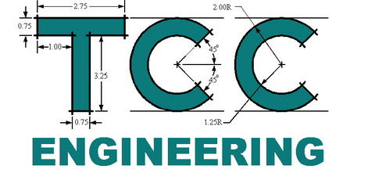

Free Pizza

Day!



CLUB

Thursday, 1/22, 12:30-1:20

Room H-179

**Virginia Beach Campus in the ATC**

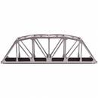**ALL STUDENTS WELCOME TO JOIN THE FUN!**

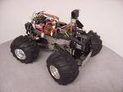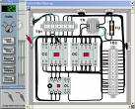

Upcoming plans include: Election of officers, possible CANstruction competition, update on the work done so far for the ASEE robotics competition in Montreal (June 2020), Adopt-a-Road cleanups, club projects and competitions, fundraising, guest speakers, field trips, and more.