EGR 120 Due date: _________________________
Introduction to Engineering
File: N120Bot2

Team Assignment #2

Testing the Arduino-BOT Servos

References:
1) Arduino-BOT Lecture #2 - http://faculty.tcc.edu/PGordy/Egr120/
2) Robotics with the Board of Education Shield for Arduino web tutorials - http://learn.parallax.com/tutorials/robot/shield-bot/robotics-board-education-shield-arduino
3) Board of Education Shield for Arduino documentation - https://www.parallax.com/downloads/robotics-board-education-shield-arduino
4) Arduino web site (software, microcontrollers, examples, and more) - https://www.arduino.cc/

Team Assignment:
1) Check the Servo Port jumper
As indicated in Arduino-BOT Lecture #2, verify that the Servo Port jumper is in the 5V position (see diagram below).
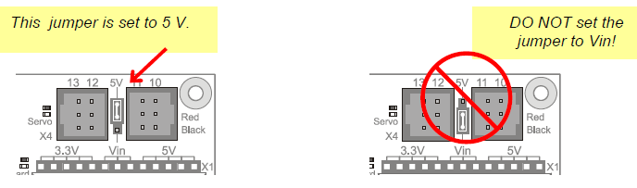

2) Left and Right Servo Connections
As indicated in Arduino-BOT Lecture #2, verify that the left servo is connected to Servo Port 11 and the right servo is connected to Servo Port 10. The ball is a rear wheel for left/right reference. See the diagram below.
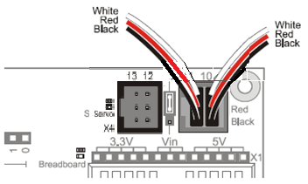
Connect LEFT servo to Port 11
Connect RIGHT servo to Port 10
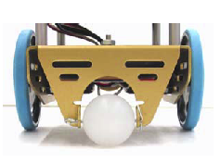
Left wheel
Rightwheel
Rear wheel

3) Testing the right servo
Turn the Arduino-BOT on its side with the left wheel facing up. Put a piece of tape on the wheel to assist you in counting wheel revolutions.
- Enter the program below. Be sure to add a block of comments at the beginning of the program as done in previous programs.
- Use the program below to test the servo. Specifically:
- Begin by using a Pulse Width of 1300.
- Run the program and count the number of clockwise (CW) wheel revolutions (to the nearest ¼ revolution) that occur in 15 seconds (servo will stop after 15 seconds). Note: record CCW revolutions as negative.
- Record the value in the table provided (or in Excel).
- Repeat for Pulse Widths of 1320, 1340, … , 1700.
- If the Servo did not completely stop with a Pulse Width of 1500, find the exact Pulse Width needed to make it stop and record the value.
- Print one example of the program (any Pulse Width) to include in your team report.
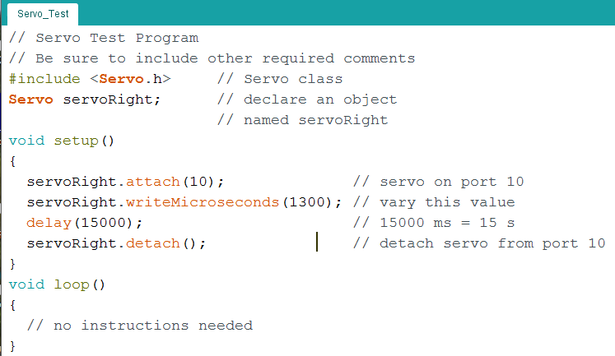

Vary the pulse width from 1300 to 1700 and count the wheel revolutions

Note: If you are testing the right servo and the left servo is also turning, you can stop it by attaching it to a pin and then detachinging. For example:
Servo servoLeft;
servoLeft.attach(11);
servoLeft.detach( );

4) Testing the left servo
Repeat step 3 for the left servo. Change the servo port in the Arduino code and use appropriate variable names for the left servo. Print a sample program for your team report.
5) Analysis
  - Type the two tables into Excel. Include information such as course number, team assignment number, Arduino-BOT number, team number, each team member’s name (only if present), a descriptive title, and the filename (pick an appropriate filename).
  - Graph CW RPM versus PULSOUT for each servo (use a separate graph for each servo). An example is shown below:

  - Add additional columns to your tables in Excel for velocity in in/s, ft/s, and mph. Include sample Excel formulas under the table. Note that the Arduino-BOT has wheels with a diameter of 2.5 inches. (Hint: The robot travels a distance equal to one wheel circumference for each revolution.)
  - Note that the Arduino-BOT will travel forward if the right servo turns clockwise and the left servo turns counter-clockwise. What is the Arduino-BOT’s maximum forward speed in rpm, in/s, ft/s, and mph?
  - Using the maximum forward speed shown above, how long will it take the robot to travel 10 feet? (Show your calculation.) Note that Time = Distance/Velocity.

Table for recording servo speeds in lab (or enter the values directly into Excel)

Pulse Width (us) | # CW Revolutions in 15 s | RPM  (CW) |  | Pulse Width (us) | # CW Revolutions in 15 s | RPM  (CW)
1300 |  |  |  | 1300
1320 |  |  |  | 1320
1340 |  |  |  | 1340
1360 |  |  |  | 1360
1380 |  |  |  | 1380
1400 |  |  |  | 1400
1420 |  |  |  | 1420
1440 |  |  |  | 1440
1460 |  |  |  | 1460
1480 |  |  |  | 1480
1500 |  |  |  | 1500
1520 |  |  |  | 1520
1540 |  |  |  | 1540
1560 |  |  |  | 1560
1580 |  |  |  | 1580
1600 |  |  |  | 1600
1620 |  |  |  | 1620
1640 |  |  |  | 1640
1660 |  |  |  | 1660
1680 |  |  |  | 1680
1700 |  |  |  | 1700
 | 0 | 0 |  |  | 0 | 0

4) Report
Organize your results into a report and submit a single typed report for the group to the instructor by the assigned due date. The report should consist of:
- Title Page – Include a title page as shown below.
- Program Printouts – Include printouts for both programs (for any Pulse Width value). Always include comments in all programs specifying the course number, team assignment number, BOE-BOT number, your team number, each team member’s name (only if present), the program number (Program 2A), the filename (pick an appropriate filename), and a description. Also include comments explaining the code.
- Analysis - Neatly present all required tables, graphs, and calculations. All tables and graphs should be nicely formatted. Include descriptive titles or headings for calculations.
- Discussion - Write 1-2 paragraphs discussing the following:
- Did you run into any problems testing the servos?
- Is one of your servos faster than the other? List the max speed in rpm for each servo.
- Does the speed vary linearly as the Pulse Width varies from 1300 to 1700 us?
- Did your servos stop at exactly 1500 us? If not, show the Pulse Width value where they stopped.
- What direction and speed (full-speed CW, for example) might you use on each servo to make your robot go forward, go backward, turn left, and turn right?

EGR 120
Introduction to Engineering

Team Assignment #2 – Testing the Arduino-BOT Servos

Date
Group #N (your group number)
Arduino-BOT number

Attendance & Participation Record:
(list all team members and all dates when teams worked
together in class on this assignment and check boxes to mark attendance)

Team Member | Date 1 | Date 2
John Doe
etc

Demonstration of Programs

Program | Successfully  Demonstrated
1
2

