EGR 120 Due date: _____________________
Introduction to Engineering
File: EGR120H2

Homework Assignment #2 – TCC Engineering and Transfer Information

Reading Assignment:
- Read Chapter 1 in Engineering Fundamentals – An Introduction To Engineering, 5E by Moaveni.
- TCC Student Handbook for Engineering

Assignment by last name:
In most parts below, 5 items are listed (labeled A, B, C, D, and E) that are to be investigated. Each student should only use 1 of the 5 items according to the first letter of the last name, as follows:
First letter of last name | Item to use in each case below
A - E | A
F - J | B
K - O | C
P - T | D
U - Z | E

- Create a word-processing document containing the statements and answers to each part of the assignment. For example:
Student Name
Course and section
Assignment Number

Answer #1) The following _________ electives (PLS, PSY, etc) can be used to satisfy the Social Science (or Humanities) Elective: _______________________________ (assigned part only).

Answer #2 _________ (course number) is available in these semesters: __________________

Answer #3) A minimum GPA of _________ is required to transfer to ________________
•
•

Add two attachments (curriculum sheets) to the end of the assignment.
- Curriculum Sheet for ODU (engineering program of your choice)
- Curriculum Sheet (checksheet) for Virginia Tech (or another university of your choice for the engineering program of your choice)

- Note that URLs and links are changed often. If any links listed do not work, be creative and search until you find the desired information.

Page 2
Universities and Colleges (80 points)

- Tidewater Community College - go to www.tcc.edu
- Browse the site to see what information is available
- Find the Engineering Curriculum by following the links below:
- College Catalog
- Curricula of Study: College/University Transfer Programs
- Find Engineering (831)
- Notice that note (1) is listed next to the Humanities Elective and the Social Studies Elective in the A.S. degree in Engineering. The note directs you to a page in the TCC College Catalog. Go back to the college catalog as follows:
- College Catalog
- General Information on: … and go to the page indicated in the note above.
- An alternative is to select the pdf file for the entire college catalog (Print all in one pdf) and go to the page indicated in the note above.
- List all course numbers that can be used to satisfy the elective listed below (assigned part only).
- Social Studies Elective (list all Political Science courses (PLS) that can be used
- Social Studies Elective (list all Psychology courses (PSY) that can be used
- Social Studies Elective (list all Sociology courses (SOC) that can be used
- Humanities Elective (list all Philosophy courses (PHI) that can be used
- Humanities Elective (list all Music (MUS) that can be used

Answer #1) The following _________ electives (PLS, PSY, etc) can be used to satisfy the Social Science (or Humanities) Elective: _______________________________ (assigned part only).

TCC Student Handbook for Engineering – Use a printed copy or go to www.tcc.edu
- Find the Paul Gordy’s web page by following the links below:
- Faculty and Staff
- E-Directory
- Enter the instructor’s last name (Gordy) and click on Search
- Pick the Detail link next to the instructor’s name
- Pick the Homepage link under the instructor’s contact information
- TCC Student Handbook for Engineering
- Check the Tentative Annual Schedule for Engineering in the Handbook. During which semester(s) is the following course available (assigned part only)?
A) EGR 140 B) EGR 125 C) EGR 245 D) EGR 246 E) EGR 271

Answer #2 _________ (course number) is available in these semesters: __________________

- Also check the Transfer Options listed in the Handbook. What GPA is required to transfer into the following university (assigned part only)?
A) ODU B) Virginia Tech C) University of Virginia
D) George Mason University E) Virginia Military Institute

Answer #3 A minimum GPA of _________ is required to transfer to ________________

Page 3

- List the recommended Approved EGR Electives listed in the Handbook for the following programs and universities:
A) Mechanical Engineering at VT B) Chemical Engineering at Virginia Tech
C) Civil Engineering at ODU D) Computer Engineering at ODU
E) Electrical Engineering at ODU

Answer #4 The Approved EGR Electives for _________ (list program and university) are recommended: (list all)

- Check the sections of the Handbook related to transfer to ODU and Virginia Tech. Determine the corresponding ODU course number and VT course number for the TCC course listed below (assigned part only).
A) EGR 120 B) EGR 110 C) EGR 140 D) EGR 245 E) EGR 270

Answer #5 The TCC course _________ transfer to ODU as _________ and transfers to Virginia Tech as ______________

- Old Dominion University Engineering - go to www.odu.edu
- Browse the site to see what information is available

Mechanical Engineering Course Information
- Follow the links below:
- Academic
- Engineering & Technology (under Colleges section)
- Mechanical & Aerospace Engineering
- Academics
- Courses
- Determine the title, the pre-requisite(s) and the co-requisite(s) for the course indicated below (assigned part only).
A) MAE 303 B) MAE 305 C) MAE 311 D) MAE 312 E) MAE 315

Answer #6) The title for _________ (course number) is: ______________________________
The pre-requisite(s) the course above is(are): ______________________________
The co-requisite(s) the course above is(are): ______________________________

Electrical Engineering Course Information
- In a manner similar to the last step, find course descriptions for the ODU Electrical Engineering program.
- Determine the title, the pre-requisite(s) and the co-requisite(s) for the course indicated below (assigned part only).
A) ECE 303 B) ECE 313 C) ECE 332 D) ECE 341 E) ECE 346

Answer #7) The title for _________ (course number) is: ______________________________
The pre-requisite(s) the course above is(are): ______________________________
The co-requisite(s) the course above is(are): ______________________________

- Virginia Tech Engineering - go to www.vt.edu
- Follow the links below:
- Academics
- Academic Departments
- College of Engineering
- Departments
- Civil and Environmental Engineering (or just use www.cee.vt.edu to get here!)
- Undergraduate
- Courses & Curriculum
- Course Listing

Civil and Environmental Engineering Course Information
- Determine the title, the pre-requisite(s) and the co-requisite(s) for the course indicated below (assigned part only).
A) CEE 3314 B) CEE 3424 C) CEE 3514 D) CEE 3304 E) CEE 3434

Answer #8) The title for _________ (course number) is: ______________________________
The pre-requisite(s) the course above is(are): ______________________________
The co-requisite(s) the course above is(are): ______________________________

Chemical Engineering Course Information
- Determine the title, the pre-requisite(s) and the co-requisite(s) for the course indicated below (assigned part only).
A) CHE 3044 B) CHE 3114 C) CHE 3134 D) CHE 3184 E) CHE 3144

Answer #9) The title for _________ (course number) is: ______________________________
The pre-requisite(s) the course above is(are): ______________________________
The co-requisite(s) the course above is(are): ______________________________

- Other Engineering programs in Virginia

Determine which BS engineering degrees are offered
- Visit the website for the university listed below (assigned part only).

List all of the BS degrees in Engineering offered at the following university:
A) VCU B) NSU C) UVA D) VMI E) JMU

Answer #10) _________ (list the university) offers BS degrees in the following areas of engineering:

Curriculum Sheets (20 points)

Print a curriculum sheet for one of ODU’s engineering programs
- Find a curriculum sheet for a BS degree one of ODU’s engineering programs (your choice).
- Go to https://www.odu.edu/advisingprograms (or search until you find it)
- Curriculum Sheets
- Pick the most current academic year
- Pick the degree of your choice
- Print the curriculum and attach it to your assignment or save it and submit it electronically in Bb with your assignment.
- Sample ODU curriculum sheet (incomplete):
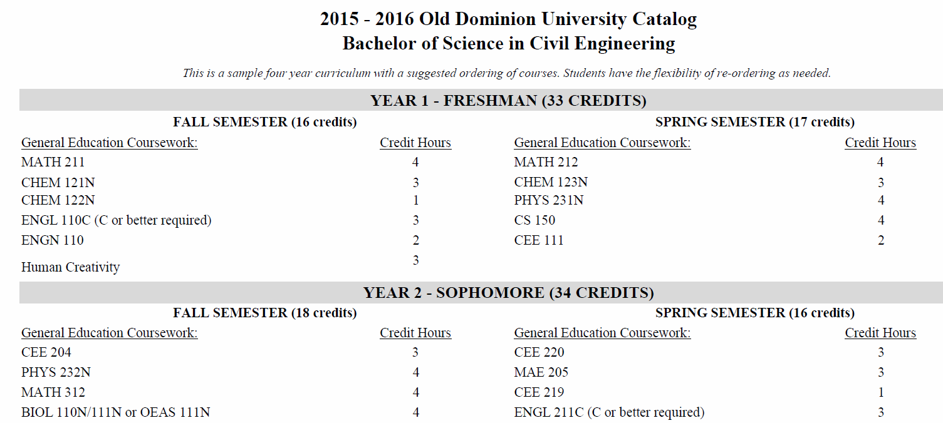

Print a curriculum sheet for one of Virginia Tech’s engineering programs (or select another university of your choice)
- Find a curriculum sheet for a BS degree one of Virginia Tech’s engineering programs (your choice).
- Virginia Tech refers to curriculum sheets as “checksheets.”
- Select the year most that would work best for you if you transferred to Virginia Tech.
- You might begin by finding the engineering department and selecting undergraduate degrees.
- Look for or search for curriculum sheet or checksheet.
- Print the curriculum and attach it to your assignment or save it and submit it electronically in Bb with your assignment.
