EGR 120 Due date: _____________________
Introduction to Engineering
File: EGR120H1
Homework Assignment #1

Reading Assignment:
- Read Section 2.5 (Your Graduation Plan) in Engineering Fundamentals – An Introduction To Engineering, 5E by Moaveni.
- TCC Student Handbook for Engineering

Assignment:
- (80 pts) Develop a graduation plan, listing exactly which courses you will need to take each semester (beginning with this semester) between now and the time that you graduate with a bachelor’s degree.
- For this assignment it is assumed that all students are pursuing a bachelor’s degree in engineering or engineering technology. If you haven’t yet decided on an engineering discipline to pursue or a university in which to transfer, simply pick a possible choice for now.
- Include both course numbers and titles.
- List specific semesters (for example: Spring 2018, Summer 2018, Fall 2018, etc., instead of Semester 1, Semester 2, etc.)
- Include a list of courses that you have already completed.
- List specific courses for Approved EGR Electives.
- List specific courses for Social Science and Humanities Electives.
- Reference: TCC Student Handbook for Engineering and the website for the engineering program at the college or university of your choice.

Example:
University selected for transfer: ODU
Engineering discipline: Civil Engineering

Classes already completed at TCC or transferred to TCC: PSY 201, MTH 163, MTH 164,

Spring 2019 – TCC (begin with the current semester)  EGR 120 – Intro to EGR  MTH 263 – Calc. I  CHM 111 – Chemistry I  HIS 121 – US History  Summer 2019 – TCC  CHM 112 – Chemistry II  EGR 110 – Engineering Graphics  Fall 2019 - TCC  MTH 264 – Calc II  PHY 241 – Physics I  EGR 140 - Statics  EGR 125 – Intro to EGR Methods  … | Fall 2020 – ODU  CEE 304 – CEE Infrastructure Systems  CEE 305 – Civil and Environmental EGR computations  CEE 310 – Structures I  CEE 323 – Soil Mechanics  CEE 335 – Soils & Hydraulics Lab  CEE 340 – Hydraulics and Water Resources  …  …  …  (include all semesters until graduation with a BS degree in engineer or engineering technology)

- Curriculum Sheets (20 points)

Print a curriculum sheet for one of ODU’s engineering programs
- Find a curriculum sheet for a BS degree one of ODU’s engineering programs (your choice).
- Go to https://www.odu.edu/advisingprograms (or search until you find it)
- Curriculum Sheets
- Pick the most current academic year
- Pick the degree of your choice
- Print the curriculum and attach it to your assignment or save it and submit it electronically in Bb with your assignment (Bb will allow you to submit multiple files).
- Sample ODU curriculum sheet (incomplete):
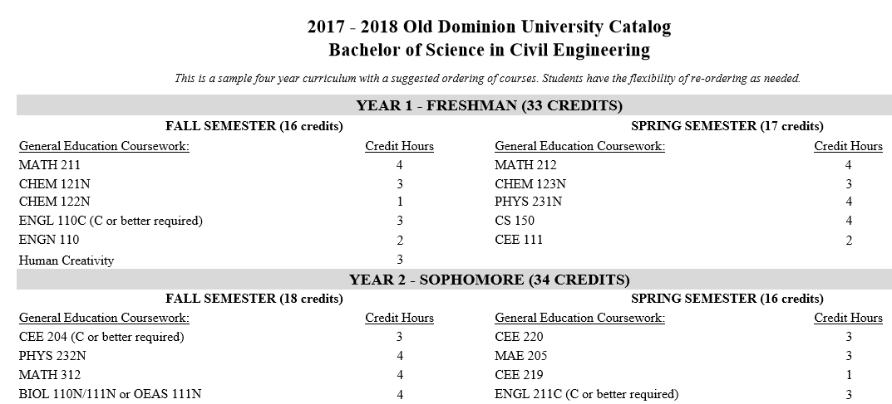

Print a curriculum sheet for one of Virginia Tech’s engineering programs (or select another university of your choice)
- Find a curriculum sheet for a BS degree one of Virginia Tech’s engineering programs (your choice).
- Virginia Tech refers to curriculum sheets as “checksheets.”
- Select the year most that would work best for you if you transferred to Virginia Tech.
- You might begin by finding the engineering department and selecting undergraduate degrees.
- Look for or search for curriculum sheet or checksheet.
- Print the curriculum and attach it to your assignment or save it and submit it electronically in Bb with your assignment (Bb will allow you to submit multiple files).
- Sample Virginia Tech curriculum sheet (incomplete):
