EGR 120 Due date: ____________________
Introduction to Engineering
File: EGR120-Excel-C
Homework Assignment #10 (EGR120-Excel-C)

Reading Assignment:
Read Chapter 14 in Engineering Fundamentals – An Introduction To Engineering, 5E by Moaveni.
Class Notes - Excel C PowerPoint Presentation
Computer Assignment:
- Complete the assignment described below.
- Use only one Excel file to store all parts of the assignments by placing each part on a different sheet (Sheet1, Sheet2, Sheet3, etc – renamed as Problem 1, Problem 2, Problem 3, etc) within the file.
- Submit the single Excel file using Canvas. All Excel assignments will only be accepted via Canvas.
- Warning: Your assignments must be your own work. You can ask other students questions, but sharing files is cheating. If any evidence of copied files is discovered, all parties involved will receive grades of 0 and may be subject to further disciplinary action.

Assignment:
For each problem below:
- Include your name, course number, course title, assignment number, and problem number.
- Include brief instructions.
- Include any given data in tables. The tables should include lines, complete table headings, and centered data with the provided number of digits. Always show sample Excel formulas below any table that uses formulas. Graphs should include appropriate formatting.
- Follow any other instructions given with each problem.

1. Graphing curves with multiple sets of y values
- Create a table in Excel to calculate the quantities X_{C}, X_{L}, and Z for a series RLC circuit using values of frequency, f, shown in the table below. Enter Excel formulas in the table to calculate the values of X_{C}, X_{L}, and Z using the equations below:

The values of R, L, and C are constants that should also be entered into the spreadsheet and used in the formulas above. Absolute addresses should be used when referring to the cells containing these constants.
R = | 6.80E+03
C = | 4.00E-07
L = | 3.96E-03
f(Hz) | X_{C} (Ω) | X_{L} (Ω) | Z (Ω)
100 | 3.98E+03 | 2.49E+00 | 7.88E+03
200
500
1000
2000
5000
10000
20000
50000
100000

- Form a single graph showing X_{C} vs f, X_{L} vs f, and Z vs f.
- Include a legend as shown below.
- Use a scatter plot with a smooth curve (no trendline is needed).
- The final graph should look like the graph shown below (with your name instead of John Doe).
- Use a log scale on the x-axis.
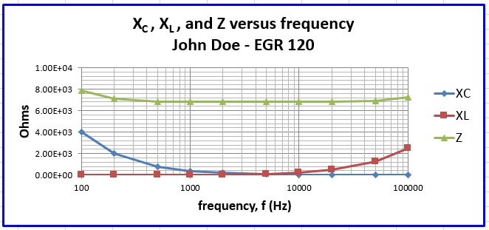
2. Graphing curves with multiple sets of x values
Shown below are voltage and current values for two types of electrical devices called diodes. One of the diodes is made of germanium and the other is made of silicon. It is common to graph these curves with common current values and with current on the y-axis.
- Create a spreadsheet with the table below
- Create a graph like the one shown below (use linear scales for both axes).
 | Germanium Diode | Silicon Diode
Current (mA) | Voltage (V) | Voltage (V)
1 | 0.473 | 0.592
2 | 0.491 | 0.627
3 | 0.502 | 0.648
4 | 0.509 | 0.663
5 | 0.515 | 0.674
10 | 0.532 | 0.710
20 | 0.550 | 0.746
30 | 0.561 | 0.766
40 | 0.568 | 0.781
50 | 0.574 | 0.793
100 | 0.592 | 0.828
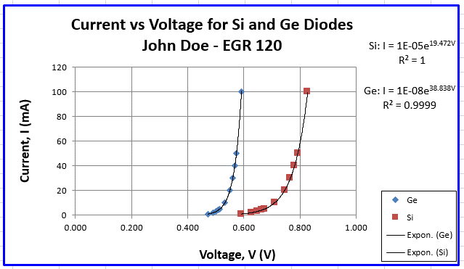

3. Statistics and Sorting
Download the file WorldPopulationTable.xls from the course Canvas site or from
http://www.tcc.edu/faculty/webpages/pgordy/Egr120/
Sort the data in several ways to answer the following questions:
- Which 5 countries had the lowest population in 1999? (Not counting 0, --, or NA)
- Which 5 countries had the highest population in 2006?
- What was the average population of all countries in Africa in 2004?
- What was the average population of all countries beginning with the letter B in 2005?
- How many countries had a population between 40 million and 60 million in 2003?
- Which 5 countries had the largest percentage growth in population from 2005 to 2006? Hint: Add a new column labeled Growth using (2006 population-2005 population)/(2006 population)*100.

4. Pie Chart
Create a pie chart with the following data.
- Include a legend.
- Include percentages, discipline titles, and the number of degrees next to each pie slice. Each percentage should include 1 digit after the decimal point.
- Include the title: 1999 Bachelor's Degrees Awarded by Discipline

2004 Bachelor's Degrees Awarded by Discipline
(Total: 72,893)
Source: American Society of Engineering Education
Discipline | B.S. Degrees Awarded
Mechanical | 14,182
Electrical | 12,500
Computer Science | 9,156
Civil | 8,142
Computer | 5,838
Chemical | 4,801
Industrial/Manufacturing | 3,790
Electrical/Computer | 2,700
Other | 2,488
Aerospace | 2,232
Biomedical | 2,019
General Engineering | 1,138
Metallurgical & Materials | 817
Agricultural | 601
Architectural | 590
Environmental | 576
Eng. Science & Physics | 501
Engineering Management | 302
Petroleum | 233
Nuclear | 202

5. Look Up Tables and Look Up Functions
Many college courses use statistics to assign test and course grades based on the mean and the standard deviation for the class. This is common in universities, but less common in community colleges, because this is not considered to be a good method unless class sizes are 35 or greater.
- Create a table containing the last name, first name, and test scores for a class of 35 engineering students. All test scores must be in the range 0 to 100, but let most of the test scores be in the 60’s, 70’s, 80’s, and 90’s with a reasonable distribution of scores. Do not repeat any names. If the names are not already in alphabetical order, sort them alphabetically (by last name) using Data – Sort. Set up a fourth column in the table for the letter grade which Excel will assign statistically as described below. (Your table should be unique and use different information from anyone else in your EGR 120 class.)
- Use statistical functions in Excel to find the mean, standard deviation, maximum, and minimum. Label and box each answer.
- Create a lookup table which will list the cutoff between each grade range as follows:
A/B cutoff: Mean + Standard Deviation
B/C cutoff: Mean + Standard Deviation/3
C/D cutoff: Mean - Standard Deviation/3
D/F cutoff: Mean - Standard Deviation
- Use a lookup function to assign the letter grade A, B, C, D, or F to each student based on the grade cutoffs specified in the lookup table.
- An example (incomplete) Excel spreadsheet is shown below:
- As always, include sample Excel equations (as text) to show your calculations.
Last name | First name | Test Score |  | Grade
Anderson | Tim | 82 |  | C | Note: use the lookup function
Brown | Lisa | 83 |  | B | to assign each letter grade
Butler | John | 91 |  | B
…
…
White | Jeremy | 72
Mean: | 77.8
Std Dev: | 14.1
Max: | 99
Min: | 54
Lookup | Table
Grade | Value
F | 0
D
C
B | 82.5
A | 91.9

6. Histogram and Cumulative Distribution Function
An electrical engineering student bought a pack of twenty 10 kΩ resistors from a local electronics store. The resistors have a 10% tolerance, so all values should lie between 9 kΩ and 11 kΩ. The student measured each value using an ohmmeter and the results are shown below.
- Generate a histogram (and the bin/frequency table) based on the ranges specified below. Note: the form shown for the bounds are not in the correct format, so add an additional column for bin values. Be sure to check “Chart Output” and “Cumulative Percentage” to show both the histogram and the Cumulative Distribution Function.
- Using the result of the output table (Cumulative Percentage), answer the following (in a nicely formatted table):
  - What percentage of the resistor values are below 9.6 kΩ?
  - What percentage of the resistor values are above 10.4 kΩ?
  - What percentage of the resistor values are between 9.8 kΩ and 10.2 kΩ?
Resistance, R (kΩ) |  | Bounds for Histogram
10.15 |  | 9.0 – 9.2 kΩ
9.97 |  | 9.2 – 9.4 kΩ
10.51 |  | 9.4 – 9.6 kΩ
9.65 |  | 9.6 – 9.8 kΩ
9.74 |  | 9.8 – 10.0 kΩ
10.13 |  | 10.0 – 10.2 kΩ
9.44 |  | 10.2 – 10.4 kΩ
10.66 |  | 10.4 – 10.6 kΩ
9.50 |  | 10.6 – 10.8 kΩ
10.29 |  | 10.8 – 11.0 kΩ
9.87
10.51
10.24
9.81
9.76
10.40
10.11
9.95
10.72
9.39

Extra Credit (up to 10 points):
Work Problem 14.23 in the textbook. Additional details:
- Create a nicely-formatted table with V, Fuel Consumption in miles per gallon (given formula) and gallons per mile (inverse of the formula given).
- Let V vary from 30 to 70 in increments of 2 mph.
- Create two nicely-formatted graphs: Miles per gallon vs V and Gallons per mile vs V
- Use the max( ) function in Excel to find the maximum mpg from the table. (As always, show the Excel formula used to find this result.) Highlight the row in the table corresponding to this value.
- At what speed does the car have the highest fuel efficiency?

