EGR 272 Due date: ______________

Circuit Theory II

File: N272PS1

**PSPICE Assignment #1**

**Reference**:

PSPICE Lecture – Transient Analysis

**PSPICE Assignment**:

1. **Circuit 1**: This circuit includes a switch that closes at time t = 0 in order to charge the capacitor.

A) **Assigned circuit values:** Use values for Circuit 1 based on your Student ID as follows:

* Let R = first 3 non-zero digits of your Student ID in ohms
* Let C = last 3 non-zero digits of your Student ID in F
* Let Vs = last 3 non-zero digits of your Student ID in volts
* Let IC (initial condition) = last 2 non-zero digits of your Student ID in volts
* Ex: For the ID 20345607, use R = 234 Ω, C = 567 F, Vs = 567 V, and IC = 67 V.
* Show how your determined your values.

1. **Draw the schematic:** Construct Circuit 1 in PSPICE using your assigned values.
   * Add text to the schematic, including name, course, assignment number, and the purpose of the problem.
   * Add text showing how you determined the length of the transient analysis.
   * Label all nodes.
   * Display the initial condition (IC).

C) **Analyze the circuit and graph the results:** Graph the voltage for the source, resistor, and capacitor (on the same graph).

* Add text to label each curve
* Add text to the graph including your name and the problem number.

D) **Discussion:** Discuss the graphs. Do they appear as expected? Did the value used for 5Tau look correct (explain)?

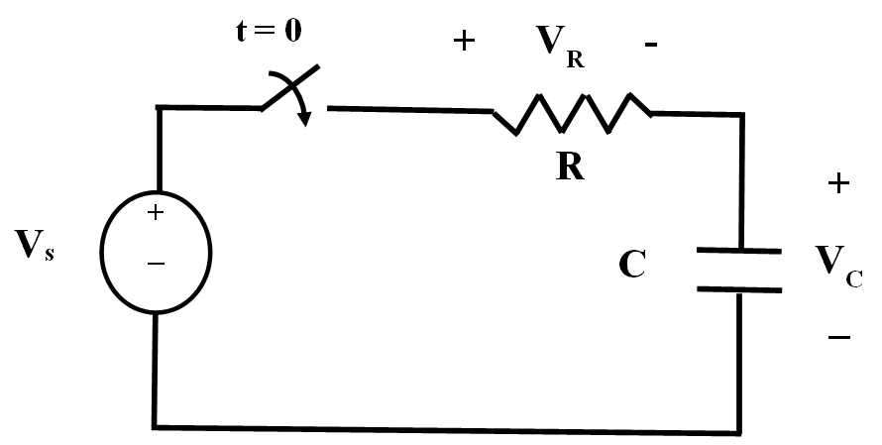

Circuit 1

2. **Circuit 2:** Circuit 2A shows a switch opening and closing periodically, allowing the capacitor to periodically charge and then discharge. When analyzing this circuit using PSPICE, the switch and DC voltage source can be replaced by a pulsed voltage source as shown in Figure 2B. When the pulsed source is HIGH (50V) this circuit acts like Circuit 2A with the switch in position A. When the pulsed source is LOW (0V) it acts like Circuit 2A with the switch in position B.

1. **Draw the schematic:** Construct Circuit 2B in PSPICE using the same assigned values for R and C as were used in Circuit 1.
   1. Use part VPULSE.
   2. Use IC = 0 (and display the value).
   3. Add text to the schematic, including name, course, assignment number, and the purpose of the problem.
   4. Add text showing how you determined the length of the transient analysis if the capacitor is to charge 4 times and discharge 4 times.
   5. Label all nodes.

B) **Analyze the circuit and graph the results:** Graph the source voltage and the capacitor voltage on the same graph such that the capacitor charges and discharges 4 times.

* Add text to label each curve
* Add text to the graph including your name and the problem number.

C) **Discussion:** Discuss the graphs. Do they appear as expected? Did the capacitor have enough time to fully charge and fully discharge duing each period of the pulse?

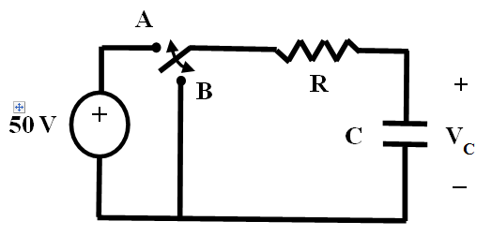 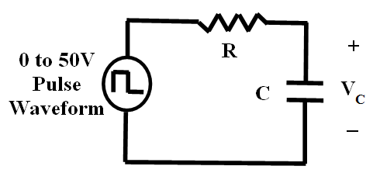

Circuit 2A Circuit 2B

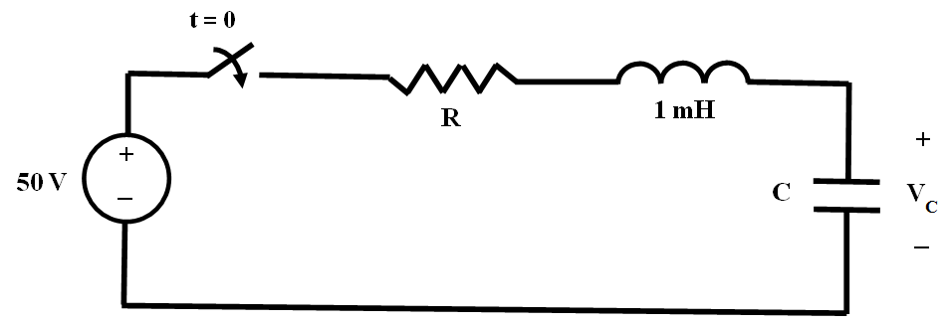

Circuit 3

3. **Circuit 3**: Circuit 3 is 2nd-order circuit. It might be overdamped, underdamped, or critically damped based on the values of the components.

A) **Assigned circuit values:**

* 4 different values of R will be used as described below:



* Calculate R for each of the 4 cases above using the value of C assigned for Circuit 1. Use L = 1 mH. Show your calculations.

1. **Draw the schematic:** Construct Circuit 3A (Circuit 3 using the appropriate value of R)
   1. Add text to the schematic, including name, course, assignment number, and the purpose of the problem.
   2. Add text identifying the type of response (overdamped, underdamped, etc)
   3. Add text showing length of the transient analysis as 5/α (show the calculation).
   4. Label all nodes.
   5. Use IC = 0 and display this value.

C) **Analyze the circuit and graph the results:** Graph the capacitor voltage.

* Add text identifying the type of response (overdamped, underdamped, etc)
* Add text to the graph including your name and the problem number.

1. **Discussion:** Discuss the graph. Do it appear as expected? Did the value used for 5Tau look correct (explain)?
2. Repeat parts B, C, and D for Circuit 3B.
3. Repeat steps B, C, and D for Circuit 3C.
4. Repeat steps B, C, and D for Circuit 3D.
5. Use a PARAMETRIC and TRANSIENT analysis together to generate a series of 4 curves ranging from your smallest R value to your largest R. Use the longest of the final transient times from the previous circuit. Include a clearly labeled schematic and a graph. Label the type of response next to each curve.