EGR 272  
Circuit Theory II

File: EGR272Pre-Test

**EGR 272 Pre-Test**

EGR 271-272 are foundational electrical engineering courses and cover concepts that will be used in other electrical engineering courses. EGR 272 students are expected to remember basic principles and techniques from EGR 271. This pre-test will provide you with sample problems from EGR 271 that you should be able to solve.

1. If I = 2 A, VR equals:

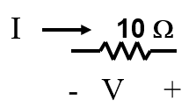

1. 20 V B) -20 V C) 5 V D) -5 V
2. If VR = -20 V, I equals:

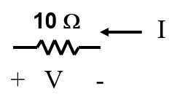

1. 2 A B) -2 A C) 200 A D) -200 A
2. Find RAB. RAB = ___________

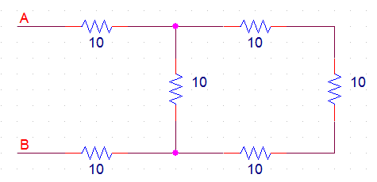

1. Find RAB. RAB = ___________



1. Use ***voltage division*** to find the voltage Vx below: Vx = _______________



1. Use ***voltage division*** to find the voltage Vx below: Vx = _______________



1. Use ***current division*** to find the current Ix below: Ix = _______________



1. Use ***current division*** to find the current Ix below: Ix = _______________



***Note: Problems 9, 10, 11, and 12 use the same circuit. It will be analyzed using 4 different techniques. Of course, the 4 answers should be the same!***

1. Find Ix and Iy as follows:
   1. Find the total resistance seen by the source
   2. Find Ix Ix = _______________
   3. Use ***current division*** to find Iy: Iy = _______________



1. Find Iy using two ***source transformations*** to reduce the circuit to a single mesh circuit:

Iy = _______________



1. Find Ix and Iy using ***mesh equations***.

Ix = _______________

Iy = _______________



Iy

Ix

1. Find Ix and Iy as follows:
   1. Write ***node equations*** for find the voltages VB and VC. Use node D as ground.

VB = ______________ VC = _____________

* 1. Use the node voltages to find Ix and Iy.

Ix = _______________ Iy = _______________

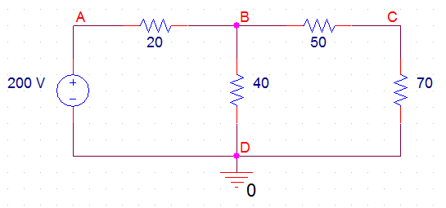

**Ix**

**Iy**

1. Find the power dissipated by the 8 ohm resistor by first reducing the 4 mesh circuit below to a 1 mesh circuit using ***source transformations***. P = ________



1. Find the voltage Vx using superposition. Vx = _____________



1. Find the voltage Vo and Io for the op amp circuit below. Vo = _____________ Io = _______________



**Io**

**+**

**Vo**

**_**

1. Consider the capacitor shown below. Note the polarity.

**- v(t) +**

**4uF**

**i(t)**

1. Any capacitor acts like the following in ***steady-state***:
   1. A short circuit b. An open circuit c. A current source d) none of the above
2. Which one of the following is true for a capacitor?
   1. v(0+) = v(0-) b. i(0+) = i(0-) c. both a and b d) none of the above
3. If a capacitor has ***no initial stored energy***, which one of the following is true?
   1. v(0) = 0 V b. i(0) = 0 A c. both a and b d) none of the above
4. If v(t) = 10 V for the capacitor shown above, find the energy stored in the capacitor
5. If v(t) = 10e-2t for the capacitor shown above, find i(t)
6. If i(t) = 10e-2t for the capacitor shown above, find v(t). The capacitor has no initial stored energy.
7. Consider the inductor shown below. Note the polarity.

**i(t)**

**2mH**

**+ v(t) -**

1. Any inductor acts like the following in ***steady-state***:
   1. A short circuit b. An open circuit c. A current source d) none of the above
2. Which one of the following is true for a inductor?
   1. v(0+) = v(0-) b. i(0+) = i(0-) c. both a and b d) none of the above
3. If a inductor has ***no initial stored energy***, which one of the following is true?
   1. v(0) = 0 V b. i(0) = 0 A c. both a and b d) none of the above
4. If i(t) = 8 mA for the inductor shown above, find the energy stored in the inductor
5. If v(t) = 10sin(20t) for the inductor shown above, find i(t). The inductor has no initial stored energy.
6. If i(t) = 10sin(20t) for the inductor shown above, find v(t).