EGR 270
Fundamentals of Computer Engineering
File: N270L1

Lab # 1
Introduction to Logic Circuits

Lab Format
This is a Team Lab so it may be done with a single partner or alone.
If partners are used:
- A single set of Preliminary Work needs to completed before lab begins. Preliminary Work will be checked in lab and will be part of the lab report grade.
- A single lab report needs to be submitted.
- Both partners must be present for the entire lab in order to receive credit.
Lab reports will not be accepted until all required circuits have been demonstrated to the instructor.

A. Objectives
The objectives of this laboratory are to introduce the student to:
- basic breadboarding and wiring techniques
- the use of input switches and output LEDs in generating truth tables for a combinational logic circuit
- circuit documentation and report writing

B. Materials
Breadboard
5V Power Supply
74LS08 Quad 2-input AND
74LS32 Quad 2-input OR
74LS86 Quad Exclusive-OR
220 Ω and 2.2 k Ω resistors
DIP switch (4 or more switches)
LED

C. Introduction
This lab focuses on several practical issues related to breadboarding and testing combinational logic circuits. Several helpful points are made below.

Wire gauge - Use only 22 gauge wire. The breadboard may be damaged by forcing smaller gauge (larger diameter) wire into the holes.

Wire color - Use organized color schemes when wiring circuits. For example, use RED wire for all Vcc connections, BLACK wire for all ground connections, BLUE wire for all input switches, and YELLOW wire for all intermediate signal connections.

Wire length and placement - Use wires that are the appropriate length so that they can lie flat on the breadboard. Avoid running wires over IC’s in case the IC’s need to be removed.

Testing IC’s - If a chip tester is available in lab, you might consider testing your IC’s.

Inserting IC’s - IC’s are not difficult to insert in the socket strips once they have been properly adjusted. Brand new IC’s are shipped with their pins bent apart from the vertical (typically 15° outward) in order to facilitate handling by automatic insertion equipment. Therefore, before an IC is used for the first time its pins must be bent back so that their spacing is vertical.

IC Orientation - Arrange all IC’s in the same direction. This will facilitate connecting Vcc on each IC to a 5V strip on the breadboard and GND on each IC to a ground strip. If an IC is reversed (thus Vcc and ground are reversed), it may be destroyed. It is recommend that you begin wiring by making all Vcc and ground connections.

IC Diagram – Shows the orientation and the order of the ICs on the breadboard as well as the assigned chip number (U??) and the manufacturer’s part number.
U1-74LS04
U2-74LS08
U3-74LS08
U1-74LS32
breadboard

IC Removal - It is recommended that you use some an IC extraction tool for removing IC’s. Attempts to remove IC’s by hand will often result in bent pins.

LEDs - LEDs (light emitting diodes) are diodes that emit light when they are forward biased (a positive voltage placed across the LED from anode to cathode as in Figures 2A and 2B). The amount of light produced is proportional to the current through the LED (see Figure 2C).

The resistance of an LED is sufficiently low such that if 4V is placed directly across an LED, it will be destroyed. Therefore, a current-limiting resistor should always be used with an LED. The resistor must be chosen to yield a current such that an appropriate brightness is obtained. If the ouput voltage of a logic gate is 5V, if about 1.5V is dropped across the LED, and if the desired current range to produce a suitable brightness is 12 - 20 mA, then the value of the current-limiting resistance can be calculated as follows:

Common values for current-limiting resistors are 220 Ω , 270 Ω , 330 Ω and 470 Ω.
Active-HIGH and Active-LOW outputs
LEDs can be wired either to light when the output of a gate is HIGH (active-HIGH) or to light when the output of a gate is LOW (active-LOW). Both methods are shown in Figure 3. We will typically use active-HIGH outputs.

Switches - If switches are not available on the breadboard, they can be formed easily using single-pole single-throw (SPST) switches as shown in Figure 4.
2.2k
5V
Closed = LOW = ON
Open = HIGH = OFF
Switch
Output
Multiple Switches – Labs will commonly require 4 or more input switches where one switch is used to for each digital input. 4 digital switches can be easily formed using a DIP switch with 4 switches as shown below.

Since we read numbers left to right, put the MSB (A in this case) on the left.
2.2k
5V
Open = HIGH = OFF
Closed = LOW = ON
B
2.2k
5V
C
2.2k
5V
D
2.2k
5V
A
4 DIP Switches
Memorize this!
Dip Switch Orientation
Note that it doesn’t matter if a dip switch is inserted with OFF at the top and ON at the bottom or the other way around. However, since it is perhaps more natural to associate HIGH with Up and LOW with Down, it is recommended that you orient the dip switch with ON (LOW) at the bottom and OFF (HIGH) at the top.

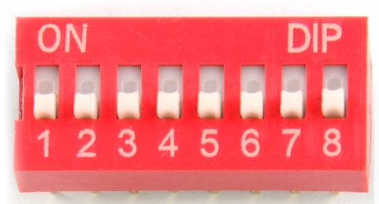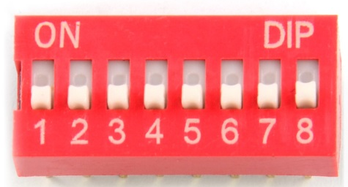
NOT preferred (X) Preferred ()

D. Preliminary Work
Include instructions with each step.
1. Show the following for Circuit 1 below.
A) Pinouts for all IC’s used (Pinouts are available on the course Bb site in the document entitled: “Lab Reference Sheets.” They can be easily copied and pasted into your report.)
B) Logic Diagram using PSPICE, including:
- Assigned chip numbers and part numbers (For example: U1 – 74LS08)
- All IC pins properly labeled
- Input switches (including DIP switches, resistors, etc)
- Output LEDs or 7-segment displays, including current-limiting resistors
C) Breadboard Layout using Fritzing, including:
- Assigned chip numbers and part numbers (For example: U1 – 74LS08)
- Input switches (including DIP switches, resistors, etc)
- Output LEDs or 7-segment displays, including current-limiting resistors
- See the document Fritzing Tutorial – Program for Breadboard Layout
2. Determine the truth table for Circuit 1.
3. Repeat step 1 for Circuit 2.
4. Repeat step 2 for Circuit 2.

E. Laboratory Work
1. Construct Circuit 1. Note any changes from the Preliminary Work.
2. Test Circuit 1, filling in a truth table prepared for recording the circuit response for all possible input combinations. The truth table should match the truth table prepared in the Preliminary Work. Demonstrate proper operation of the circuit to the instructor.
3. Construct Circuit 2. Note any changes from the Preliminary Work.
4. Test Circuit 2, filling in a truth table prepared for recording the circuit response for all possible input combinations. The truth table should match the truth table prepared in the Preliminary Work. Demonstrate proper operation of the circuit to the instructor.

F. Report
All lab reports should have the following sections.
- Title Page – Include course number and name, lab number and title, date, name, and lab partner’s name.
- Preliminary Work – See specifications in Preliminary Work section. Be sure to include instructions. Preliminary Work will be briefly checked before lab and will be graded in detail with the report.
- Lab Results – Include the following:
  - List instructions or clear descriptions for each part of the lab.
  - Neatly record all measured data (for example, show the measured truth tables). Note that it is not sufficient to simply say that the circuit output matched the expected results. Show the measured results.
  - Note any changes to the circuit (for example if you used different pins, resistor values, etc.). If each circuit was built exactly as shown in the PSPICE schematic, say so.
  - List any problems that occurred in lab (for example, if you had to replace a bad IC or if you learned something helpful).
- Discussion – Discuss the key results of the lab. Discuss any problems, errors, changes, etc. A good question to consider when writing the discussion is “What did I prove or demonstrate in this lab?”

