EGR 270
Fundamentals of Computer Engineering
File: Fritzing_EGR270.docx

Breadboard Layouts and Schematics using Fritzing

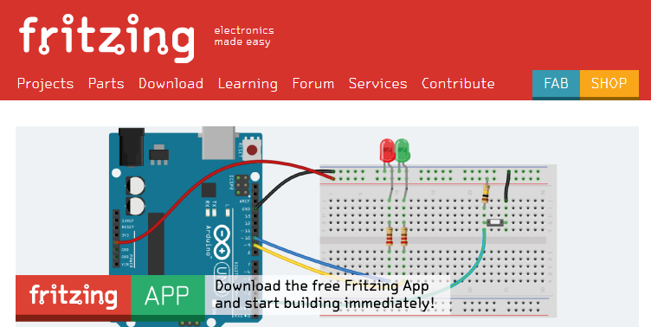

Fritzing is a free program for creating breadboard layouts, schematics, and printed circuit board (PCB) layouts.
Fritzing can be downloaded from: http://fritzing.org/home/

Fritzing will be used in EGR 270 to create breadboard layouts. Schematics can be created as well, although PSPICE will more typically be used for schematics so that they can be analyzed as well.

Fritzing has extensive libraries of components and also allows the user to create custom components. A few of the Core Parts are shown below.
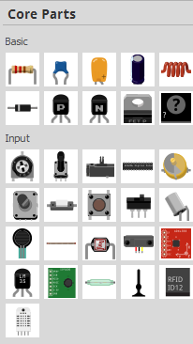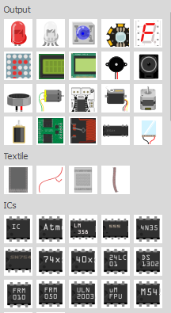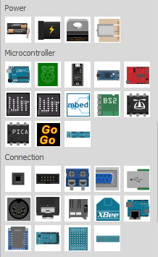
Example: Produce a standard breadboard layout in Fritzing that is similar to the breadboards used in EGR 270.

Launch Fritzing
- Select the Breadboard tab
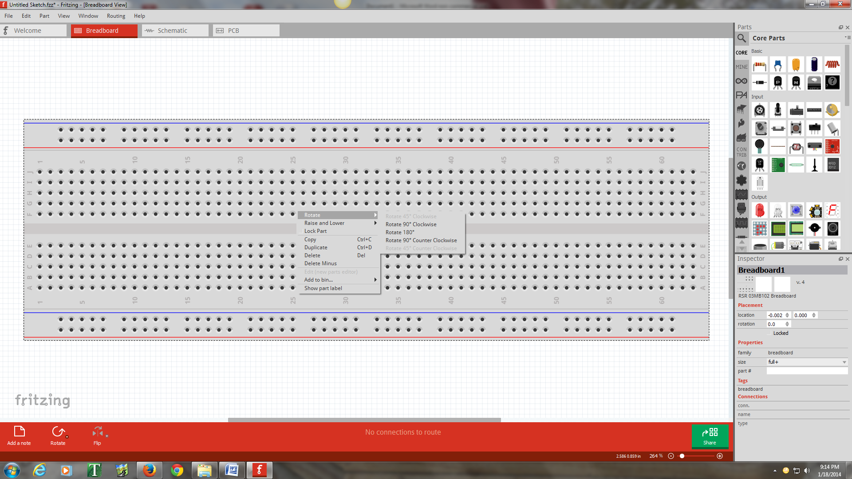

- Right-click on the breadboard and select Rotate – Rotate 180° to match the orientation of breadboards used in lab (red “power rail” at the top).
- Right-click on the breadboard and select Duplicate to add a second breadboard
- Zoom using the mouse wheel and move one breadboard above the other
- Right-click on each breadboard and select Lock Part so that the breadboards will not move
In EGR 270 the red power rails are typically used for 5V so it is convenient to tie them all together.
- Add a wire between the red power rails by pressing the left mouse button and dragging the cursor between the desired holes.
- Right-click on the wire and change Wire Color to Red (or use the Inspector window on the bottom left of the screen).

- Similarly add red wires connecting all red power rails and black wires connecting all black power rails.
- Also add red and black wires extending from the breadboard to connect to the DC power supply in lab.
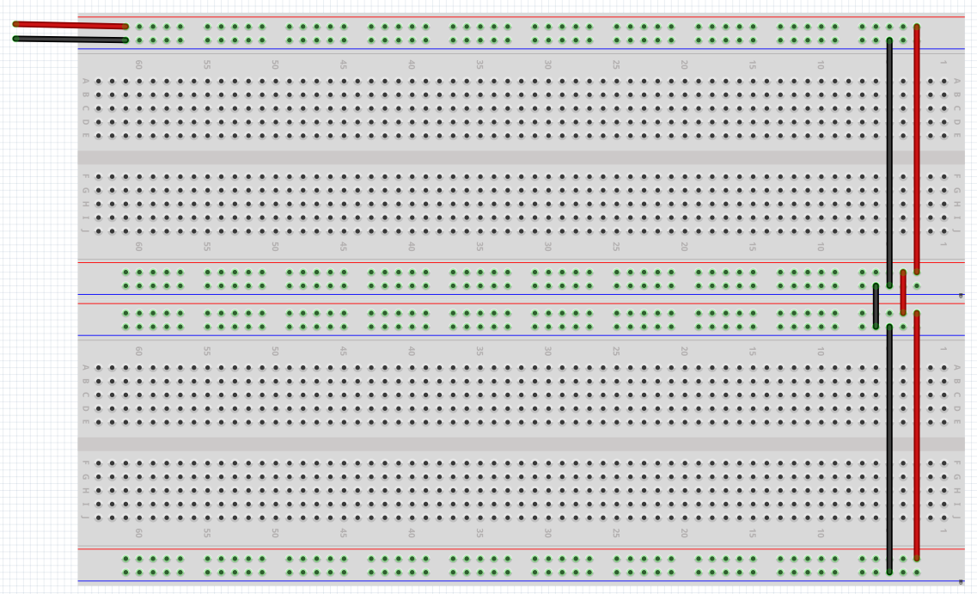

Since all labs will use the basic breadboard setup above, save this file as EGR270Breadboard.fzz
A similar file has also been saved by the instructor and is available on the course website.

Breadboard Images: You can also make images of breadboard layouts as follows:
- File – Export – Save as image – JPG, pdf, etc
- You can insert images into Word using Insert - Image
Example: The following schematic was drawn in PSPICE. Draw the breadboard layout in Fritzing.
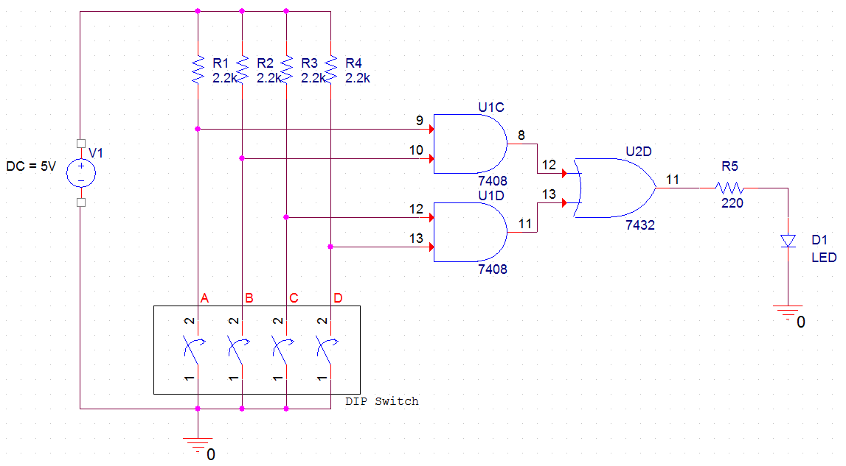
Launch Fritzing
- Select File - Open and open the file EGR270Breadboard.fzz
- Save the file as EGR270Lab1.fzz (for example)
- Drag a resistor from the Core – Basic bin of the Parts library to the breadboard
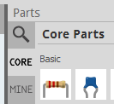
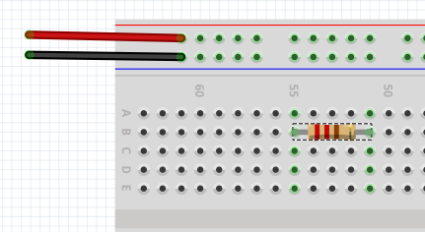
- Select the resistor and use the Inspector in the lower right of the screen to change the Resistance to 2.2kΩ
- Right-click on the resistor and Rotate it by 90° (or use the Rotate tool on the bottom left of the screen)

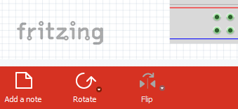
- Right-click on the resistor and select Duplicate (or use Copy and Paste) to create three more resistors.
- Move the resistors so that the tops of the resistors are connected to the 5V (red) power rail.
- Notice that the color bands of the resistors are Red-Red-Red for 2.2kΩ
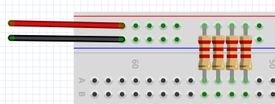
- Switch to the SparkFun-Electromechanical bin in the Parts library. Drag the Dip Switch to the side of breadboard. It is generally a good idea to drag a component to the side of the breadboard if you wish to change its number of pins or else Fritzing seems to like to add wires connecting various pins.
- Use the Inspector to change the part from dipswitch-02 to dipswitch-08. Unfortunately, a dip switch with 4 switches is not available.

- Drag the 8-position DIP switch onto the breadboard.
- The ON position of the switch will correspond to a LOW, so it is often convenient to mount the switch upside down so that Up is HIGH and Down is LOW (more natural). Rotate the switch by 180°.
- Be sure that the pins on the dip switch are in breadboard holes and that the dip switch bridges the large gap between the holes in the middle of the breadboard.
- Be sure that switches 1,2,3,4 line up with the 4 resistors.
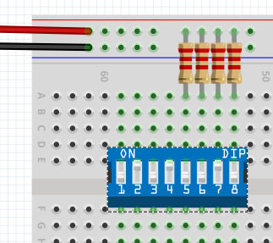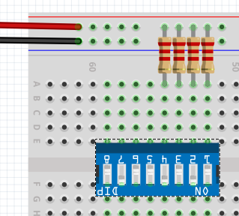
Rotate the switch
- Add black wires from the bottom of the 4 dip switches in use to the black power rail (ground).
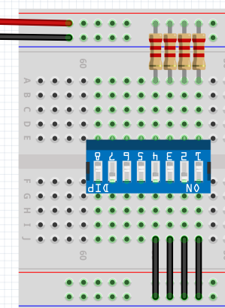
- Add ICs (integrated circuits). Note that Core bin of the Parts Library only has a few ICs. It would be unreasonable to list all possible ICs as there are millions of them. To add an IC not in the list, use the generic part named IC. Drag the part IC to the side of the breadboard (not onto the breadboard).
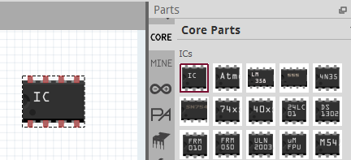
- Select the part and use the Inspector to change the number of pins to 14.
- Also change the Chip Label to 74LS08.
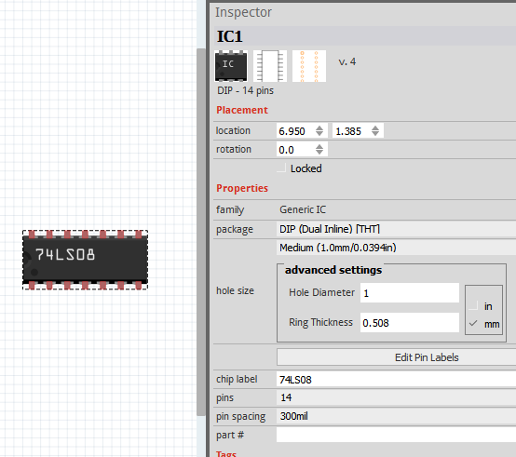

- Right-click on the part and select Edit (New Parts Editor)
- Select the Metadata tab and change the Title to 74LS08
- Select File – Save As New Part and then select OK in the window Filename prefix
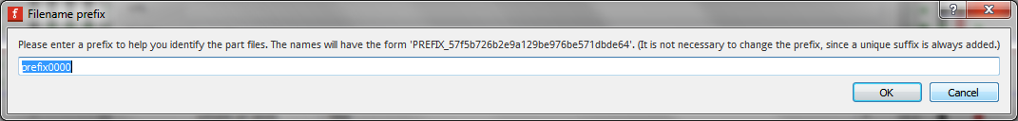
- The new part should now appear in the My Parts library for future use.
- Drag newly created part onto the breadboard.
- Similarly create a part for the 74LS32 and drag it onto the breadboard.
- Also add red wires from pin 14 to the red power rail and black wires from pin 7 to the black power rail
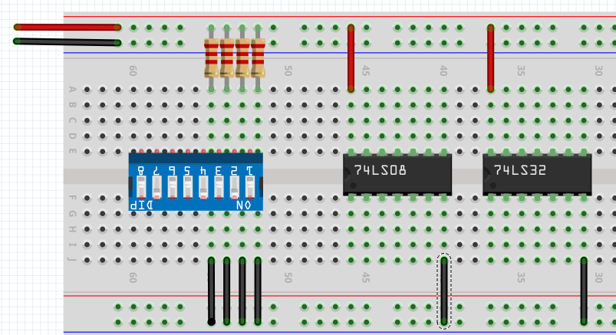

- The DIP switches represent inputs A, B, C, and D from left to right (generally keep the MSB on the left). Add the blue wires shown below to match the schematic. Be sure that pin numbers match the schematic.
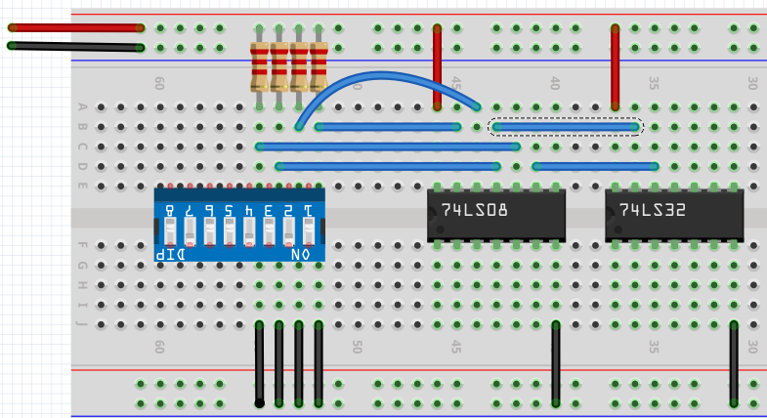
- How was the curved wire above formed?
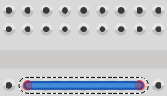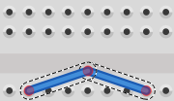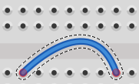
Ctrl + Drag the middle of the wire to add a smooth bend
Drag the middle of the wire to add a bend point
Draw a straight wire from starting hole to ending hole

- Add an LED to the schematic. Pause over each terminal to identify the anode (+) and cathode (-).
- The legs of the LED are adjustable. Since the anode leg is typically longer, shorten the cathode leg.
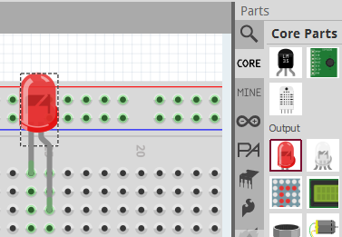
- Add wires and a 220 Ω current-limiting resistor in series with the LED from the output of the OR gate to ground. The schematic is now complete! Be sure to save the schematic.
