Atmel Studio 7 Installation and Modification
We will be using in EGR 270 to teach assembly language programming for the Atmega328P (microcontroller on the Arduino UNO).
This free software can be downloaded from:
http://www.atmel.com/tools/atmelstudio.aspx#download

Modifications to Atmel Studio 7 installed in EGR labs:
- Launch Atmel Studio 7
- Select the following menus: Tools – External Tools
  - If External Tools does not appear under Tools menu go to Tools – Select Profile and change to Advanced.
The External Tools window will open (see next page). Enter the following information:
- In title: Send to Arduino
- In command: Enter the following exactly: – you may want to cut and paste this:
C:\Program Files (x86)\Arduino\hardware\tools\avr\bin\avrdude.exe
- In arguments: Enter the following exactly (including quotes) – you may want to cut and paste this:
-C "C:\Program Files (x86)\Arduino\hardware\tools\avr\etc\avrdude.conf" -p atmega328p -c arduino -P COM4 -b 57600 -U flash:w:"$(ProjectDir)Debug\$(TargetName).hex":i
- Check "Use output window" box.
- Click OK.
- When you are done, you will see the new option "Send to Arduino" in the Tools menu.

Note: The instructions pasted in the Arguments section used COM4. This may need to be changed to a different COM port depending on what COM port the computer assigns to the Arduino Nano when you connect it to the computer with a USB cable.

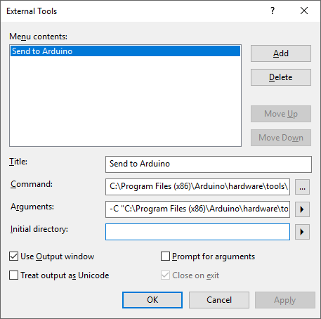
(Same window shown again, but scrolled to the end of the text in each box):
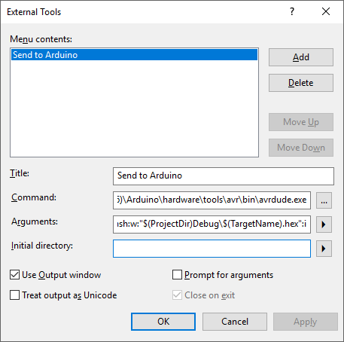

What does the External Tool do?
- Uses the following program to download your program: avrdude.exe
- Downloads the hex file to flash memory for your project: -U flash:w:"$(ProjectDir)Debug\$(TargetName).hex":i
- Sets the baud rate to 57600 bits/s: -b 57600
- Sets the COM port: -P COM4
- Specifies the microcontroller: -p atmega328p -c arduino

