EGR 262
Fundamental Circuits Lab
File: N262L8
Lab # 8
ADC, PWM, and class Servo

A. Objectives
The objectives of this laboratory are to introduce the student to:
- Use the Arduino UNO’s built-in 10-bit successive-approximation ADC
- Use ADC and PWM to vary an LED’s brightness using a potentiometer
- Use class Servo to control servos
- Use ADC and class Servo to control servos using a potentiometer

B. Materials
Breadboard with Arduino UNO
Adaptor (120V AC to 12 VDC, 1000 mA)
220 Ω resistor
10 kΩ potentiometer
LED
Standard servo (HiTec HS-311 or similar)

C. Introduction
See the Presentation for Lab #8 for more detailed background information.

D. Pre-Lab Tasks
- If a 10kΩ potentiometer is used to vary the analog input voltage on pin A2 as shown in Circuit 1 below, use Excel to calculate the value of R needed to produce each analog input voltage in the table below, where x is the last digit in your Student ID. Also calculate the Value that will be read by statement Value = analogRead(A2) in both decimal and binary form.

Analog voltage (V)  Arduino  UNO  A0  A1  A2  A3  A4  A5  5V  R  10k-R  (10k pot)  analog input | R  (kΩ) | Value  (decimal form) | Value  (binary form)
0.0
0.5x
1.0x
1.5x
2.0x
2.5x
3.0x
3.5x
4.0x
4.5x
5.0

Circuit 1 Table 1
- Search online for a specification for the HiTech HS-311 servo. Determine the following specifications:
  - Operating voltage
  - Torque
  - Rotation range (in degrees)
  - Pulse width (range)
  - Pulse cycle (or distance between pulses)
  - Speed
- Given the speed of the servo above, how long will it take to rotate 180 degrees°?
- Write a C++ program (Program 8A) for the Arduino UNO to read the analog input on pin A2 and to display the value read in both decimal and binary form. Also display the input analog voltage. (Note: This program is essentially provided in the presentation for this lab.)
- Write a C++ program (Program 8B) for the Arduino UNO to read the analog input on pin A2 and to use this value to control the brightness of an LED connected to pin D11.
- Write a C++ program (Program 8C) for the Arduino UNO where the user can enter the pulse width in μs (1500, for example) and class Servo will be used to send the pulse to pin D13 to control a servo.
- Write a C++ program (Program 8D) for the Arduino UNO where a servo connected to pin D13 will be rotated slowly (about 4s to turn 180 degrees) back and forth from 0° to 180° three times. (Use a for loop to vary the pulse width in small increments and perhaps include a small delay in the loop.) Assume that the pulse width varies from 1300μs to 1700μs, although these constants will be adjusted in lab.
- Write a C++ program (Program 8E) for the Arduino UNO where a potentiometer connected to analog input A2 can be turned causing a servo connected to D13 to rotate over a 180 degree range.

E. In-Lab Tasks
- Testing Program 8A
  - Build Circuit 1 and download Program 8A.
  - Connect a voltmeter to measure the analog input voltage to pin A2.
  - Carefully adjust the potentiometer to provide the input analog voltages listed in the Pre-Lab work (as closely as possible).
  - Capture the results from the serial monitor for each case and include them in your report.
  - Record your measured results along with your specified analog voltages from Pre-Lab in a table like the one shown below.
  - Demonstrate the program to the instructor.
  - Record comments for any problems encountered or lessons learned.

Pre-Lab | Voltmeter | Serial Monitor
Specified Analog voltage (V) | Measured analog voltage (V) | Calculated analog voltage (V) | Value  (decimal form) | Value  (binary form)
0.0
0.5x
1.0x
1.5x
2.0x
2.5x
3.0x
3.5x
4.0x
4.5x
5.0
- Testing Program 8B
  - Build Circuit 2 and download Program 8B.
  - Verify that the LED varies from very dim (or off) to very bright as the potentiometer is varied.
  - Record the results.
  - Demonstrate the program to the instructor.
  - Record comments for any problems encountered or lessons learned.
- Testing Program 8C
  - Before powering the servo, move the horn back and forth to verify that it rotates 180 degrees.
  - Cut out the image of the protractor (Figure 5), including the slot at point A. Rotate the servo horn fully CCW (0 degrees) and tape the protractor onto the servo body (below the horn) with the horn lined up to 0 degrees on the protractor (Figure 6). You might also tape a piece of wire onto the servo horn to serve as a pointer.
  - Build Circuit 3 and download Program 8C.
  - Verify that the servo moves when different values for the pulse width are entered. Adjust the PulseWidth until you find the values corresponding to 0° and 180°. Record these values.
  - Make a table and record the angle of the servo horn read on the protractor for 11 evenly spaced values of pulse width. For example, if the PulseWidth for 0° is 1100μs and the PulseWidth for 180° is 1900μs, then use increments of (1900-1100)/10 = 80μs. A sample table is shown below.

Measured PulseWidth for 0°: 1100μs
Measured PulseWidth for 180°: 1900μs

PulseWidth (μs) | Angle measured on protractor (degrees)
1100
1180
1260 | Use your values!
1340
1420
1500
1580
1660
1740
1820
1900
  - Demonstrate the program to the instructor.
  - Record comments for any problems encountered or lessons learned.
- Testing Program 8D
  - Continue using Circuit 3 and download Program 8D.
  - Verify that the servo goes back and forth from 0° and 180°exactly 3 times (3 times forward and 3 times backwards).
  - Adjust the delay time in the for loop so that the servo takes about 4 seconds to go from 0° and 180° and about 4 seconds to go from 180° and 0°.
  - The total time to go back and forth 3 times should be close to 24 seconds. Keep adjusting the program until the time measured on a stopwatch is within 0.5 seconds of this goal. Record the time.
  - Demonstrate the program to the instructor.
  - Record comments for any problems encountered or lessons learned.

- Testing Program 8E
  - Build Circuit 4 and download Program 8E.
  - Verify that the servo turns back and forth from 0° and 180° as the potentiometer is turned.
  - Record the results.
  - Demonstrate the program to the instructor.
  - Record comments for any problems encountered or lessons learned.

5V
10 kΩ
Arduino
UNO

A0
A1
A2
A3
A4
A5
Circuit 2
D11
LED
220 Ω
5V
10 kΩ
Arduino
UNO

A0
A1
A2
A3
A4
A5
Circuit 1

Arduino
UNO

Circuit 3
D13
5V
Servo
5V
10 kΩ
Arduino
UNO

A0
A1
A2
A3
A4
A5
Circuit 4
D13
5V
Servo

F. Post-Lab Tasks
- Discuss the performance Program 8A. How close were the voltages calculated by your program to the voltages measured with a voltmeter?
- Discuss the performance of Program 8B.
- Discuss the performance of Program 8C.
- Compare the values of PulseWidth measured for 0° and 180°to the values specified by the manufacturer.
- Use Excel to graph Servo Angle versus PulseWidth. Is the graph linear?
- Discuss the performance of Program 8D.
- How difficult was it to adjust the time for the servo to go back and forth 3 times to the desired value?
- What was the recorded time for your servo to go back and forth 3 times?
- What is the fastest time that the servo could go back and forth 3 times based on the servo speed recorded in the Pre-Lab section?
- Discuss the performance of Program 8E. Did the servo turn smoothly back and forth as the potentiometer was adjusted?

G. Report
A lab report is due 1 week after the date of the experiment. Use the same format as in previous labs.

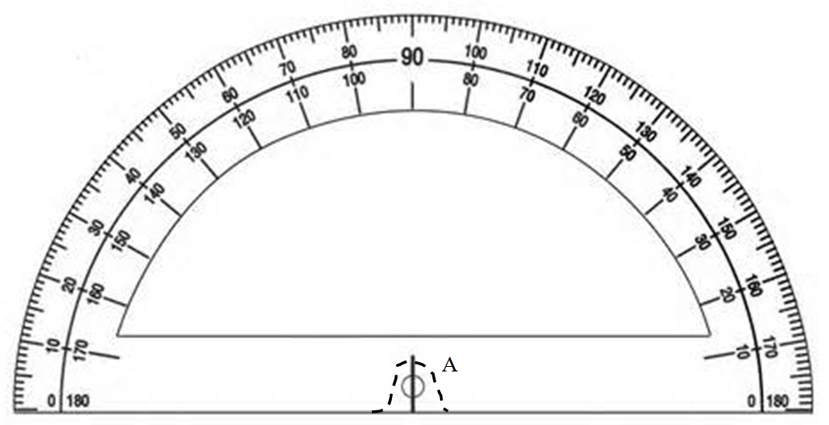
A

Figure 5 - Protractor - Cut out this protractor (along the outer edge and along the dotted line)

Wire taped onto servo horn as a pointer
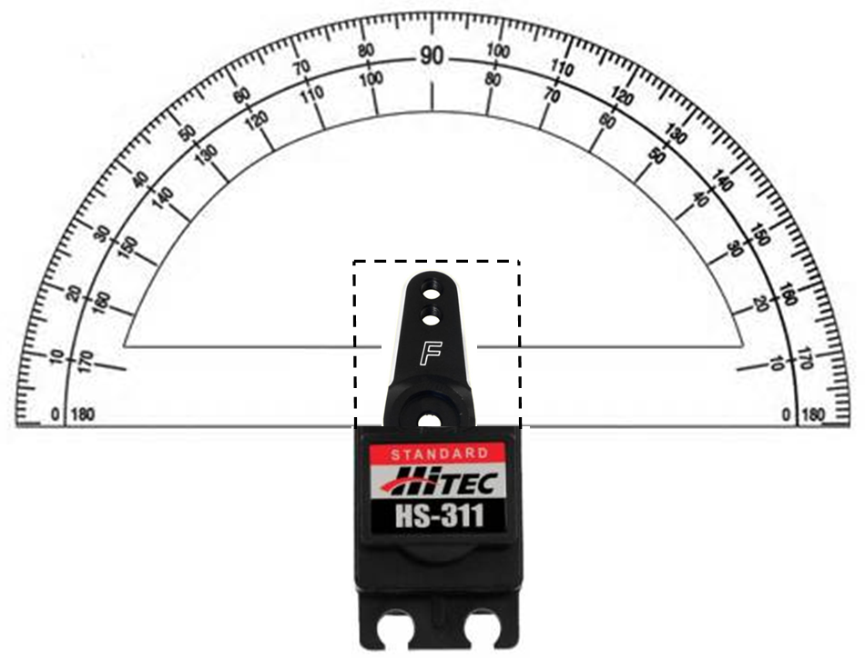

Figure 6 – Protractor taped onto servo body with center of horn in position A (current angle = 90°))

