EGR 262
Fundamental Circuits Lab
File: N262L6
Lab # 6
Improved Digital-to-Analog Converter

A. Objectives
The objectives of this laboratory are to introduce the student to:
- Using pulse width modulation (PWM) and an RC circuit to built an improved DAC
- Measuring ripple voltage on an oscilloscope

B. Materials
Breadboard with Arduino UNO
Adaptor (120V AC to 12 VDC, 1000 mA)
Oscilloscope
WaveStar software for capturing oscilloscope images
Resistor
Capacitor

C. Introduction
In Lab 5 a program was written and tested that produced a PWM signal on output D11 of the Arduino UNO. In Lab 6 the same program will be used, but an RC circuit will be added to D11 (see Circuit 1 below) to reduce the ripple voltage and create an improved DAC. See the Presentation for Lab #6 for more detailed background information.
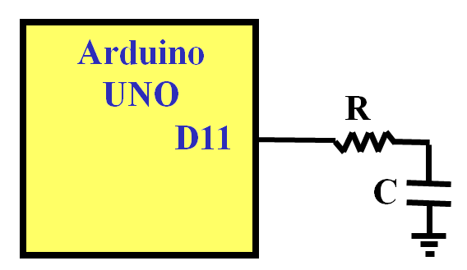
Circuit 1

D. Pre-Lab Tasks
- Use Excel to calculate V_{DC} and V_{R} (using Eq 7-8 from the lab presentation) as RC varies from 1ms to 20ms. Also calculate % ripple (= V_{R}/V_{DC}*100).
  - Create a table similar to the one shown below.
  - Highlight the line in the table where % ripple is closest to 10%. This should correspond to RC = 0.010.
  - Create a graph of % ripple vs RC.

RC (s) | V_{DC} (V) | V_{R} (V) | % ripple
0.001
0.002
0.003
0.020

- Create a table showing 5 values of R and C that could be used for RC = 0.010 from above. Use standard 5% resistor values and use 1kΩ < R < 10kΩ . A table of 5% resistor values is available online or in the Pinouts document for this course.
- Use Excel to calculate V_{DC} and V_{R} (using Eqs 9-10 from the lab presentation) as D varies from 0 to 1. Also create two separate graphs: V_{DC} vs D and V_{R} vs D.

D | V_{DC} (V) | V_{R} (V)
0.00
0.05
0.10
1.00

- Does the graph of V_{DC} vs D indicate that V_{DC} varies linearly with D? Is this important? Why?
- Based on the graph of V_{R} vs D, for what value of D is V_{R} maximum?
- Include a copy of your program from Lab 5 where the user is prompted to enter a value from 0 to 255 and the Arduino will produce the corresponding PWM signal on D11.

E. In-Lab Tasks
- Turn on the oscilloscope before the computer
  - The oscilloscope must be turned on before the computer in order to capture oscilloscope images using Wavestar.
  - If the computer is already on, turn on the oscilloscope and restart the computer.
- Measuring component values
  - Determine which resistor and capacitor values are available in lab and select the pair that most closely matches one of the lines in your table of RC values from the Pre-Lab section. Show the table again and highlight the pair selected.
  - Measure the resistance with an ohmmeter and record its value.
  - Measure the capacitance with an impedance bridge and record its value.
  - Calculate RC using these measured values and compare it in a table to the desired value of RC of 10ms. Include % error.
- Capturing oscilloscope images of the PWM signal and the capacitor voltage
  - Download and run your program from Lab 5.
  - View the output of pin D11 on Channel 1 of the oscilloscope. View the capacitor voltage on Channel 2 of the oscilloscope.
    - Use DC Coupling for both inputs.
    - Use 1V/div for both inputs.
    - Align the ground lines for both inputs on a major division.
    - Show 1-2 periods (adjust the sec/div control).
    - Capture the image using WaveStar for the following 8 inputs: 2X, 5X, 8X, 11X, 14X, 17X, 20X, and 23X, where X is the last digit in your Student ID. Include the images in your report and show the value of the input and the duty cycle corresponding to each image.
- Measuring Output Voltages
  - Measure and record the output voltage with a voltmeter for the following 28 inputs: 0, 1, 1X, 2X, 24X, 254, and 255, where X is the last digit in your Student ID. Also record the value predicted by your program. A sample table for X = 6 is shown below:

Input | V_{DC} (V) predicted by program | V_{DC} (V) measured using voltmeter
0
1
16
26
…
236
246
254
255

- Measuring ripple voltage with the oscilloscope
  - Display only the capacitor voltage on the oscilloscope.
  - Change from DC coupling to AC coupling. This will allow you to change the scale to zoom in on the capacitor voltage to accurately measure the ripple voltage.
  - Show 1-2 periods.
  - Add two cursors to measure the ripple voltage as follows:
    - Select the Cursor menu.
    - The top button next to the screen will give a choice of Off, Time, or Voltage. Select Voltage.
    - Note that small lights turn on next to the Position knobs, indicating that they now control the cursors.
    - Move one cursor to the max value of the waveform.
    - Move the other cursor to the min value of the waveform.
    - The value Delta on the screen is the difference between the cursors so it is the ripple voltage.
    - Capture the image using WaveStar for the following 8 inputs: 2X, 5X, 8X, 11X, 14X, 17X, 20X, and 23X, where X is the last digit in your Student ID. Include the images in your report.
    - A sample image is shown below. Label the input, D, and V_{R} as shown in the sample image.
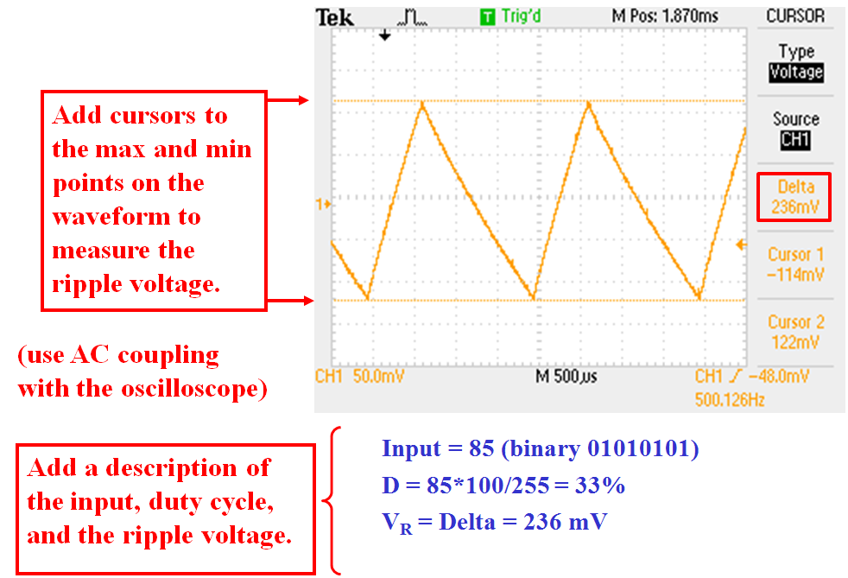
- Comments
  - Record comments for any problems encountered or lessons learned in this lab.

F. Post-Lab Tasks
- Discuss the performance DAC circuit and program.
- Discuss the images measured in Step 3 of the In-Lab section. How does the capacitor voltage change when the input is changed?
- Show the table of DC voltages that were measured in step 4 of the In-Lab section. Add a column showing the duty cycle, D. Graph V_{DC} vs D. Is the graph linear?
- Discuss the images measured in Step 5 of the In-Lab section. How does the capacitor voltage change as the input (or D) is changed?
- Create a table showing input, D, and ripple voltage from Step 5 of the In-Lab section. The table might look as follows (use your value of X):

Input | D | V_{R} (V)
2X
5X
8X
11X
14X
17X
20X
23X

- Graph ripple vs D. Compare the graph to the corresponding graph from the Pre-Lab section.

G. Report
A lab report is due 1 week after the date of the experiment.
- The lab report must be your own work. Copying data, tables, graphs, circuits, etc., from other students is not allowed and will result in grades of 0 on the lab.
- Be sure to follow good practices for presenting all tables and graphs. See the Presentation for Lab #1 for examples.
- The lab report should consist of the following sections:
- Title Page (include course number & title, lab number & title, date, and your name)
- Pre-Lab Tasks
  - Include instructions or headings for all items to make the report easy to follow.
- In-Lab Tasks
- Include instructions or headings for all items to make the report easy to follow.
- Be sure to include comments from lab as well as measured data.
- Post-Lab Tasks
- Include instructions or headings for all items to make the report easy to follow.

