EGR 262
Fundamental Circuits Lab
File: N262L4
Lab # 4
Digital-to-Analog Conversion

A. Objectives
The objectives of this laboratory are to introduce the student to:
- Digital to analog conversion using an R-2R ladder network

B. Materials
Breadboard with Arduino UNO
Adaptor (120V AC to 12 VDC, 1000 mA)
Seven 220 Ω resistors
Ten 2.2 kΩ resistors
Two 10 kΩ resistors
Common-anode 7-segment display (GNS 3011 or similar)
Two momentary pushbutton switches (BTS-1102B-2 or similar)

C. Introduction
Circuit 1 below will be constructed and tested in lab using programs written for the Arduino UNO. See the Presentation for Lab #4 for more detailed background information.
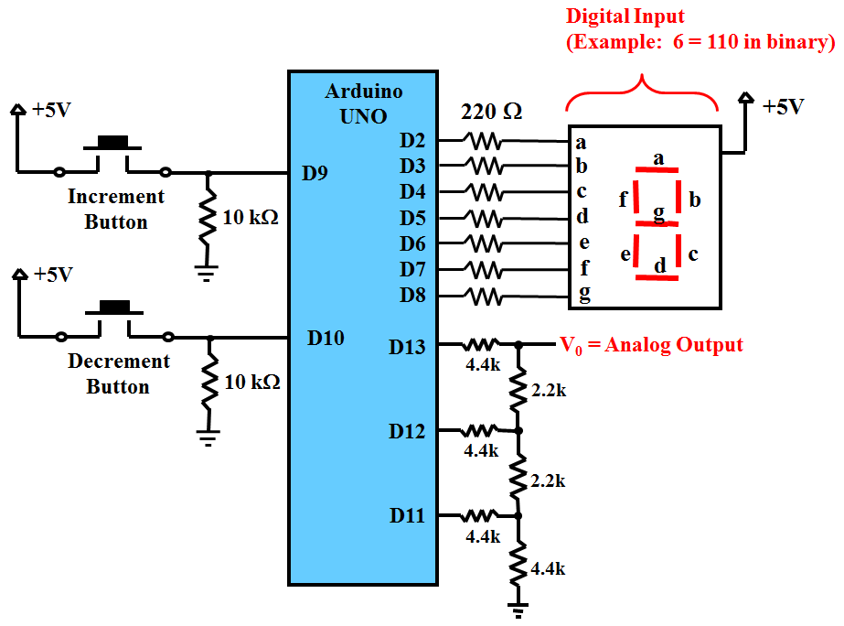
Circuit 1
D. Pre-Lab Tasks
- Use Fritzing to draw a breadboard layout and schematic for Circuit 1.
  - You should be able to simply add on to your Lab #3 breadboard layout.
  - Save your breadboard layout and schematic for Lab 4 (.fzz file)
  - Export the breadboard as a jpg image to insert in your lab report.
  - Export the schematic as a jpg image to insert in your lab report.
- Perform a detailed analysis of the 3-bit R-2R ladder network to be used in the lab and shown below.

Use superposition to analyze the circuit as shown in the lab presentation. In particular:
  - Analyze the circuit with b₂ = 5V, b₁ = 0V, and b₀ = 0V. Show all details of the analysis.
  - Analyze the circuit with b₂ = 0V, b₁ = 5V, and b₀ = 0V. Show all details of the analysis.
  - Analyze the circuit with b₂ = 0V, b₁ = 0V, and b₀ = 5V. Show all details of the analysis.
  - Create a table of analog outputs versus digital inputs for all possible combinations of b₂, b₁, and b₀ (see slide 14)
  - Use Excel to form a stairstep graph of Analog Outputs versus Digital Inputs (see slide 16)
- What is the resolution (as a voltage) of the 3-bit DAC to be used in lab? What is the resolution as a percentage?

- Write a function R2R( ) to control the R-2R DAC as follows:
  - Input: Count (should have value 0 to 7 represention binary 000 to 111)
  - Outputs: D13, D12, and D11 should be set HIGH or LOW according to the binary value of the input.
  - The function might look as follows:
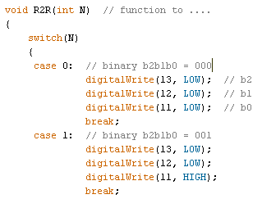

- Write a C++ program for Lab #4 as follows: to control the R-2R DAC as follows:
  - This program builds on the program for Lab #3, so begin with that program.
  - Display brief instructions on the computer screen.
  - A second button switch will be added. One will be used to increment the counter and one to decrement the counter.
  - The count should be initialized to 0 and shown on the 7-segment display and the computer screen.
  - The count should be mod-8.
  - When the user presses a button:
    - The program should determine which button was pressed.
    - The count should increment or decrement based on the button pressed.
    - Two versions of the readButton( ) function will be needed with different variable names in each function (except for local variables): one for incrementing and one for decrementing. This is necessary because the readButton( ) function uses the last button state, last time the function was called, etc.
    - The count should be displayed on the 7-segment display. Do not make any changes to the display_digit( ) function from Lab #3.
    - The count (in decimal and binary form) should be displayed on the computer screen.
Hint: Serial.print(78, BIN) gives "1001110" (it is OK that it doesn’t show leading zeros)
    - The function R2R( ) should be called to set or clear the appropriate digital pins
  - The program might look something like the following:

// Initial block of comments
// Global variables for incReadButton( ) function
// Global variables for decReadButton( ) function
// Other global variables
void setup( )
{ // Define input and output pins
// Set up serial communication
// Display instructions on the computer screen
// Display initial value (0) on 7-segment display
// Display initial value (0) on computer screen
// Call R2R( ) to send initial value (000) to output pins
}
void loop( )
{ // if(incReadButton(incrementPin) == 1 && decReadButton(decrementPin) = 00)
{
// Increment counter
// Adjust counter for mod-8 operation
// Display count on computer screen
// Display count on 7-segment display
// Call R2R( ) to send count to output pins
}
elseif( ……..)
}
void incReadButton(int buttonPin)
{
// Modified code from Lab #3 (incReadButton( ) and decReadButton( ) must use different variable names)
}
void decReadButton(int buttonPin)
{
// Modified code from Lab #3 (incReadButton( ) and decReadButton( ) must use different variable names)
}
void display_digit(int N)
{
// Use code from Lab #3 (do not make any changes)
}
void R2R(int N)
{
// See Lab #3 Lecture for details
}

E. In-Lab Tasks
- Build Circuit 1
  - Most of the circuit should already be in place from Lab #3. Add the additional parts.
  - The circuit should match your Fritzing breadboard layout.
  - Use neat wiring practices.
- Testing the Program
  - Download and run the program for Lab 4.
  - Verify that the counter properly increments and decrements (mod-8) both on the 7-segment display and on the computer screen.
  - Connect a voltmeter to output V₀ on the R-2R ladder network. Measure and record the voltage for all 8 possible inputs. Compare the voltages to the predicted analog voltages in the Pre-Lab section. If they are not close, check the circuit and/or program for errors.
  - Once the program is running correctly, use PrintScreen to obtain a copy of the output to the computer screen and include it in the report.
  - Demonstrate the program to the instructor .
  - If any changes were made to the program, save the program under a different name (L4v2, perhaps) and include a copy in the Post-Lab section.
  - Record comments for any problems encountered or lessons learned.

F. Post-Lab Tasks
- Discuss the performance of the program.
- Compare the measured analog outputs with the predicted analog outputs for each digital (binary) input. Include % error.
- If you wanted to replace the 3-bit R-2R ladder network with a 10-bit R-2R ladder network:
  - How many digital output pins would be needed for the R-2R circuit?
  - How many 2.2 kΩ resistors would be needed?
  - How many different analong voltages would be available?
  - What would be the increment between voltages (the resolution as a voltage)?

G. Report
A lab report is due 1 week after the date of the experiment.
- The lab report must be your own work. Copying data, tables, graphs, circuits, etc., from other students is not allowed and will result in grades of 0 on the lab.
- Be sure to follow good practices for presenting all tables and graphs. See the Presentation for Lab #1 for examples.
- The lab report should consist of the following sections:
- Title Page (include course number & title, lab number & title, date, and your name)
- Pre-Lab Tasks
  - Include instructions or headings for all items to make the report easy to follow.
- In-Lab Tasks
- Include instructions or headings for all items to make the report easy to follow.
- Be sure to include comments from lab as well as measured data.
- Post-Lab Tasks
- Include instructions or headings for all items to make the report easy to follow.

