EGR 262
Fundamentals of Computer Engineering
File: Fritzing_EGR262.docx

Breadboard Layouts and Schematics using Fritzing

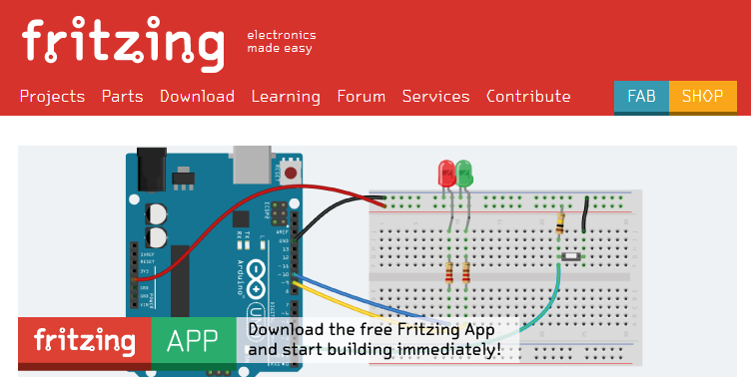

Fritzing is a free program for creating breadboard layouts, schematics, and printed circuit board (PCB) layouts.
Fritzing can be downloaded from: http://fritzing.org/home/

Fritzing will be used in EGR 262 to create breadboard layouts and schematics.

Fritzing has extensive libraries of components, including Arduino microprocessors. It also has many examples using Arduinos.
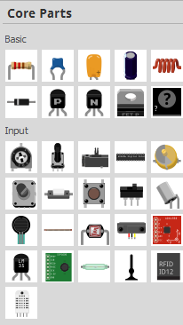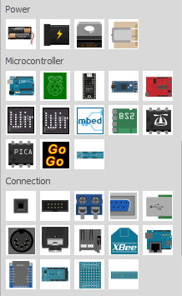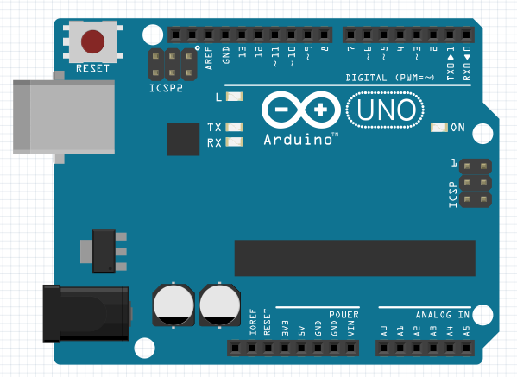

Fritzing also has many examples using Arduinos. One example circuit is shown below.

Example: Produce a standard breadboard layout with an Arduino UNO in Fritzing that is similar to the breadboards used in EGR 262.

Launch Fritzing
- Select the Breadboard tab
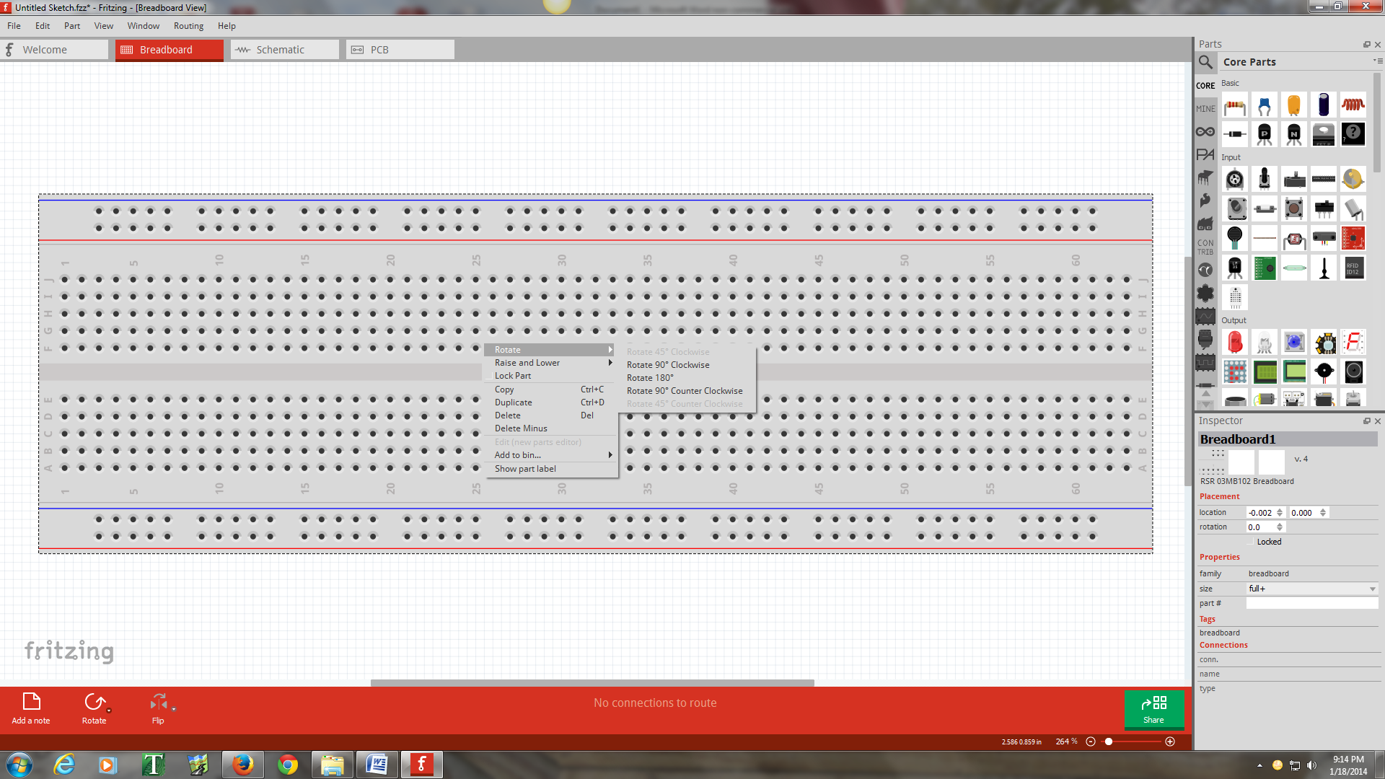

- Right-click on the breadboard and select Rotate – Rotate 180° to match the orientation of breadboards used in lab (red “power rail” at the top).
- Right-click on the breadboard and select Duplicate to add a second breadboard
- Zoom using the mouse wheel and move one breadboard above the other
- Right-click on each breadboard and select Lock Part so that the breadboards will not move

- In EGR 262 the red power rails are typically used for 5V so it is convenient to tie them all together.
- Add a wire between the red power rails by pressing the left mouse button and dragging the cursor between the desired holes.
- Right-click on the wire and change Wire Color to Red (or use the Inspector window on the bottom left of the screen).

- Similarly add red wires connecting all red power rails and black wires connecting all black power rails.
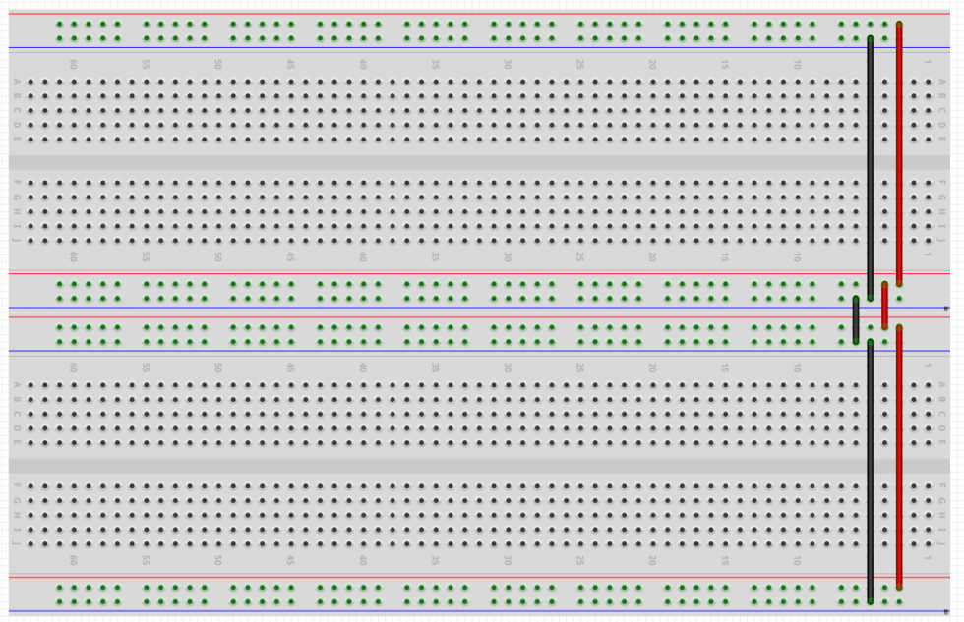
- Add an Arduino UNO to the breadboard in the approximate position where it is mounted on the breadboards in lab.
- Lock the Arduino in place.
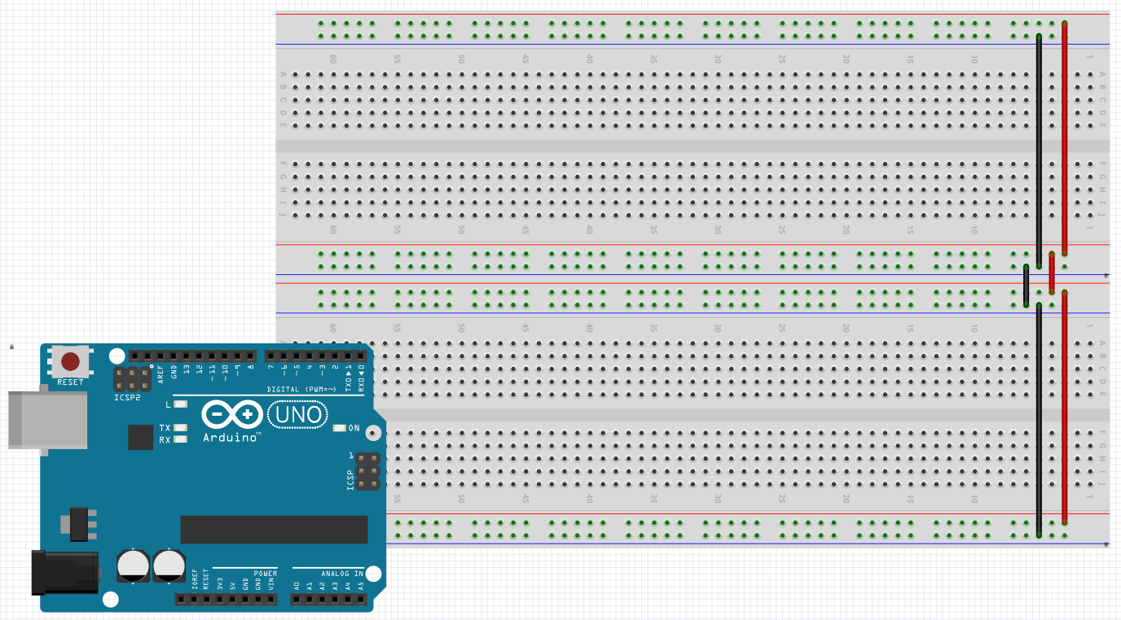
- Add a connection from the 5V pin on the Arduino UNO to the red power rail.
- Add a connection from the GND (ground) pin to the black power rail.
- Use curved wires to avoid blocking the labels on the Arduino so that the labels can be read.
- Curved wires are formed as follows:
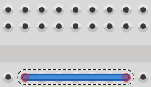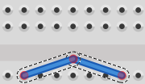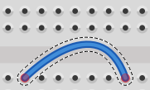
Ctrl + Drag the middle of the wire to add a smooth bend
Drag the middle of the wire to add a bend point
Draw a straight wire from starting hole to ending hole

- Initially draw the wires straight as shown below. Bend the wires so that they no longer block the labels on the Arduino UNO.
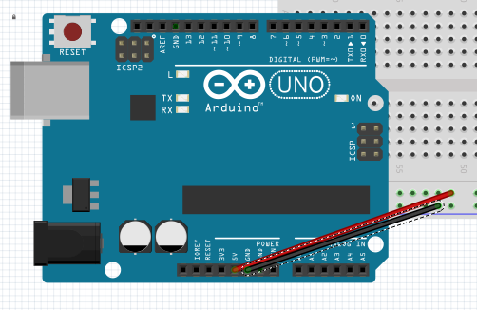
- Final EGR 262 breadboard template:
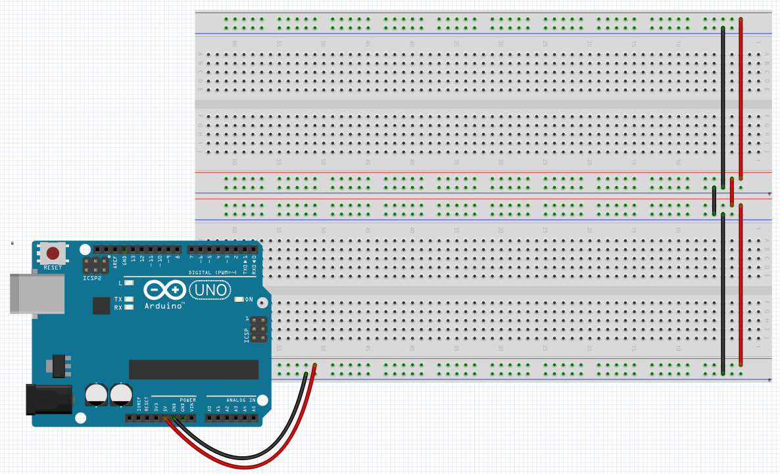

Saving Breadboard Layouts:
Since all labs will use the basic breadboard setup above, save this file as EGR262Breadboard.fzz
A similar file has also been saved by the instructor and is available on the course website.

Breadboard Images: You can also make images of breadboard layouts as follows:
- File – Export – Save as image – JPG, pdf, etc
- You can insert images into Word using Insert - Image

Breadboard Layout using Fritzing
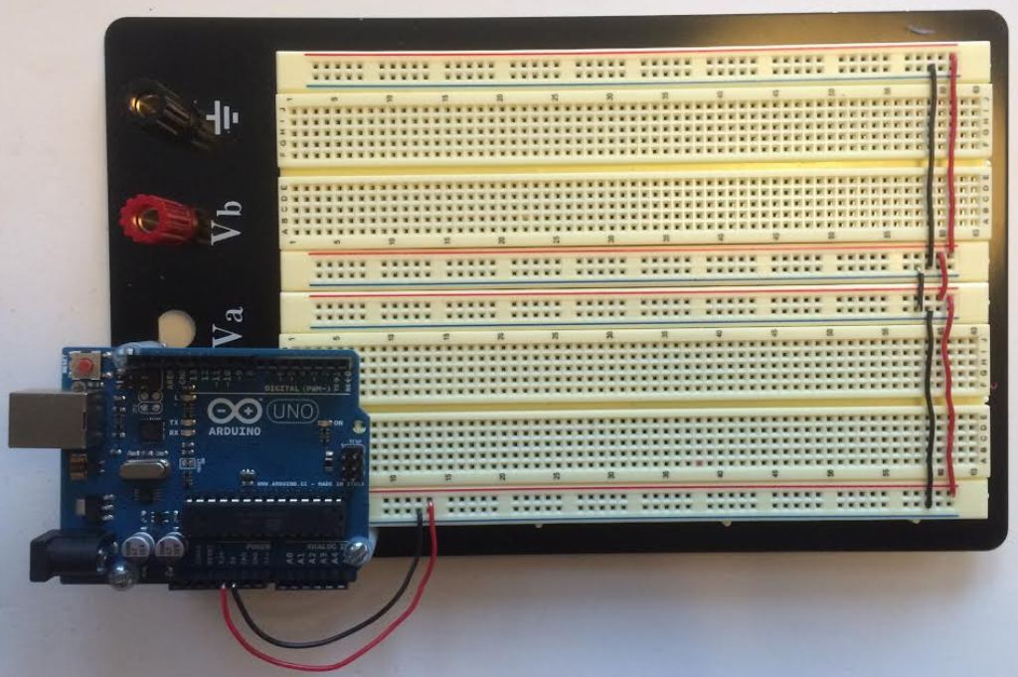
Photo of actual breadboard in lab
Example: Use Fritzing to draw a breadboard layout and schematic based on the schematic provided below.
Arduino
UNO
D2
330 Ω
LED

Launch Fritzing
- Select File - Open and open the file EGR262Breadboard.fzz
- Save the file as EGR262Lab1.fzz (for example)
- Drag a resistor from the Core – Basic bin of the Parts library to the breadboard
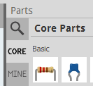
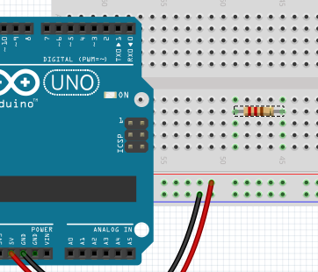
- Select the resistor and use the Inspector in the lower right of the screen to change the Resistance to 330 Ω (note that the color bands correctly change to Orange-Orange-Brown)
- If desired, right-click on the resistor and Rotate it by 90° or use the Rotate tool on the bottom left of the screen (rotation not necessary in this example).
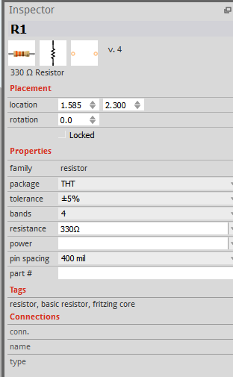

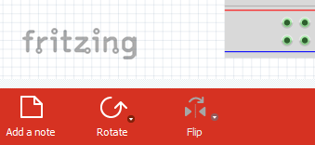

- Add an LED to the breadboard. Pause over each terminal to identify the anode (+) and cathode (-).
- The legs of the LED are adjustable. Since the anode leg is typically longer, shorten the cathode leg.
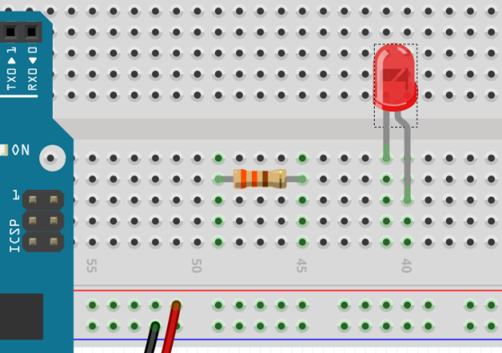
- Add a blue wire from pin D2 on the Arduino UNO to the resistor. Be sure to add a curve to the wire so that it does not block any of the labels on the Arduino.
- Add a blue wire from the resistor to the anode of the LED.
- Add a black wire from the cathode of the LED to ground.
- The breadboard layout is now complete!
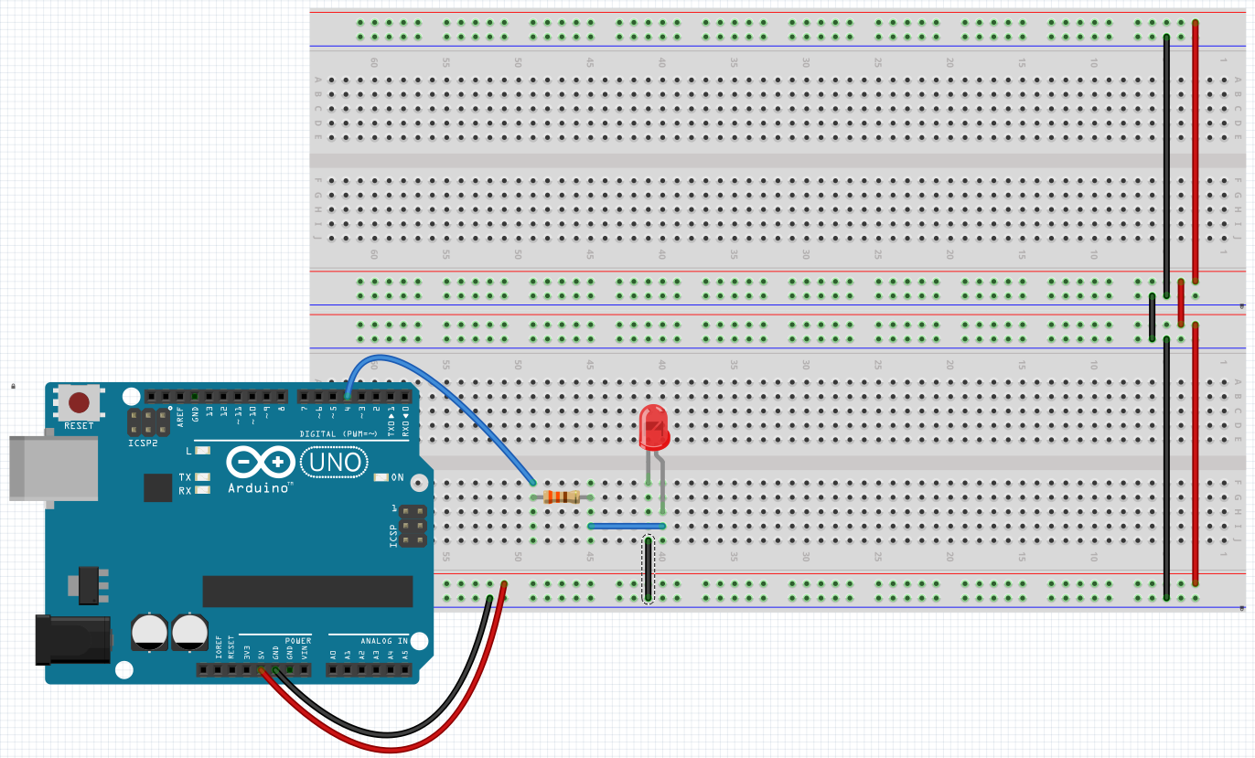

Creating Schematics with Fritzing
Fritzing has already created the schematic for this breadboard layout. When you add parts to the breadboard, they are added to the schematic as well (and vice versa). However, the schematic may look messy as the parts may not be placed in convenient locations. On more complicated example, it may be useful to go back and forth between the schematic and the breadboard to keep the parts organized.

- Select the Schematic tab. Note that the all three parts are present along with lightly colored wires showing the connections.
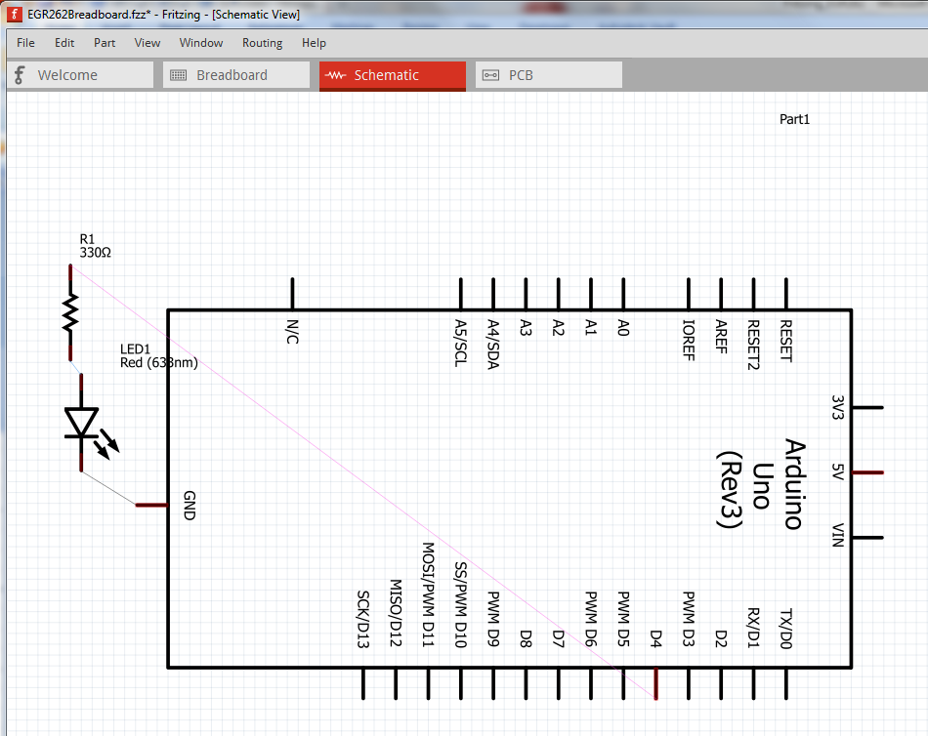
- Rotate the Arduino UNO 90 counterclockwise.
- Drag the resistor and LED to the right side of the Arduino UNO
- Rotate the resistor
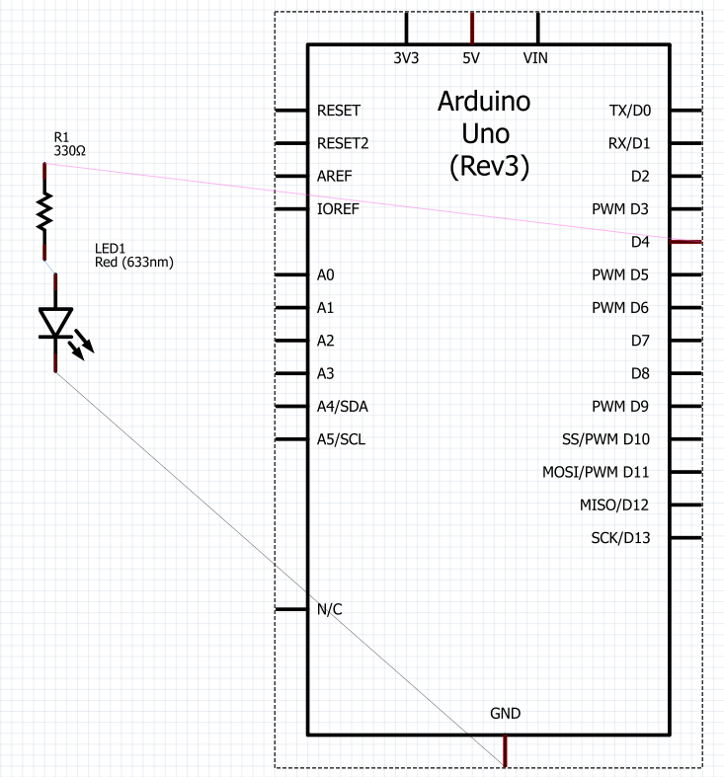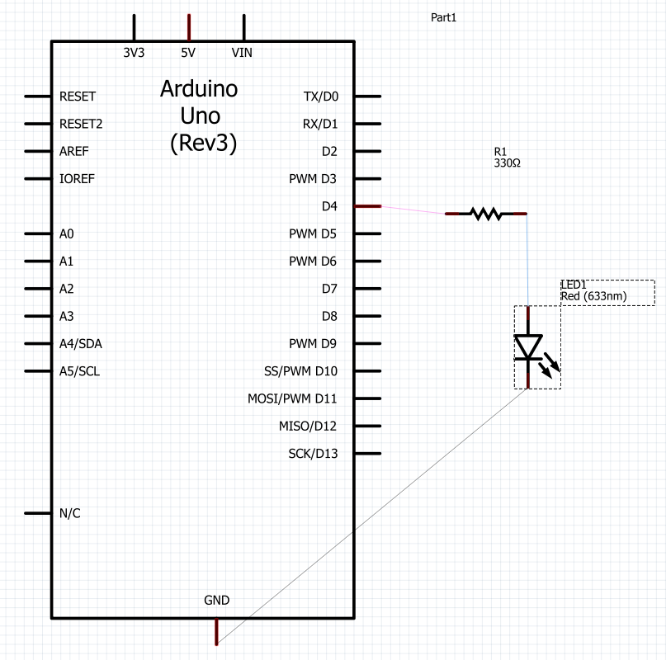

- Select each light wire and it will turn into a standard wire. Drag it into the desired location.
- The schematic is now complete!
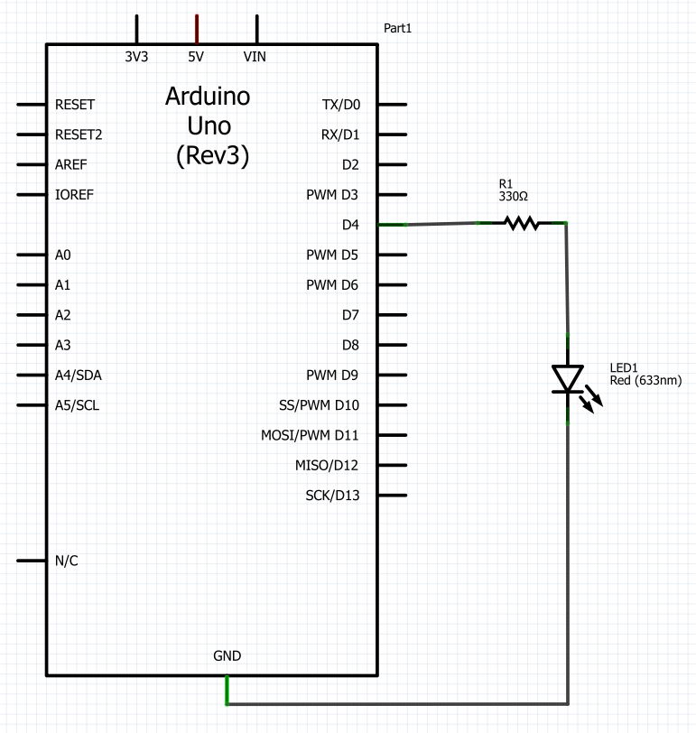
- Note that saving the file (EGR262Lab1.fzz, for example) saves both the schematic and the breadboard layout .
- If the breadboard tab is selected, exporting an image creates only an image of the breadboard layout. For example, File – Export – As Image – JPG creates the file: EGR262Lab1_schem.jpg
- If the schematic tab is selected, exporting an image creates only an image of the schematic. For example, File – Export – As Image – JPG creates the file: EGR262Lab1_bb.jpg

Basic Rules for Breadboards Produced for EGR 262 Labs:
- Use the layout shown in EGR262Breadboard.fzz
- Always use red wires for 5V connections and black wires for ground. Use other colors for intermediate connections.
- Bend wires from the Arduino so that labels on the Arduino can be seen.
- Bend wires as needed so that all connection points are clear.
- Arrange components and wires neatly.

