EGR 120 Due date: _________________________
Introduction to Engineering
File: N120Bot3

Team Assignment #3

Navigating the Arduino-BOT using Dead Reckoning
References:
1) Arduino-BOT Lecture #3 - http://faculty.tcc.edu/PGordy/Egr120/
2) Robotics with the Board of Education Shield for Arduino web tutorials - http://learn.parallax.com/tutorials/robot/shield-bot/robotics-board-education-shield-arduino
3) Board of Education Shield for Arduino documentation - https://www.parallax.com/downloads/robotics-board-education-shield-arduino
4) Arduino web site (software, microcontrollers, examples, and more) - https://www.arduino.cc/

Team Assignment:
1) Navigating the Arduino-BOT in a straight line
Finish Line
Starting
Line
Step 1 – Straight down the track
- Write and test a program to run the Arduino-BOT in a straight line as shown in the diagram below.
- Measure and record the distance, D, between the starting line and the finish line.
  - D = ______________ (inches)
- Calculate and record the time needed to navigate this distance at full speed. Use this time to estimate the required delay in your program.
- Refer to the sample program below (from lecture notes).
- Demonstrate proper operation to the instructor.
- Print your program (include required comments as usual).
The Arduino-BOT should:
- Start behind the starting line.
- Stop after the finish line, but before hitting the wall at the end of the track

Measure D:
D = _______

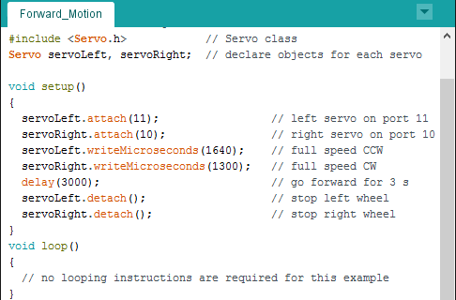

Adjust these values

2) Navigating the Arduino-BOT in a straight line and returning to the start
- Write and test a program to run the BOE-BOT in a straight line on the track, cross the finish line, and return to cross the starting line as shown in the diagram below.
- Print your program (include required comments as usual).
- Demonstrate proper operation to the instructor.

The Arduino-BOT should:
- Start behind the starting line.
- Proceed in a straight line until crossing the finish line.
- Turn around.
- Proceed in a straight line back toward the original starting line
- Cross the starting line (it is OK if the robot continues off the track onto the floor)

Step 2 – Down the track, U-turn, and return
B) BOE-BOT proceeds in straight line
C) BOE-BOT turns after crossing end line
D) BOE-BOT proceeds back to initial line
A) BOE-BOT begins behind Starting Line
E) BOE-BOT crossing Starting Line again

3) Navigating the Arduino-BOT around the course as quickly as possible
- Write and test a program to run the Arduino-BOT around the course as quickly as possible.
- Print a copy of the track and show the path used by your robot. Number each turn or straight section. Your program should include comments for each section using these numbers. Turn in a copy of the labeled track with your report.
- Print your program (include required comments as usual).
- Demonstrate proper operation to the instructor. The instructor will time the robot. Record your time and the fastest time in the class.
- Extra credit to the fastest team!

The Arduino-BOT should:
- Start behind the starting line.
- Proceed around the course until crossing the finish line. (It is OK if the robot continues off the track onto the floor.) Note that the path shown on the track below is just one possible path. A BOE-BOT might save time by cutting the corners a bit more closely.
- Demonstrate proper operation to your instructor.
- The fastest team will earn bonus points (as timed by the instructor).

Extra credit to the fastest team!
Step 3 – Navigate the course as quickly as possible
Example: Track Diagram with all turns and straights labeled (with matching comments in program)

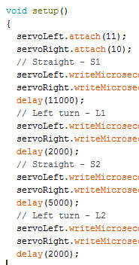
S2
R1
S3
S4
L3
L21
L1
S1

4) Report
Organize your results into a report and submit a single typed report for the group to the instructor by the assigned due date. The report should consist of:
- Title Page – Include a title page as shown below.
- Printouts – Include printouts for each of the programs for steps 1, 2, and 3 (in addition to the usual comments, include comments identifying each robot action, such as Turn Left, Turn Right, Go Straight, etc.)
- Track diagram – Include a diagram of the track showing the path used in navigating the entire course. Label each turn and straight section and include matching comments in the program.
- Analysis section.
  - What distance, D, was measured between the starting line and the finish line?
  - Show your (detailed) calculation for the time required to cover this distance.
  - What time was actually used in the first program?
- Discussion - Write 1-2 paragraphs discussing the following:
- Discuss possible reasons the time difference shown in the Analysis Section.
- How difficult was it to program your Arduino-BOT to complete the course?
- How many times did you have to adjust your program to complete the course (an estimate)?
- What was your final time? What was the fastest time in the class?
- How reliable is dead reckoning?

EGR 120
Introduction to Engineering

Team Assignment #3

Date
Group #N (your group number)
Arduino-Bot Kit Number

Attendance & Participation Record:
(list all team members and all dates when teams worked
together in class on this assignment and check boxes to mark attendance)

Team Member | Date 1 | Date 2
John Doe
etc

Demonstration of Programs

Program | Successfully  Demonstrated | Time
1 |  | - -
2 |  | - -
3 |  | (list your time)
48”
16”
16”
24”
24”
24”
96”
16”
BOE-BOE Test Track Dimensions

Instructor’s Checksheet
EGR 120 - _____ (section)
Semester: ________
Team Assignment #3 – Navigating with Dead Reckoning

Team | Program 1: Straight down the track () | Program 2: Straight down the track and return () | Program 3: Navigate the entire course (record time) *
1
2
3
4
5
6
7
8

- Program has been demonstrated (Programs 1-2)
* 10 points extra credit for the fastest team! (Program 3)

