EGR 120 Due date: _________________________
Introduction to Engineering
File: N120Bot1

Team Assignment #1

Communicating with the Arduino-BOT
References:
1) Arduino-BOT Lecture #1 - http://faculty.tcc.edu/PGordy/Egr120/
2) Robotics with the Board of Education Shield for Arduino web tutorials - http://learn.parallax.com/tutorials/robot/shield-bot/robotics-board-education-shield-arduino
3) Board of Education Shield for Arduino documentation - https://www.parallax.com/downloads/robotics-board-education-shield-arduino
4) Arduino web site (software, microcontrollers, examples, and more) - https://www.arduino.cc/

Team Assignment:
Setting Up the Hardware and Testing the System
- Obtain an Arduino-BOT from the instructor. Record the number on the Arduino-BOT box. Include this number on the title page of all reports involving the Arduino-BOT. Be sure that you use the same Arduino-BOT each class.
- Connect the USB cable from the computer to the Arduino-BOT.
- Connect the battery pack to the Arduino-BOT (be sure to disconnect this at the end of the class.) Note: Team Assignment #1 can be done with USB power instead of batteries. All later assignments must use batteries.
- Turn the Arduino-BOT on by moving the slide switch to position 1 or 2. (Position 2 also powers the servo ports which are used when navigating the robot.)
- Launch the Arduino software by double-clicking on Arduino in the Arduino-1.0.1 folder
- The software should detect the Arduino UNO and assigned a COM port to USB that you used. You may need to tell the software to use the assigned COM port as shown below using
Tools – Port – (Select the assigned COM port)

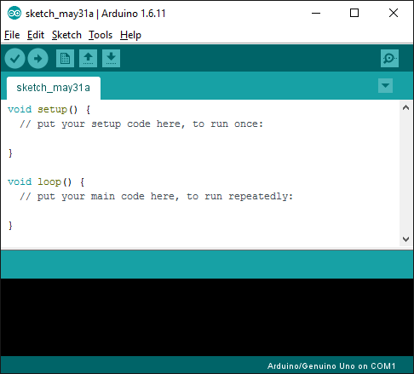
Arduino UNO detected!
COM1 incorrectly assigned
Use Tools – Port to select the correct COM port

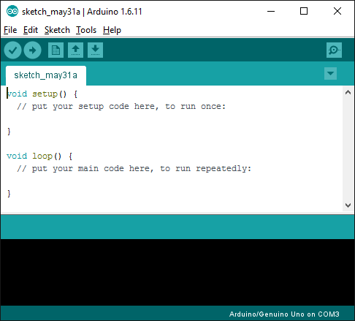
Verify that the correct COM port has been assigned

1) Program 1 – Sending a message from your Arduino-BOT
- Write a program similar to the one shown below using your correct team information. 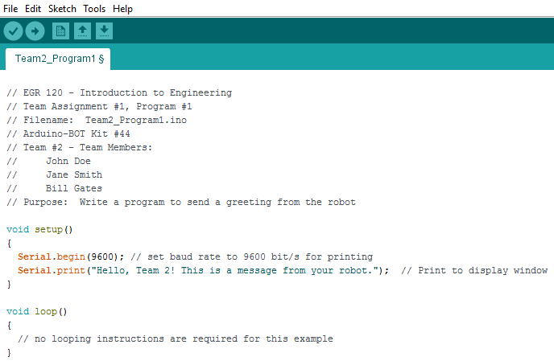
Be sure to add comments to all programs written in this course.
- All programs should include plenty of comments as illustrated above.
- Compile the program using the Verify button.
- Send the program to the robot using the Upload button.
- Select the Serial Monitor button to run the program and open a display window.
- Demonstrate proper operation of the program to the instructor.
- Save and print the program.
- Use Alt + PrintScreen (or the Windows Snipping Tool) to capture the display window. Paste it into Word and print the output (similar to that shown below).
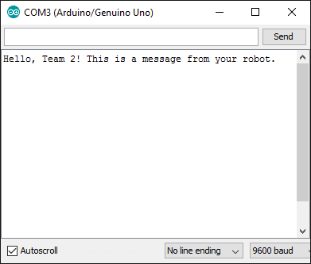

Program 2 – Write a program that will count down from N to 0
- Write a program to count down a variable X from (your Team number + 10) to 0 in steps of 1.
- Include a delay of 0.5 seconds between counts.
- Display your team number and then the values of X (one item per line) and then “End of Program.”
- For example, if your team number is 2, then the display might look as follows:
- You should find a similar example in the class notes that counts up.
- Run the program and verify that it works properly.
- Demonstrate proper operation of the program to the instructor.
- Be sure to include all required comments.
- Save and print the program.
- Print the output of the program.
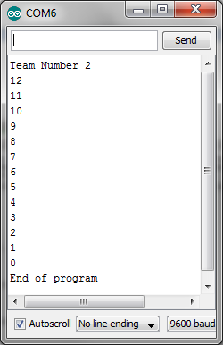

Program 3 – Turning ON and OFF an LED
- Connect a red LED and 220 Ω resistor (red-red-brown) to digital pin N+2, where N is your team number.
- Write a program to turn the LED on and off forever. (Hint: Since the LED will blink forever, put instructions to control the LED in the loop section of the program.)
- The LED should be ON for 0.75 s and OFF for 0.75 s.
- You should find a similar example in the class notes (using a different time and different pin)
- Run the program and verify that it works properly.
- Demonstrate proper operation of the program to the instructor.
- Be sure to include all required comments.
- Save and print the program.

Program 4 – Make 2 LED’s blink back and forth (alternating)
- Connect a red LED and 220 Ω resistor (red-red-brown) to digital pin N+2, where N is your team number +2.
- Connect a second LED and 220 Ω resistor to digital pin N+3.
- Write a program to make the two LEDs blink back and forth (alternating) forever.
- Each LED should be ON for 0.75 s and OFF for 0.75 s.
- Run the program and verify that it works properly.
- Demonstrate proper operation of the program to the instructor.
- Be sure to include all required comments.
- Save and print the program.

Program 5 – Traffic Light Circuit
- Connect three LEDs (Green, Yellow, and Red) and three 220 Ω resistors to the digital output pins of your choice.
- Write a program to simulate a traffic light where the Green LED is on for 10 seconds, Yellow if on for 1 second, and Red is on for 8 seconds. The traffic light should operate forever.
- Run the program and verify that it works properly.
- Demonstrate proper operation of the program to the instructor.
- Be sure to include all required comments.
- Save and print the program.

Program 6 – Make an LED blink N times
- Connect a red LED and 220 Ω resistor (red-red-brown) to the digital output of your choice.
- Write a program to make the LED blink N+5 times. (Hint: Since the LED will only blink a certain number of times, put instructions to control the LED in the setup section of the program.)
- The LED should be ON for 0.75 s and OFF for 0.75 s.
- You should find a similar example in the class notes.
- Run the program and verify that it works properly.
- Demonstrate proper operation of the program to the instructor.
- Be sure to include all required comments.
- Save and print the program.

Report
Organize your results into a report and submit a single typed report for the group to the instructor by the assigned due date. The report should consist of:
- Title Page – Include a title page as shown below.
- Printouts - Printouts for each of the programs and the results (if required). Recall that all programs are required to have an initial block of comments (as illustrated above) and should also include comments explaining most instructions.)
- Discussion - Write 1-2 paragraphs discussing the following:
- Were the Arduino-BOT and the Arduino software easy to use?
- Were you able to complete all the programming assignments?
- Did you run into any problems completing the assignment?

EGR 120
Introduction to Engineering

Team Assignment #1 – Communicating with the Arduino-BOT

Date
Group #N (your group number)
Arduino-BOT Kit Number

Attendance & Participation Record:
(list all team members and all dates when teams worked
together in class on this assignment and check boxes to mark attendance)

Team Member | Date 1 | Date 2
John Doe
etc

Demonstration of Programs

Program | Successfully  Demonstrated
1
2
3
4
5
6

Instructor’s Checksheet
EGR 120 - _____ (section)
Semester: ________
Team Assignment #1 – Communicating with the Arduino-BOT

Team | Program 1: Send a message to the team | Program 2: Count N down to 0 (where N = team number + 10) | Program 3:  Turn ON and OFF LED on pin N + 2, where N = team number for 0.75 s each | Program 4: Alternate blinking LEDs on pins N+2 and N+3, where N = team number | Program 5: Traffic light for 10s (G),  1s (Y), 8s (R) | Program 6: Blink LED N+5 times on pin N, where N = team number
1
2
3
4
5
6
7
8

- Program has been demonstrated

