EGR 120 Due date: _____________________
Introduction to Engineering
File: EGR120H5

Homework #5 (Significant Digits and Systems of Units)

Reading Assignment:
- Read Chapter 6 and Chapter 11, sections 1-2 in Engineering Fundamentals – An Introduction to Engineering, 5E by Moaveni.
- Table of Conversion Factors (inside front and back cover of the text)
- Course lecture notes
Assignment Format:
Write out the instructions and the given information with each problem. Show your work for each unit conversion problem (use dimension analysis – see example below).
The assignment may be submitted using one of the following options:
- Work the problems by hand and turn them in during class.
- Work the problems by hand, scan them, and submit them via Blackboard (the scan must be easy to read).
- Work the problems in Microsoft Word using the Microsoft Equation 3.0 (at least when dimension analysis is used) and submit via Blackboard. Use Insert – Object – Microsoft Equation 3.0 to launch the equation editor. An example using the editor is shown below. The course website includes a short tutorial on the equation editor.
Problem Assignment:
Unless otherwise instructed, assume that the values provided are exact. Express all results using 3 significant digits.
- (28 pts – 3 pts/part) Problems 6.1 and 6.2.
- (18 pts – 2 pts/part) Problems 6.5 and 6.6.
- (4 pts) Problem 6.14 (Express mass in slugs and lbm. Express weight in N and lbf.)
- (12 pts) Problems 6.16, 6.17 and 6.19. (For 6.19, express density in slug/ft³ and lbm/ft³)
- (8 pts) Problems 11.4 and 11.5
- (15 pts) Power (in watts, W) can be calculated using the formula:

Calculate power for each case below and express the result in watts using the proper prefix and the proper number of significant digits. Show your calculations similar to the example below the table.
 | Force | Distance | Time | Power
A) | 2.45 kN | 3.84 mm | 6.25 ns | 1.51 GW
B) | 1.67 MN | 6.97 μm | 1.11 ps
C) | 9.42 mN | 7.04 am | 8.88 μs
D) | 0.384 TN | 5.80 pm | 0.837 ks
E) | 8.40 GN | 9.99 fm | 7.22 Ts
F) | 2.00 PN | 1.58 Mm | 0.248 ks
For the example in Part A of the table above,
P = (2.45 x 10³ N)(3.84 x 10⁻³ m)/(6.25 x 10⁻⁹ s)
P = 1.51 x 10⁹ W = 1.51 GW
7. (3 pts) A child's circular (actually cylindrical) swimming pool is 18.0 inches deep and 8.00 feet in diameter. How many gallons of water are required to fill it?
- (12 pts) Use the online Digital Dutch Unit Converter to perform the following conversions.
- In each case you will convert a number based on your TCC Student ID. Your assigned number is the last 4 non-zero digits of your Student ID with a decimal point in the middle. Example: If your Student ID is 1257094, then your assigned number is 57.94
- For each conversion, use PrintScreen (or Snippet) to capture the screen to show your results (and perhaps paste it into a Word document). For example, if you were converting from inches to mm the screen capture is shown below (feel free to crop it). Attach your 4 screen captures to the worksheet and turn them in on the assigned due date.

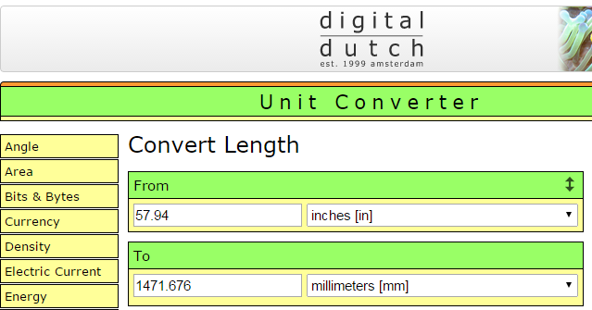

- Convert your assigned number from inches to mm (length)
- Convert your assigned number from grams/cm³ to slugs/ft³ (density)
- Convert your assigned number from Newtons to lbf (force)
- Convert your assigned number from cubic feet to cubic decimeters (volume)

