Due Date: ____________________
EGR 110
Engineering Graphics
Team Project – Step 2

(Note: This information also appears in the PowerPoint presentation for the Team Project)

Step 2: Initial Design Intent Proposal & Project Timeline (Weeks 4-5)
Each team should turn in the following items:
- Detailed Hand Sketch of your team’s cable car. See example on the following page.
- On one page include sketches of two views (side and top perhaps, but choose the best views for your design), and an isometric view such that features can be clearly seen. Use appropriate graph paper. The sketch must include all parts to be used in the cable car (other than minor hardware and fasteners), including: motor, switch, pulley, propeller (if used), drive belt (if used), battery clip, framing, etc.
- Be sure to consider the center of gravity so that the car will be balanced. A good feature is have a design that allows the battery position to be shifted slightly to balance the car.
- Use balloons to letter each component on the cable car.
- Include a table with a row for each unique part and columns for the part letter in the balloon, name of the item, material (if applicable), and an indication of how or where the part will be procured (provided, 3D printer, classroom, purchased, etc.)
- Gantt Chart - On a separate sheet(s), provide a ‘Gantt’ Timeline Chart of project tasks and deadlines.
- Include tasks and time already in the past.
- Be realistic about the time that tasks will take. If you are unfamiliar with a Gantt chart, try searching online for “Excel Gantt Chart” or similar.
- Most of the milestones are listed in the PowerPoint presentation for the Team Project, but you should indicate not just when they are due, but how long will be spent on each milestone.
- Cover Sheet - Include a cover sheet with a title, the group name, and the group members’ names.
- File Exchange – Scan your sketches (or take good quality pictures) and post them on the file exchange. Also post the Excel file on the File Exchange.

Sample Gantt chart:
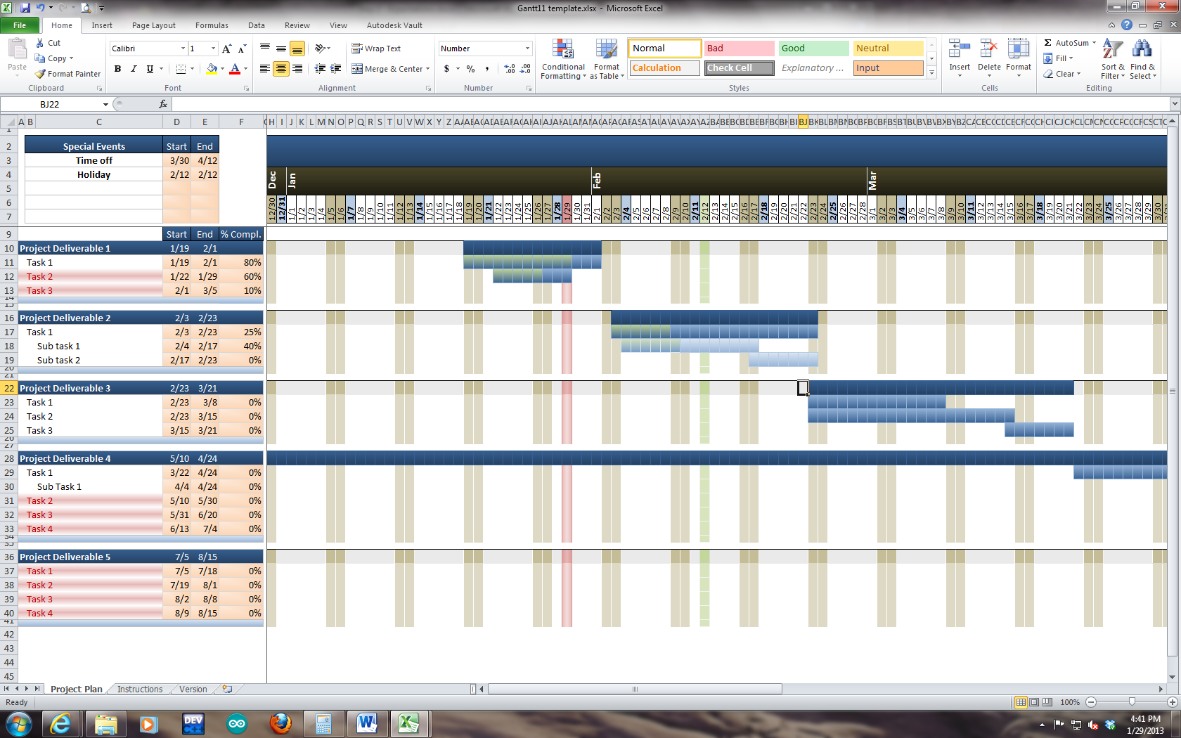

Sample Detailed Hand sketch and Parts list:
