2022 ASEE MODEL DESIGN COMPETITION
Sponsored by the Two Year College Division of ASEE

Date: July 27, 2021

Dear Colleague,

On behalf of the American Society for Engineering Education (ASEE) - Two Year College Division (TYCD), we invite you to encourage the submission of student design projects for the 24th Annual ASEE Lower Division MODEL DESIGN COMPETITION. This event will be held in conjunction with the 2022 ASEE Annual Convention in Minneapolis, MN during June 26-29, 2022 (perhaps on June 27, but this will be clarified by ASEE at a later date). This competition is open to 1st and 2nd year students at two-year and four-year colleges and universities.

The last two competitions were cancelled due to COVID and we are excited to once again give our students the chance to demonstrate their skills in this challenging robotics competition.

Each student team will design and build an autonomous robot that will catch (or gather) legal size (yellow) fish from the three blue lakes on the track and deliver them to either of two fishing stations on the track. The undersized (red) fish must be left in each lake or returned to one of the lakes. The robot must adhere to the rules of the model design competition (attached). An Exhibition session is included as part of the competition.

The main reason for this competition is for students to gain a better understanding of the design process from start to finish. Designing and building something from an idea is probably why they chose engineering in the first place. Use this design competition as a platform to reinforce their ideas and have some engineering fun! We hope to see you and your students' entries in Minneapolis.

Please find enclosed the guidelines and registration forms for this event. The interest and registration forms are on the back of this letter.

Sincerely,

Paul E. Gordy
Phone: 757-822-7175
Fax: 757-427-0327
Email: pgordy@tcc.edu

Geoff Berl
Phone: 585-502-8484
Email: gberl001@monroecc.edu

Clint Kohl
Phone: 937-766-7672
Email: KOHLC@cedarville.edu

Results from the
21st Annual ASEE Model Design Competition
June 17, 2019 - Tampa, FL

The recent competition in Tampa required teams to design and build an autonomous robot that can rescue stranded and injured residents from random locations and return them to either the hospital or storm shelter while avoiding obstacles.

9 teams competed and the results were as follows:
- 1st Place: Fire & Rescue – Cedarville University (Cedarville, OH)
- 2nd Place: AVKEA – Monroe Community College (Rochester, NY)
- 3rd Place: Plimsoll Robotics – The Apprentice School (Newport News, VA)

Group photos of all teams:

Photos of the 1st-Place team (receiving the award and the Exhibition Session):
For complete results, including scores, pictures, videos, and more, visit the competition websites at
http://faculty.tcc.edu/PGordy/ASEE/index.html, https://www.facebook.com/MCCELC, or http://robotresearchlab.com/?s=asee.

Consider bringing a team from your college to the next competition during the week of June 26-29, 2022 in Minneapolis, MN. For more information or a copy of next year’s rules, please contact Paul Gordy, pgordy@tcc.edu , (757-822-7175) or Geoff Berl, gberl001@monroecc.edu, (585-502-8484) or Clint Kohl, KOHLC@cedarville.edu (937-766-7672).
2022 ASEE TYCD MODEL DESIGN COMPETITION RULES
Minneapolis, MN

The 24th Annual American Society for Engineering Education (ASEE) Two-Year College Division (TYCD), Model Design Competition will be held during the week of June 26-29, 2022 (perhaps on June 27, but this will be clarified by ASEE at a later date) in conjunction with the ASEE Annual Convention in Minneapolis, MN.

Event Name: Robot Fishing Tournament

Objective:
To design and build an autonomous robot that can successfully gather up to 12 legal size (yellow) fish from the three blue lakes on the track and deliver them to either of two fishing stations. The lakes also contain 4 undersized (red) fish which must be left in each lake or returned to one of the lakes. The robots will have a maximum time of 120 seconds in each of their four allotted trials. The robot must begin within an 8” X 12” X 10” high size limit but may expand to any size during a trial. An Exhibit Session will precede the robot trials.

Track Specifications:
Figure 1: Isometric View of the Track
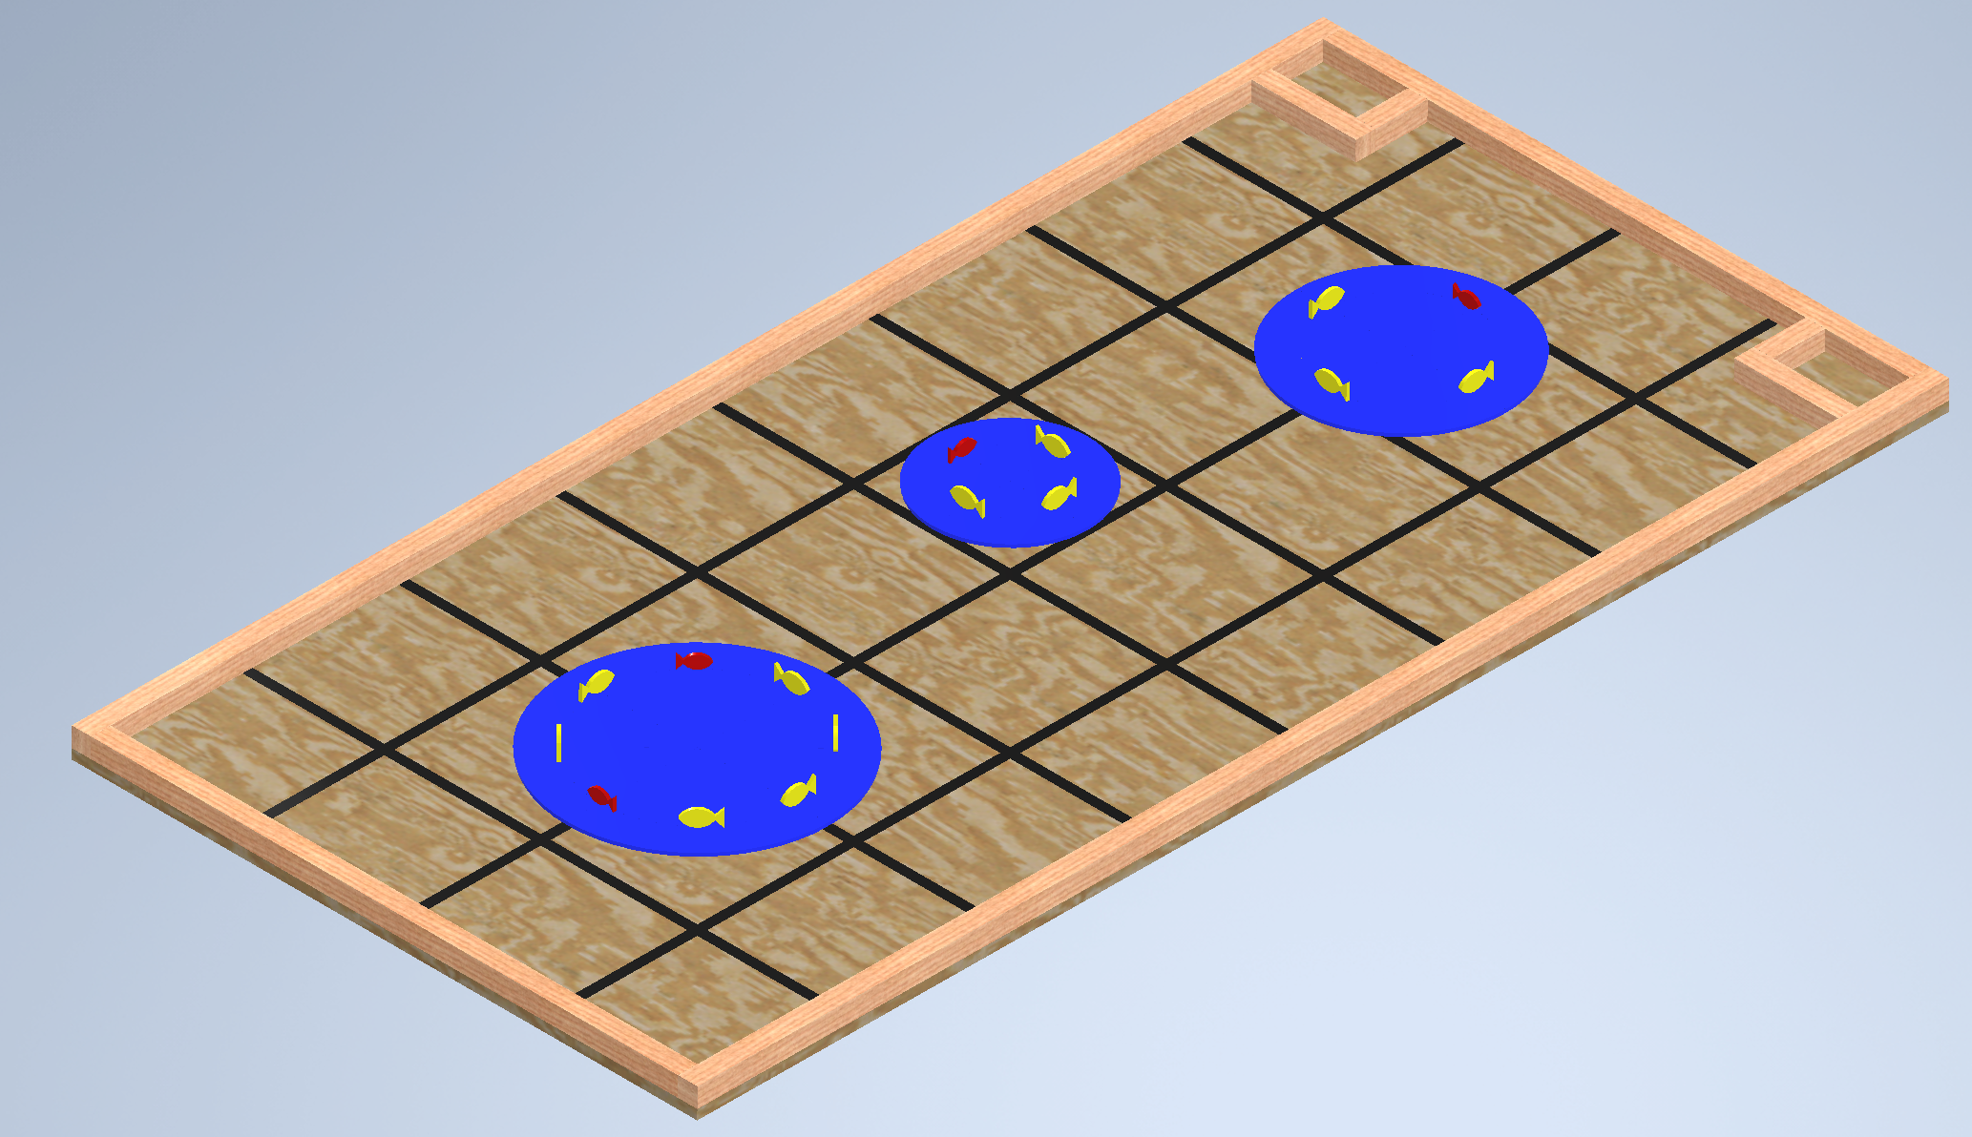
- The track contains 3 lakes: small (12” diameter), medium (16” diameter) and large (20” diameter).
- The small and medium lakes each contain exactly 3 yellow (legal) fish and 1 red (undersized) fish.
- The large lake contains exactly 6 yellow (legal) fish and 2 red (undersized) fish.
- There is a total of 12 yellow fish and 4 red fish.
- The ordering of the yellow and red fish for each lake is random and will be determined by a drawing just before each robot trial.
- All fish are swimming clockwise on a circle that is 2.5” from the outer edge of each lake.
- See later drawings for more details.

Figure 2: Track dimensions
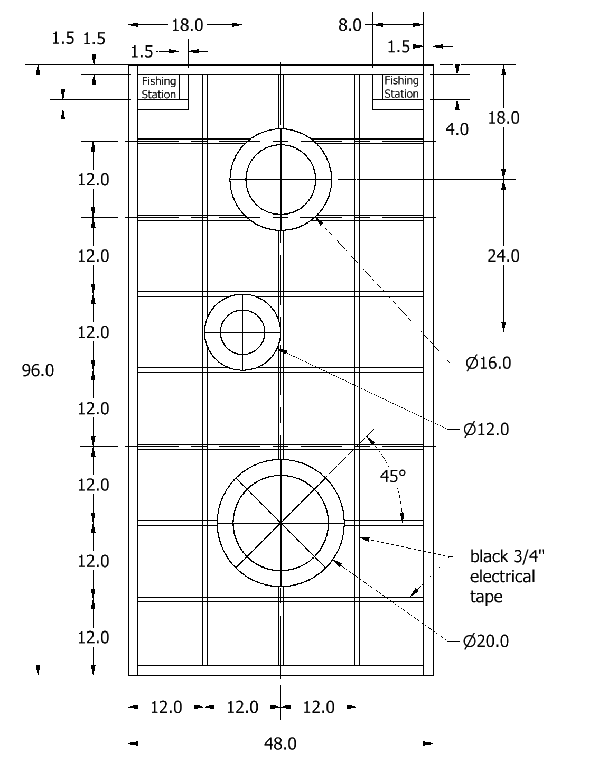
- All dimensions to tape use centerlines of the tape.
- Details for fish and lakes provided below.
Figures 3A and 3B: Red Fish Dimensions (thickness: 0.25 inches)
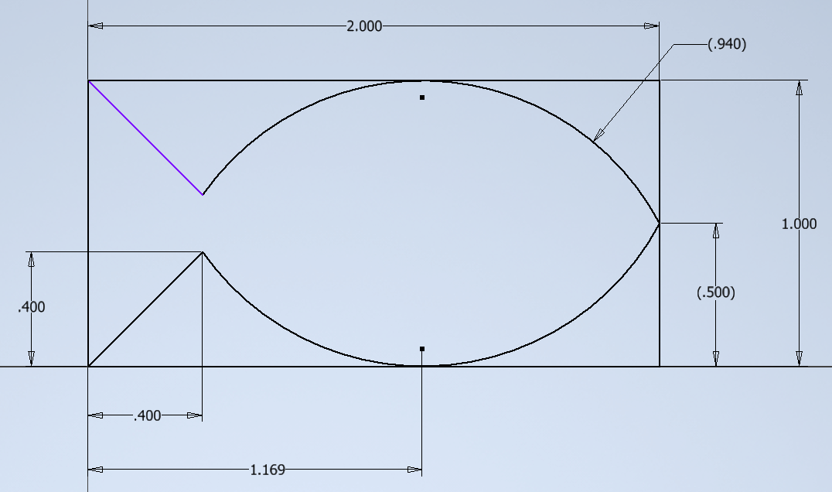

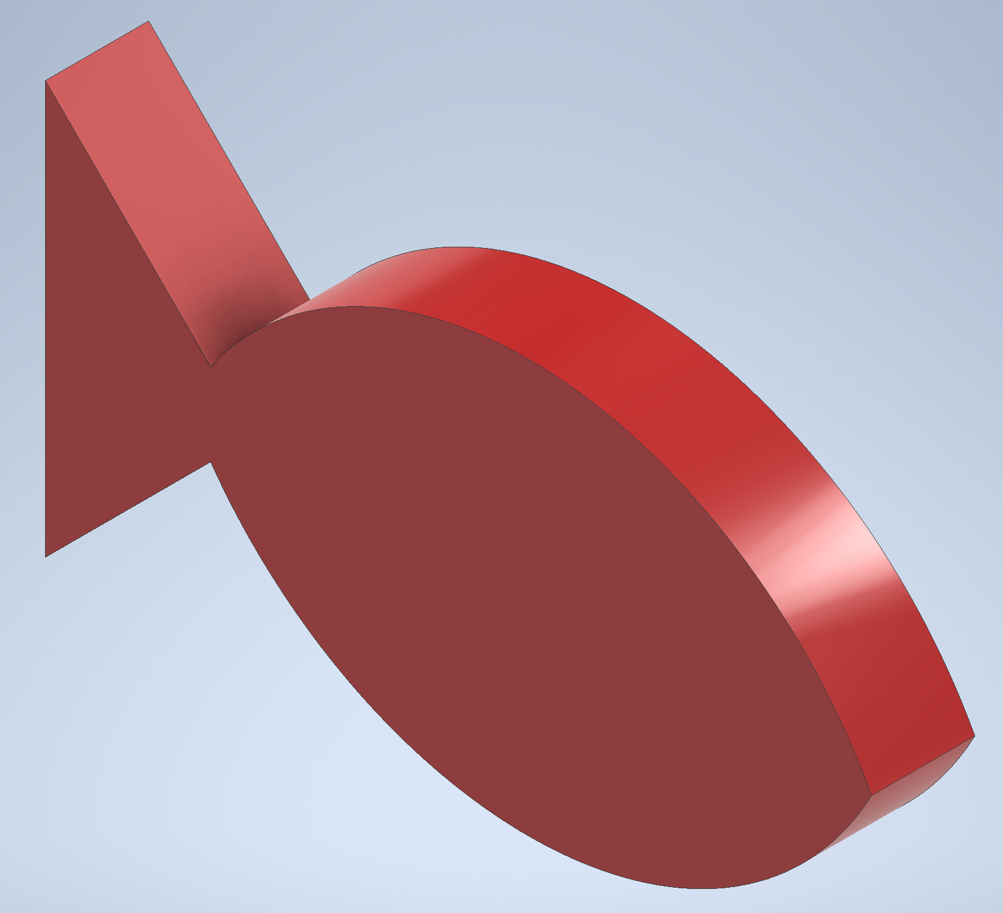

Figures 4A and 4B: Yellow Fish Dimensions (thickness: 0.25 inches)
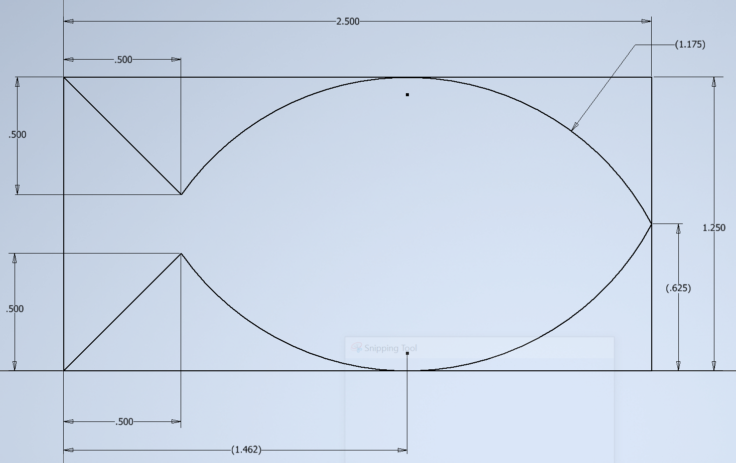

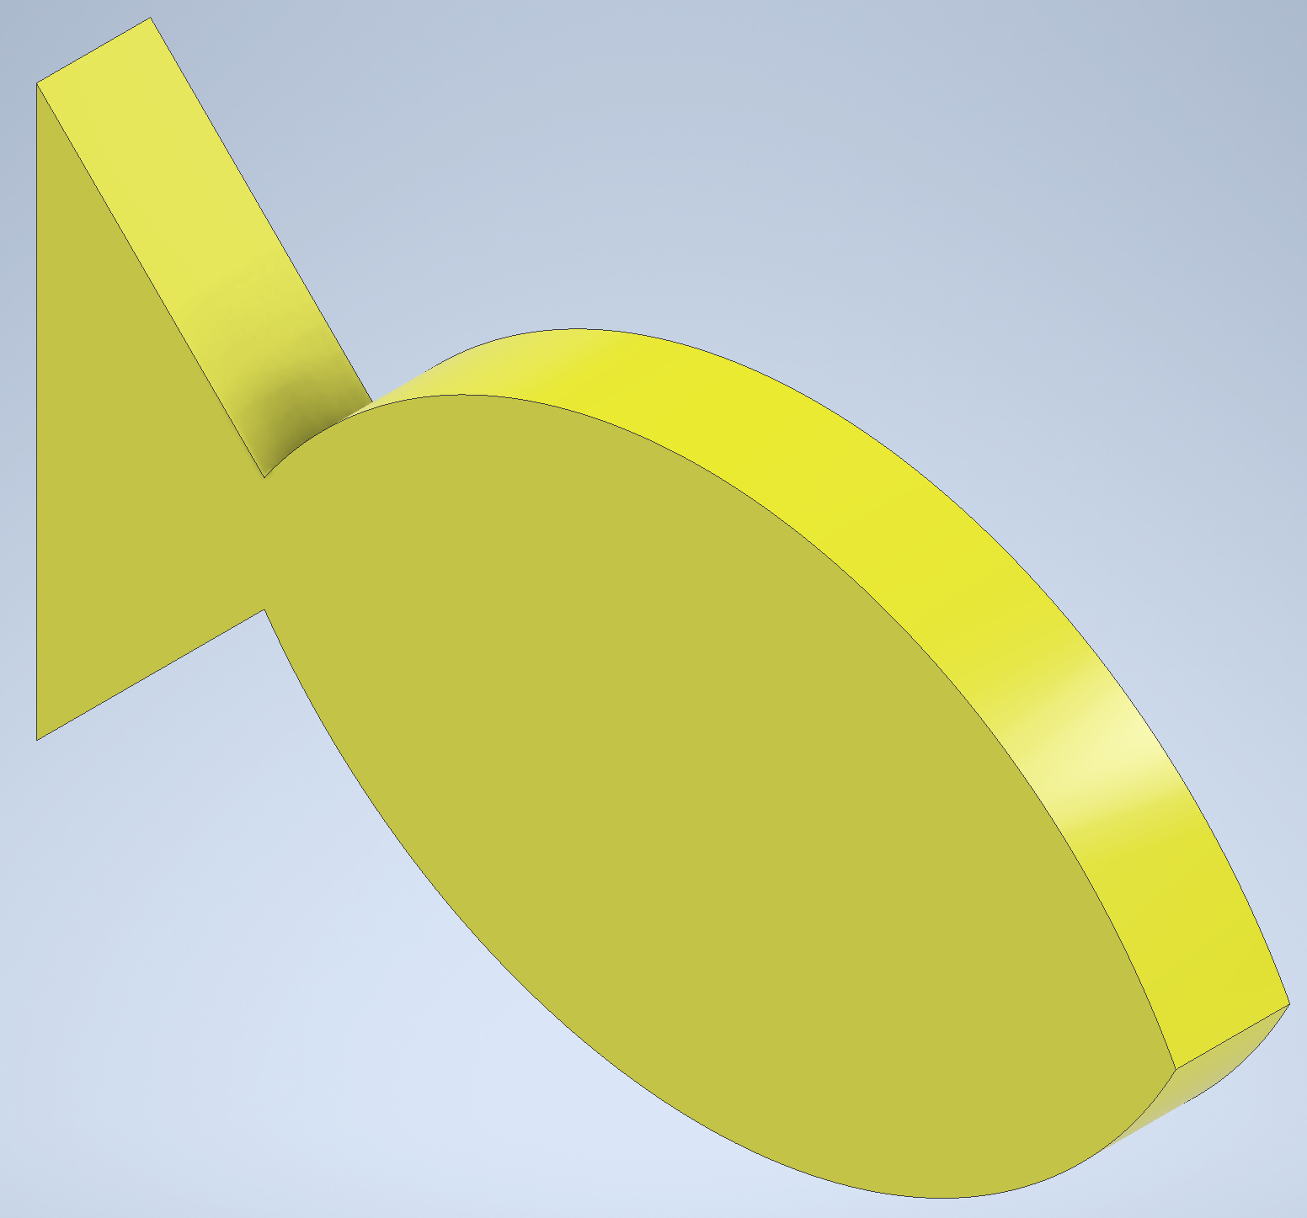
Figure 5A: Small Lake Dimensions
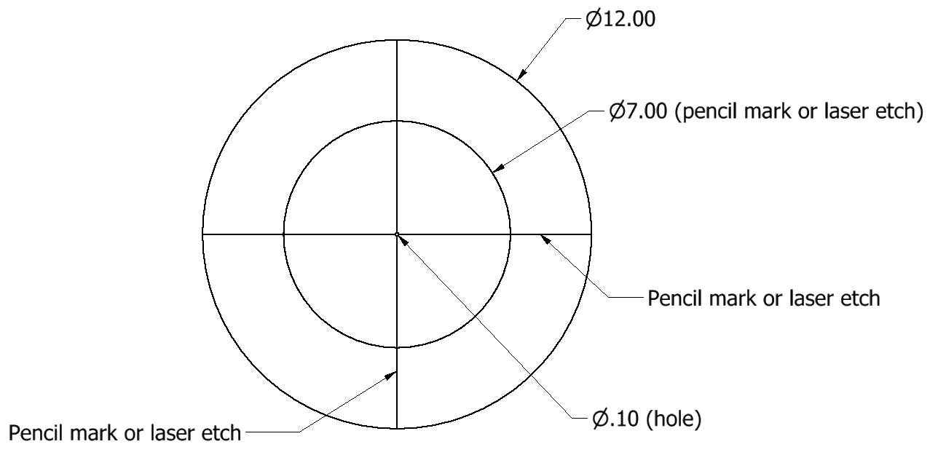

Figure 5B: Medium Lake Dimensions
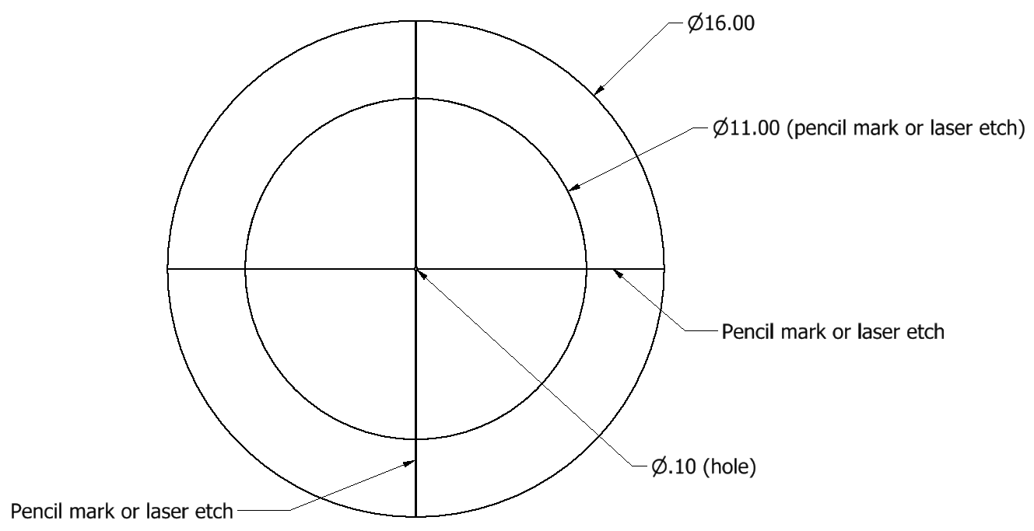

Figure 5C: Large Lake Dimensions
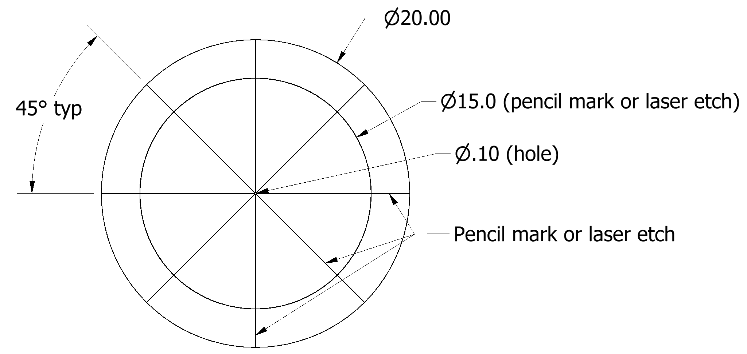

Notes for all lakes:
- The etched lines (vector engraved) are approximately 0.001” wide and 0.001” deep. A test lake was cut using a laser and the lines could still be easily seen after the lake had been painted.
- The 0.10” diameter hole in the center of each lake could possibly be used to center each lake on the track.
- See later drawings for the exact fish location on each lake.

Figure 6A: Placement of Yellow Fish on each lake (typical for any etched radius)
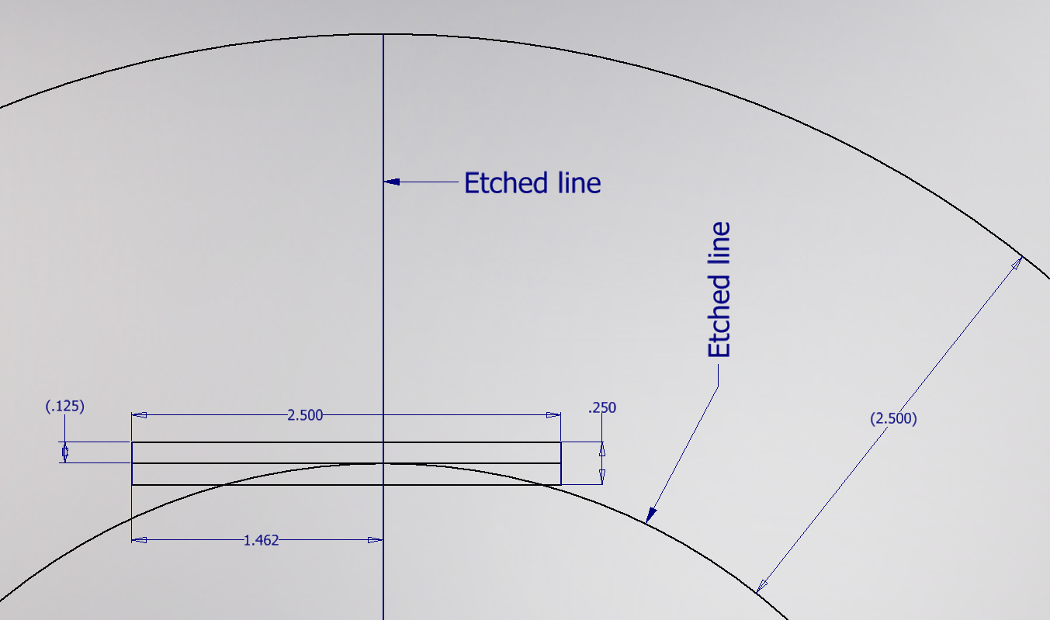

Figure 6B: Placement of Red Fish on each lake (typical for any etched radius)
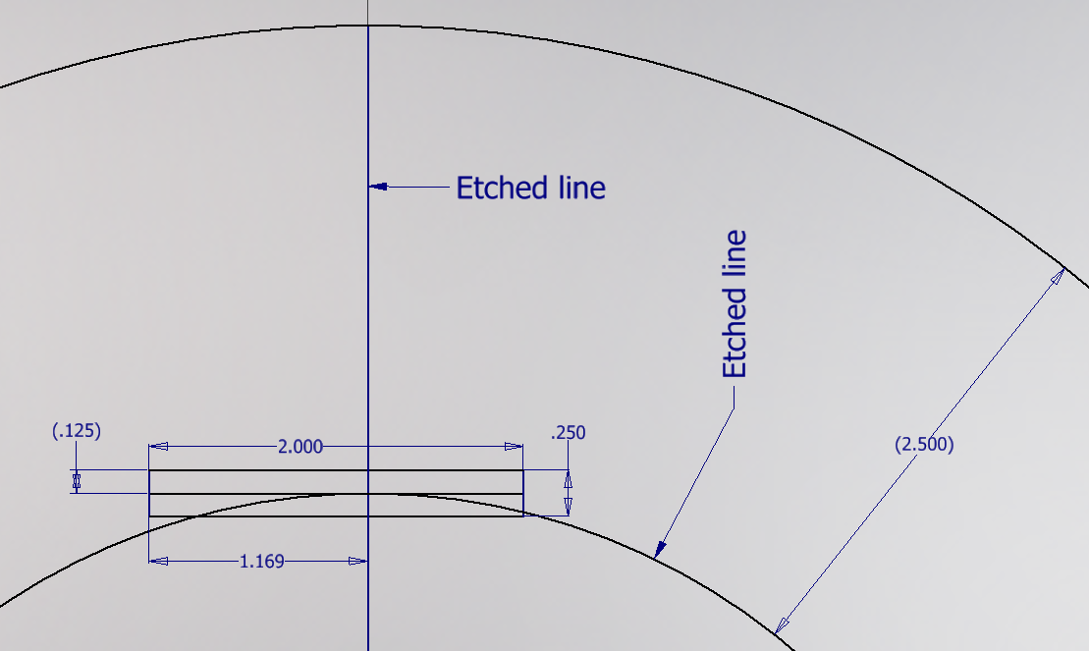

Notes for fish placement:
- Each fish is oriented to swim clockwise around the etched circle (2.5” from the outer edge).
- Each fish should be parallel to a tangent line where an etched radius crossed the etched circle.
- The bottom of each fish (tangent point on the bottom) should be located at the intersection of each etched radius and the etched circle.
- See diagrams above for further details.
- Test fish have been created using a laser cutter and they stand upright with a minimal risk of tipping over.

Required Materials:

- One 4’ X 8’ X ½” plywood (grade BC or better)
- Seven 2” x 4” x 96” boards for the substructure (not shown)
- Four 2” x 2” x 96” boards (actual size 1.5” x 1.5” x 96”) to be cut into the following lengths:
  - 96” (2 boards for the sides of the track)
  - 45” (2 boards for the ends of the track)
  - 8” (2 boards for fishing stations)
  - 4” (2 boards for fishing stations)
- One 4’ x 8’ x ¼” high grade (birch?) plywood
- One Roll of 3/4” Wide Black Vinyl Electrical Tape
- One Can of Rust-Oleum Painter’s Touch 2X Gloss Spray Paint in the following color: Apple Red
- One Can of Rust-Oleum Painter’s Touch 2X Gloss Spray Paint in the following color: Brilliant Blue
- One Can of Rust-Oleum Painter’s Touch 2X Gloss Spray Paint in the following color: Sun Yellow
- One Box of 2.5” or 3.0” Wood Screws (or deck screws) for substructure framing
- One Box of 2” Wood Screws (or deck screws) for attaching 2x2 barriers
- One Box of 5/8” Stainless Wire Brads (or finishing nails) for attaching the lakes to the track.
Available at The Home Depot (Model #03564, SKU #566787)
- One container of light pine colored Sandable Wood Filler

Construction Procedures:
Track
- Construct a 4’ x 8’ substructure using 2” x 4” boards spaced 16” on-center.
- After the substructure is square, fasten the 4’ x 8’ plywood (B side up) using 1.5” finishing nails.
- Draw light construction lines on the 4’ x 8’ plywood board to mark the centerlines for the tape as indicated in Figure 2.
- Apply the 3/4” wide black vinyl tape to the plywood. Be sure not to stretch the tape during application or else the tape will lose adherence to the track over time. Note that the ends of the black vinyl tape will be under the boards used for the outer boarder (to be added in the next step).
- Attach the 2” x 2” boards used for the outer border of the track using 2” screws.
- Attach the 2” x 2” boards used to form the fishing stations using 2” screws.
- Cut the three lakes using high grade (birch?) ¼” plywood. Using a laser cutter is recommended. The laser cutter drawing files are available on the competition website.
- If a laser cutter was not used, use a pencil to add the additional lines and circles to the lake cutouts. If the provided laser cutter file is used, the lines and circles will be etched (vector engraved) by the laser cutter.
- Paint the 3 lakes (top and sides) with the blue paint specified.
- Cut the 12 yellow fish using a laser cutter (file provided). If a laser cutter is not available, you may wish to create the 12 yellow fish using a 3D printer (stl files have been provided), however wooden fish cut by a laser cutter will be used in the competition. Paint the fish using the yellow paint specified.
- Cut the 4 red fish using a laser cutter (file provided). If a laser cutter is not available, you may wish to create the 4 red fish using a 3D printer (stl files have been provided), however wooden fish cut by a laser cutter will be used in the competition. Paint the fish using the red paint specified.
- Place the fish on the lakes in the specified locations.

Robot Specifications:

Allowable Energy Sources:
Any energy source is allowed as long as it is completely contained within the robot and does not create or emit any gaseous, liquid, or solid emissions. Energy sources must not present any safety hazards to participants or spectators.

Prohibition Against Flying Robots:
Since the competition is held in a crowded Exhibition Hall with hundreds of spectators, flying robots (such as quad copters) are prohibited.

Maximum Robot Size:
The robot must fit inside a box with vertical sides having inside dimensions of 8.0” X 12.0” and have a maximum height of 10.0”. The robot may expand to any size after the start of a trial.
If a robot exceeds the size constraints the judges will assess a one-time penalty that will be deducted from their exhibit session score. The amount of this penalty will be commensurate with the degree of the oversize and the advantage this infraction would permit. Past penalties for ¼” oversize were 20pts. Entries with dimensions greater than 1” beyond those allowed will be disqualified and not able to compete in the robot time trials.

Components, Fabrication, and Cost:
Team members using materials which are commonly available to the general public must perform all fabrication. Use of commercially available vehicles, robots, or entire kits such as RC cars, Legos, K-nex, Fischer-Technics, Parallax or erector sets may not be used. The use of Lego Mindstorm microcontroller bricks are prohibited. Individual components from these cars, robots, or kits (except the Mindstorm Brick) may be integrated into a team’s robot as long as the majority of the robot’s components are not from the same car, robot, or kit source. The cost of purchasing all components must not exceed $400.

Robot Time Trial Rules:

- It is the responsibility of the team to inspect the condition of the track and the placement of the fish before starting their robot to be certain that everything is in order. Once a team presses or pulls the start mechanism, the run counts as an official trial and may not be done over.
- The order of testing will be determined by random draw and the same order will be used for all 4 time trials. Teams will alternate on the two competition tracks making 2 rounds on each track during the complete 4 rounds of competition. For example: if during round 1 a team competes on track A, then for round 2 that team will compete on track B. Teams will be assigned their track and are not free to choose which track they run on.
- While the preceding team is on the opposite track for a trial, the on-deck team must have their robot on the other track ready to run immediately after the previous team completes their trial. Each team will have one minute to begin a trial after being called.
- All teams will be called for a trial in a current round before any teams begin the next round of testing.
- Robot sizes will be tested with the measuring box prior to each team’s first run and in subsequent runs if requested by the competition officials (judges). Team members will be responsible for placing the measuring box over their robots. If a robot fails to meet the size constraints the judges will assess a penalty proportional to the severity of the violation (See Robot Specifications).

- The competition officials will randomly draw fish for each from a container so that the order of the yellow and red fish will not be known in advance. The intent of the competition is that the robots will not know the order of the yellow and red fish, so teams should not attempt to preprogram their robots with the fish order, even at the last minute before a trial begins. If judges determine that a robot was preprogrammed with the fish order in advance, the team will be disqualified for that trial.

- The robot must start touching one of the two fishing stations.

- The robot may extend beyond the perimeter of the track during the trial as long as the robot is fully supported by the plywood track surface or the perimeter boards.

- The time for a trial will begin when the judge gives the team the command to start. Once this start command is given, a team may only activate a single switch or mechanism to start the robot.

- If a robot fails to move once the judge’s start command is given, the team members may work on their robot to get it moving but the time will continue to run from the time when the start command was given. If the robot has not moved within 120 seconds of the start command, a score of zero will be assigned for that trial.

- A trial will end when any of the following actions occur:
a. The robot becomes disabled or shows no evidence of being able to continue.
b. The robot has successfully achieved a total of delivering 12 yellow fish to either fishing station (or the yellow fish may be divided between the two fishing stations.
c. The team chooses to end their run.
d. 120 seconds elapses from the start command.

- Teams may make changes or repairs to their robots between trials but they must be ready within one minute of being called to the track.
- Teams may not make practice runs during the Exhibit Session or after the start of the Robot Time Trials.

Robot Time Trial Scoring:

Robots will earn points by delivering yellow fish to either of the fishing stations.

A yellow fish has been successfully delivered to a fishing station if it touches the 3.5” x 6.5” plywood base of the fishing station or if it touches another yellow fish that has been validly placed in a fishing station.
Red fish must be left in one of the lakes or returned to any of the lakes or a penalty will apply. A red fish is in a lake if it is completely supported by the blue surface of the lake or by another red fish. A red fish may overhang the edge of the lake as long as it is not in contact with the track surface.

- Points earned for successfully delivering yellow fish: 10 Points will be awarded for each yellow fish delivered to a fishing station.

- Points deducted for removing a red fish from a lake: 10 Points will be deducted for each red fish that is not in one of the three lakes at the end of a trial run.

- Bonus points: Bonus points may be earned for a perfect trial run. A perfect trial run is achieved by delivering all 12 yellow fish to either of the fishing stations and leaving all 4 red fish in any of the lakes.
Bonus Points = (120 – trial time), where trial time is the time to complete the trial run, rounded up to the nearest second.
Example: If a robot has a perfect run and completes the trial run in 99.5 seconds, then the number of bonus points is 120 – 100 = 20 and the total score is (12 yellow fish)(10 pts/fish) + 20 = 140 pts.

Exhibit Session Scoring:
A maximum score of 120 points may be earned in the Exhibit Session. Scoring details are described below.

Overall Scoring:
The overall score for a team will be equal to the sum of the scores for the Exhibition Session and the four Robot Time Trials. A team will be disqualified from the competition if they fail to participate in the entire Exhibition Session.

Overall Score = Sum of the Points from all four Robot Time Trials + Exhibition Session Point Total

Exhibit Session:
Prior to the Robot Time Trials, each team must participate in an exhibit session where they will create a booth to promote their project to judges, other students, and conference attendees. Each team will be supplied with a 6’ long table, a board behind the table suitable for mounting poster boards, and electrical power. The entire session is scheduled to last approximately 2 hours. The exact date and time will be specified later, but generally takes place on the morning before the robot time trials.

All participants must be present during the entire exhibit session. Teams may use posters, written documents, physical prototypes, multimedia displays, and other visual aids at their booths. In addition, each team’s robot must remain on display at their booth for the entire duration of the exhibit session. Team members may neither work on, nor test their robots during this session. The number of entries from a given school will be limited by the available space during the exhibit session.

Students from each team are required to visit the exhibits from all other schools. A captain from each school will score each team from other schools on a scale from 0-20 (20 being best) based upon the criteria that the judges will use. Each school will designate a single captain even if that school has multiple teams. The captains’ score will be computed by deleting the highest and lowest scores from the captains and then computing the average of the remaining scores.

The judges will visit each booth for approximately 10 minutes depending on the number of teams competing. During this visit, team members will guide the judges through their display for the first five minutes. In the second 5 minute period, the judges will ask the team questions. Each judge will score teams on a scale of 0 to 20 (20 being best) on the first five items below. The score in each category will be computed by deleting the highest and lowest scores from the judges, and then computing the average of the remaining scores.

1. Design Development:
Guide the judges through the design process that your team followed from the initial ideas to the final solution. Describe your rationale for making design decisions.

2. Robot Operation:
Discuss how your robot works.

3. Fabrication Methods:
Explain how you fabricated your robot.

4. Design Analysis:
Convince the judges that your design is optimal based upon its performance, cost, and environmental impact.

5. Exhibit Quality:
Your exhibit quality will be judged on the following items: team and exhibit appearance, technical expertise displayed, communication skills, and effectiveness of visual aids.

6. Captain Scoring:
The score from the captains will be added to the judges’ scores from the five categories above.

Schedule of Events on the day of the competition:
The exact schedule may vary as the competition is subject to the scheduling needs of ASEE. A typical schedule might be as follows (but look for emails from the competition organizers for any possible time changes):
6:45 am: Report to the Exhibition Hall
- Set up your team’s table
- Draw for the order of the presentations and time trials
7:00 – 9:00 am: Exhibit Session
- Judges will visit each table in the order determined by the drawing
- Team captains will visit the table of all other teams
- The track is closed during the Exhibit Session. Teams may not work on robots or test robots at this time.
9:45 am – 1:00 pm: Robot Time Trials
- Trial 1: Each team will compete in the order determined by the drawing.
- Trial 2: Each team will compete in the order determined by the drawing.
- Trial 3: Each team will compete in the order determined by the drawing.
- Trial 4: Each team will compete in the order determined by the drawing.
1:00 pm (or when the time trials end): Awards and Team Photos

Rule Interpretation Questions:

Prior to the date of the competition direct your inquiries to either of the following:
Paul Gordy Geoff Berl Clint Kohl
Tidewater Community College Monroe Community College Cedarville University
1700 College Crescent 1000 E. Henrietta Road 251 N. Main St.
Virginia Beach, VA 23453 Rochester, NY 14623 Cedarville, OH 45314
Email: PGordy@tcc.edu Email: gberl001@monroecc.edu Email: KOHLC@cedarville.edu

On the date of the competition:
The judges will interpret the intent of the rules and make all decisions. If the judges determine that a team is in violation of the intent of any rule or specification, they will deduct points in proportion to the severity of the violation. All decisions by the judges are final and may not be appealed. Teams have shown respect for the judges, participants, and spectators in the past, and this positive attitude is expected from each participant this year.

Competition Registration Questions:

Questions related to registering for the competition should be directed to:

Paul Gordy
Tidewater Community College
1700 College Crescent
Virginia Beach, VA 23453
Phone: 757-822-7175
Email: pgordy@tcc.edu

Please find the entry forms on the following pages. The Interest Form should be received no later than May 1, 2022. A Registration Form for each model design team must be received no later than July 1, 2022.

PROJECT TEAM / ENTRY LIMITATIONS:

Each team must have at least one faculty advisor and at least 2 student members but no more than 10 student members. Each team member must primarily be enrolled in freshman or sophomore level classes. The number of entries from each school will be limited by the space available in the Exhibit Session. If a school has more than one entry then each team must represent a unique solution to the design problem. Multiple copies of the same solution are prohibited.

ASEE ANNUAL CONVENTION PASSES:

It is not required that student team members or faculty advisors be registered for the ASEE Annual Convention. Passes will be provided for all team members and advisors so that they can enter the conference area and exhibition area on the day of the competition. Details for obtaining passes will be made available a couple of weeks prior to the competition.

PRACTICE SESSION:

It is expected that two tracks will be ready for teams to practice on by the day before the competition. More details will be conveyed via email in the weeks before the competition. Teams should be considerate and only use the tracks for brief periods if other teams are waiting to use the tracks.

On the day of the competition the tracks will be available in the Exhibition Hall for teams to practice on prior to and following the Exhibit Session. No practice runs may be made during the Exhibit Session or after the Robot Time Trials have begun.

AWARDS:

First, second, and third-place teams will receive plaques.

Revision History:
7-27-21: First publication of the rules

2022 ASEE Model Design Competition Registration Form

Name of college/university: _______________________________________________________________

Team Name: ________________________________________________________________________

Name of faculty advisor(s): _______________________________________________________________

Mailing Address: _______________________________________________________________________

Phone: ______________________________________

Email (print clearly): _____________________________________________________________________

Student team captain: ____________________________________________________________________

Other student team members:

1. __________________________ 2. __________________________ 3. __________________________

4. __________________________ 5. __________________________ 6. __________________________

7. __________________________ 8. __________________________ 9. __________________________

Which students/advisors need badges for the convention center? (Badges are needed if you are not registered for the convention).
Circle one: All need badges None need badges Only those listed below need badges

Will your team require electrical power at your Exhibition Table? Circle one: YES NO

Please submit this form to: Paul E. Gordy
Tidewater Community College
1700 College Crescent
Virginia Beach, VA 23453
Phone: 757-822-7175
Email: PGordy@tcc.edu

Return one copy of this form for each team entered by
July 1, 2022 (by US mail , fax, or email)
2022 ASEE Model Design Competition Interest Form

Name of college/university: _______________________________________________________________

Name of faculty advisor(s): _______________________________________________________________

Mailing Address: _______________________________________________________________________

Phone: ______________________________________

Email (print clearly): _____________________________________________________________________

Number of model entries desired : _________________

Please submit this form to: Paul E. Gordy
Tidewater Community College
1700 College Crescent
Virginia Beach, VA 23453
Phone: 757-822-7175
Email: PGordy@tcc.edu

Return this form by May 1, 2022 (by US mail , fax, or email)

