

**2020 ASEE MODEL DESIGN COMPETITION**

**Sponsored by the Two Year College Division of ASEE**

Date: June 11, 2019

Dear Colleague,

On behalf of the American Society for Engineering Education (ASEE) - Two Year College Division (TYCD), we invite you to encourage the submission of student design projects for the 22nd Annual ASEE Lower Division MODEL DESIGN COMPETITION. This event will be held in conjunction with the 2020 ASEE Annual Convention, Montreal, Quebec, Canada, June 22, 2020. This competition is open to 1st and 2nd year students at two-year and four-year colleges and universities.

As this year’s competition will be held in Canada which is known for its committed fans, each student team will design and build an autonomous robot that will perform a sort of hockey skirmish by making goals with pucks laid around the track. The robot must adhere to the rules of the model design competition (attached). An Exhibition session is included as part of the competition.

The main reason for this competition is for students to gain a better understanding of the design process from start to finish. Designing and building something from an idea is probably why they chose engineering in the first place. Use this design competition as a platform to reinforce their ideas and have some *engineering fun!* We hope to see you and your students' entries in Tampa.

Please find enclosed the guidelines and registration forms for this event. The interest and registration forms are on the back of this letter.

Sincerely,

Paul E. Gordy

Phone: 757-822-7175

Fax: 757-427-0327

Email: [pgordy@tcc.edu](mailto:pgordy@tcc.edu)

Geoff Berl

Phone: 585-502-8484

Email: [gberl001@monroecc.edu](mailto:gberl001@monroecc.edu)

Clint Kohl

Phone: 937-766-7672

Email: [KOHLC@cedarville.edu](mailto:KOHLC@cedarville.edu)

Results from the

**21st Annual ASEE Model Design Competition**

June 17, 2019 - Tampa, FL

The recent competition in Tampa required teams to design and build an autonomous robot that can rescue stranded and injured residents from random locations and return them to either the hospital or storm shelter while avoiding obstacles.

9 teams competed and the results were as follows:

* 1st Place: ***Fire & Rescue – Cedarville University (Cedarville, OH)***
* 2nd Place: ***AVKEA – Monroe Community College (Rochester, NY)***
* 3rd Place: ***Plimsoll Robotics – The Apprentice School (Newport News, VA)***

Group photos of all teams:

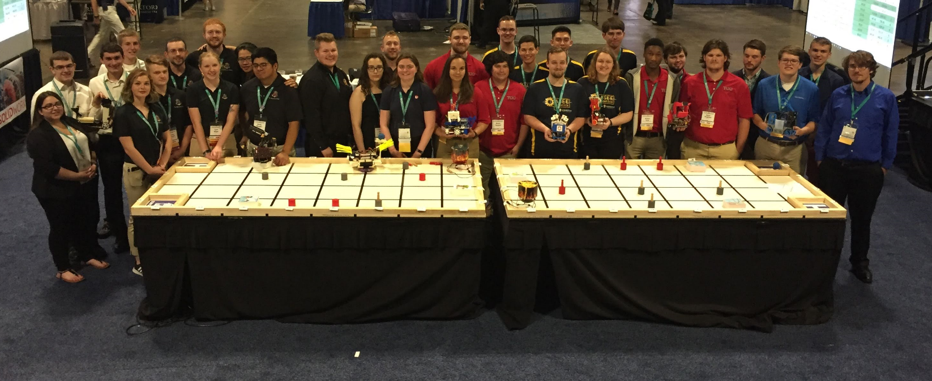

Photos of the 1st-Place team (receiving the award and the Exhibition Session):

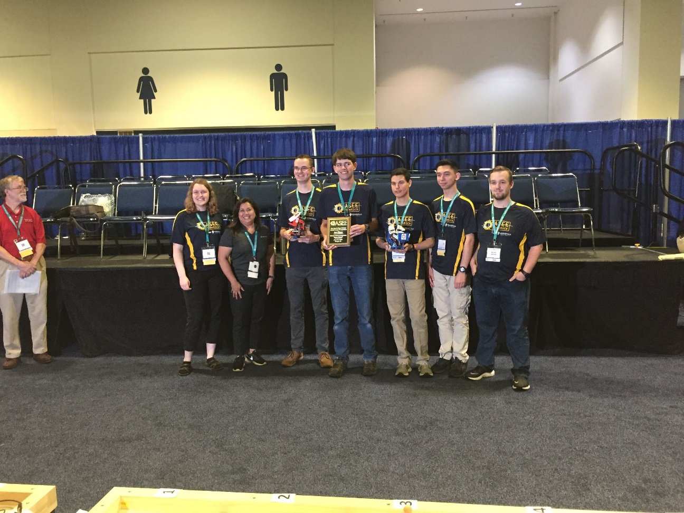 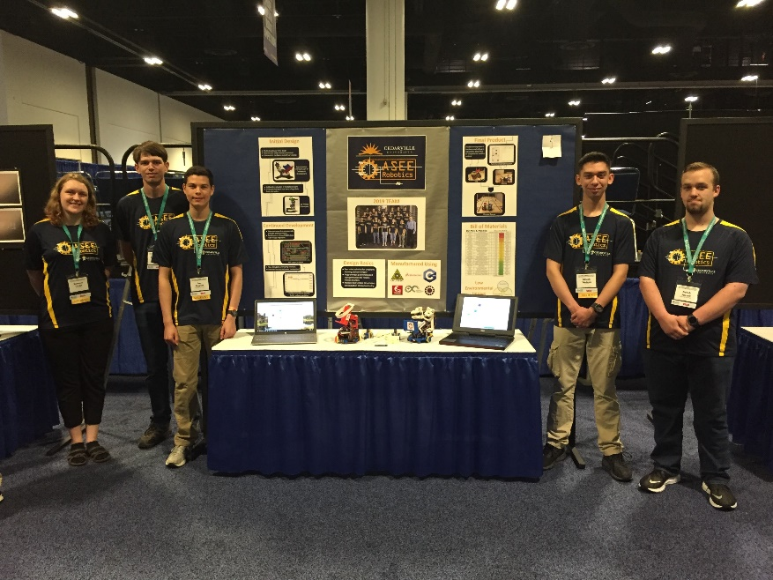

For complete results, including scores, pictures, videos, and more, visit the competition websites at

<http://faculty.tcc.edu/PGordy/ASEE/index.html>, <https://www.facebook.com/MCCELC>, or <http://robotresearchlab.com/?s=asee>.

Consider bringing a team from your college to next year’s competition on June 22, 2021 in Montreal, Quebec, Canada. For more information or a copy of next year’s rules, please contact Paul Gordy, [pgordy@tcc.edu](mailto:pgordy@tcc.edu) , (757-822-7175) or Geoff Berl, [gberl001@monroecc.edu](mailto:gberl001@monroecc.edu), (585-502-8484) or Clint Kohl, [KOHLC@cedarville.edu](mailto:KOHLC@cedarville.edu) (937-766-7672).

**2020 ASEE TYCD MODEL DESIGN COMPETITION RULES (Revised 9-5-19)**

**Montreal, Quebec, Canada**

**June 22, 2020**

The 22nd Annual American Society for Engineering Education (ASEE) Two-Year College Division (TYCD), Model Design Competition will be held Monday, June 22, 2020 in conjunction with the ASEE Annual Convention in Montreal, Quebec, Canada.

**Event Name:** Hockey Skirmish

**Objective:**

To design and build an autonomous robot that can successfully make hockey goals with five pucks (painted wooden dowels) laid around the track while a goalie (servo controlled panel) intermittently blocks the goal. The pucks must be delivered to the appropriate opposing team goal. The robots will have a maximum time of 120 seconds in each of their four allotted trials. The robot must begin within an 8” X 12” X 10” high size limit but may expand to any size during a trial. An Exhibit Session will precede the robot trials.

**Track Specifications:**

**Figure 1: Isometric View of the Track**

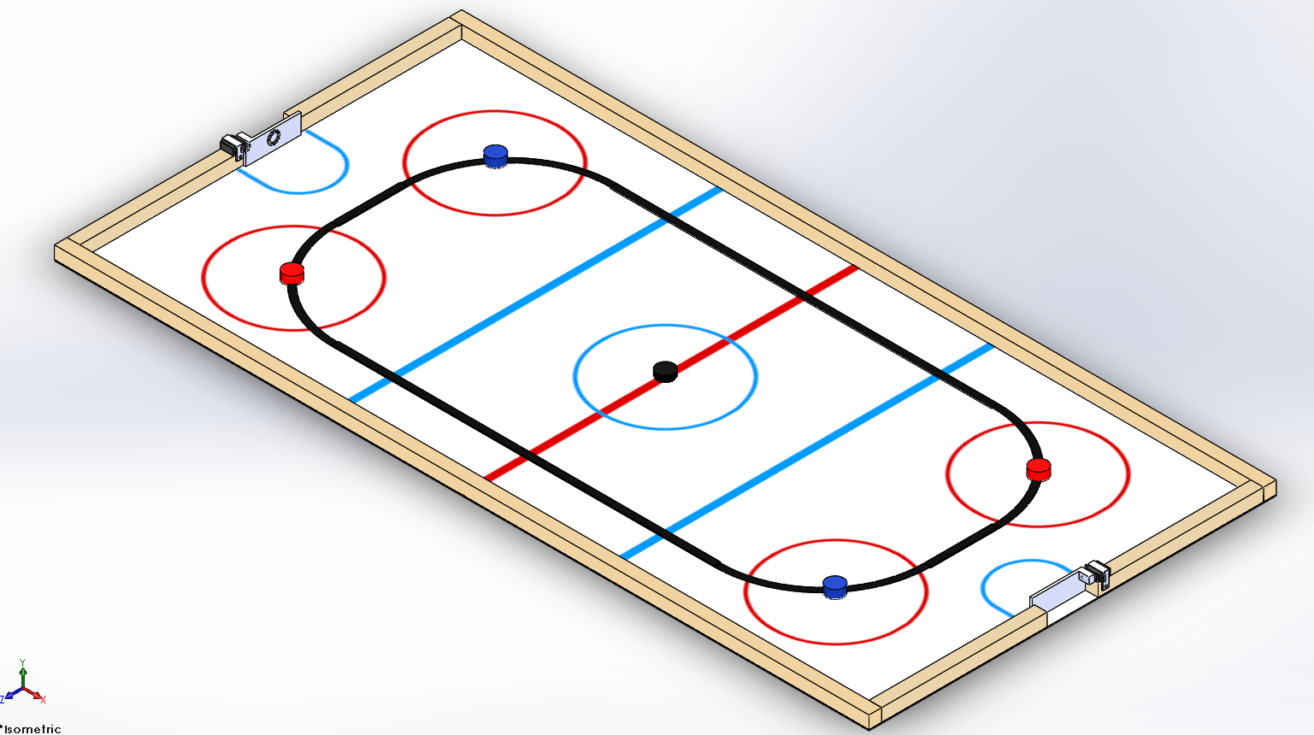

1. **The far goal is the red goalie and the near goal is the blue goalie, each is identified by a neopixel ring emitting the corresponding color for that goalie.**
2. **The pucks will be laid out as follows, starting from the furthest puck in the figure and moving clockwise, blue, red, blue, red with the black puck placed directly on center.**
3. **The goalies will expose the goal for ~3 seconds and obstruct the goal for ~2 seconds in an endless loop.**

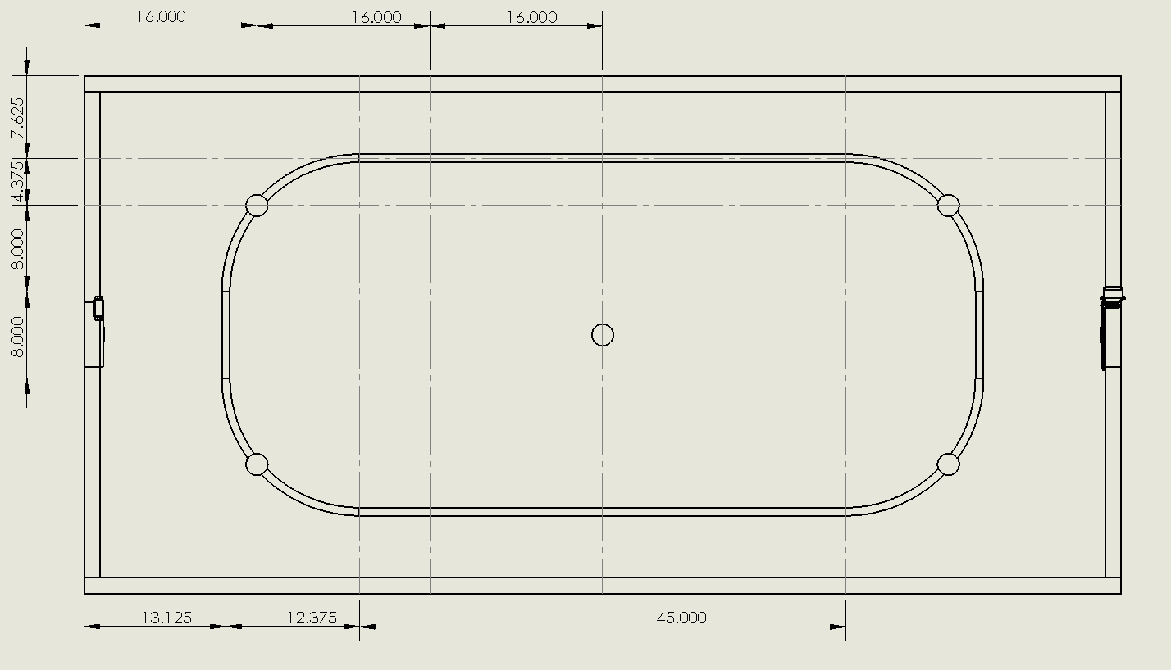

**Figure 2:** Track dimensions

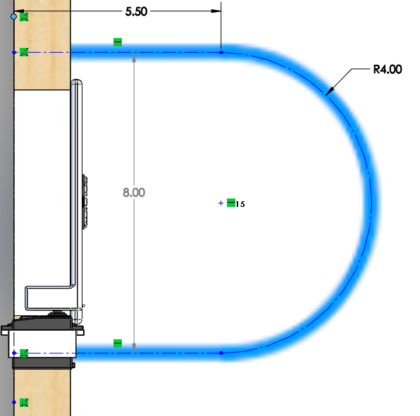 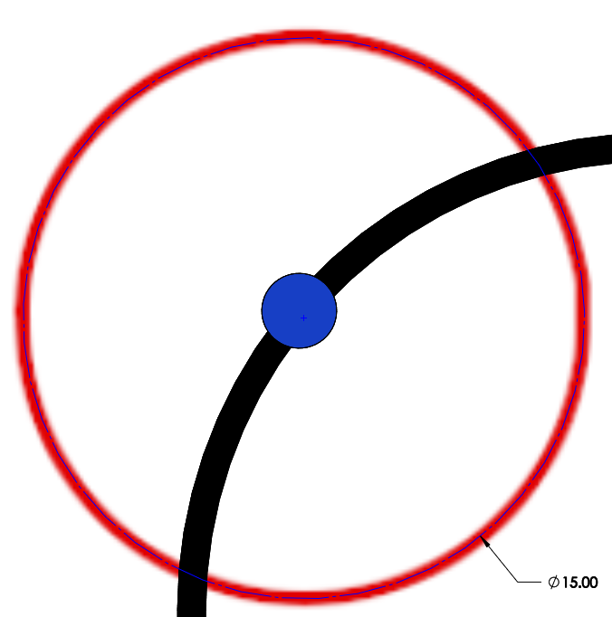

**Figure 3:** Goalie Crease dimensions **Figure 4:** All 5 Circle dimensions 15” Diameter

* The crease (**Figure 3**) and all 5 circles (**Figure 4**) are approximately 0.5” thick and the three stripes in the center are approximately 1” thick
* All tape and line dimensions are to the center line
* Although effort will be made to build the tracks according to specifications, participants should allow for some minor variations in dimensions due to practical construction limitations.

**Required Materials:**

1. **One** 4’ X 8’ X 0.12” sheet of Eucatile Hardboard Thrifty White Tile Board
2. **Seven** 2” x 4” x 96” boards for the substructure (not shown)
3. **Three** 2” x 2” x 96” boards (actual size 1.5” x 1.5” x 96”) to be cut into the following lengths:
   * 96” (2 boards for 8’ sides)
   * 19.5” (4 boards, 2 for each of the 4’ ends)
4. **One** Roll of 3/4” Wide Black Vinyl Electrical Tape
5. **Five** 2” dowels cut 1” in length, these will be the pucks.
6. **One** Can of Rust-Oleum Painter’s Touch **2X Gloss** Spray Paint in the following color: **Apple Red**
7. **One** Can of Rust-Oleum Painter’s Touch **2X Gloss** Spray Paint in the following color: **Brilliant Blue**
8. **One** Can of Rust-Oleum Painter’s Touch **2X Gloss** Spray Paint in the following color: **Gloss Black**
9. **One** Box of 2.5” or 3.0” Wood Screws (or deck screws) for substructure framing
10. **One** Box of 2” Wood Screws (or deck screws) for attaching 2x2 barriers
11. **One** Box of 1.5” Finishing Nails for attaching the tile board to the substructure
12. **Four** 1” wood screws for attaching servo mounts
13. **One** container of light pine colored Sandable Wood Filler
14. **One** 4 pack of Sharpie Pro King Size markers (must include red and blue)
15. **One** tape measure with decimal inch values (easier than working with fractions for this track)

#### Goalies

1. **Two** Futaba S3003/S3004 servo motors ([Link](https://www.amazon.com/gp/product/B001KAPMG6))
2. **Two** NeoPixel Rings 12 x 5050 RGB LED with Integrated Drivers ([Link](https://www.amazon.com/gp/product/B00KAE3R1U))
3. **Two** Arduino Nano or Arduino Nano clone boards ([Link](https://www.amazon.com/gp/product/B0713XK923))
4. General purpose wire for hookup
5. **Two** “mini” size breadboards or similar ([Link](https://www.amazon.com/gp/product/B077PK858F))
6. **Two** LM7806 voltage regulators (to supply servo voltage)
7. **Two** LM7805 voltage regulators (to supply Arduino voltage)
8. **Two** 1000mAh 2S Lithium Polymer batteries ([Link](https://www.amazon.com/gp/product/B012CMFAL2))
9. **Two** Battery connectors able to connect the above battery to a breadboard ([Link](https://www.amazon.com/gp/product/B07P5TG1BP))
10. **Two** 3D printed goalie wall (see website for STL files)
11. **Two** 3D printed servo mount (see website for STL files)
12. **ASEE Goalie PCB** (optional – will replace mini breadboards above) ([Link](https://oshpark.com/profiles/ASEE-Robotics-Contest))

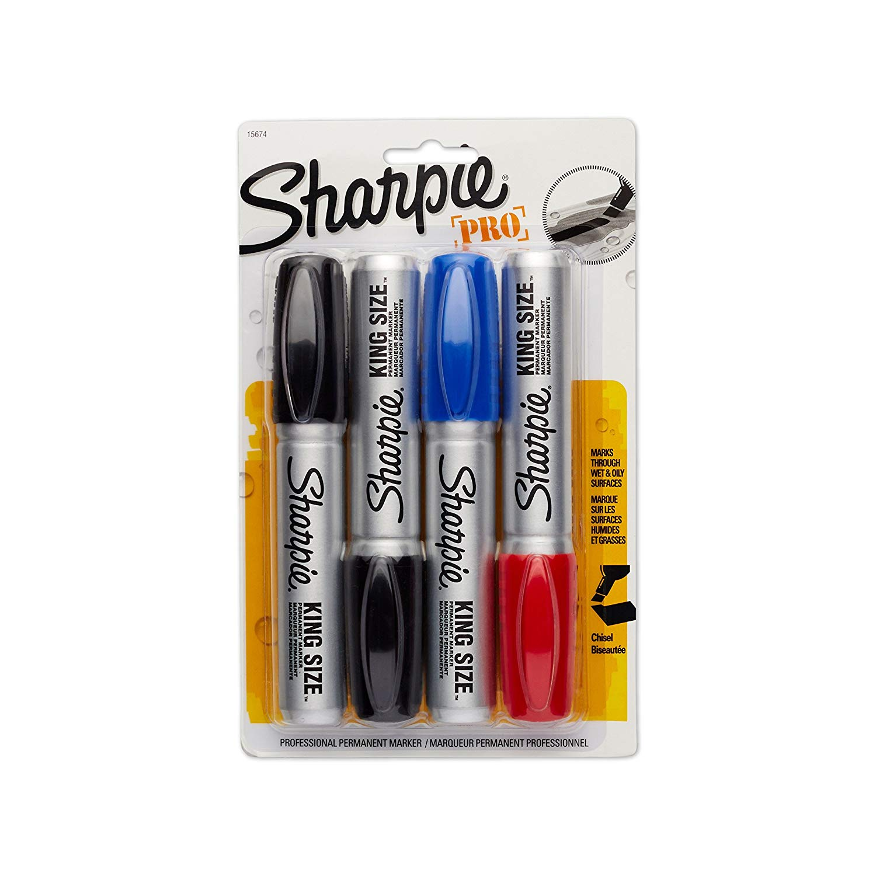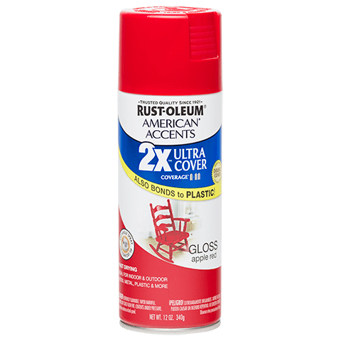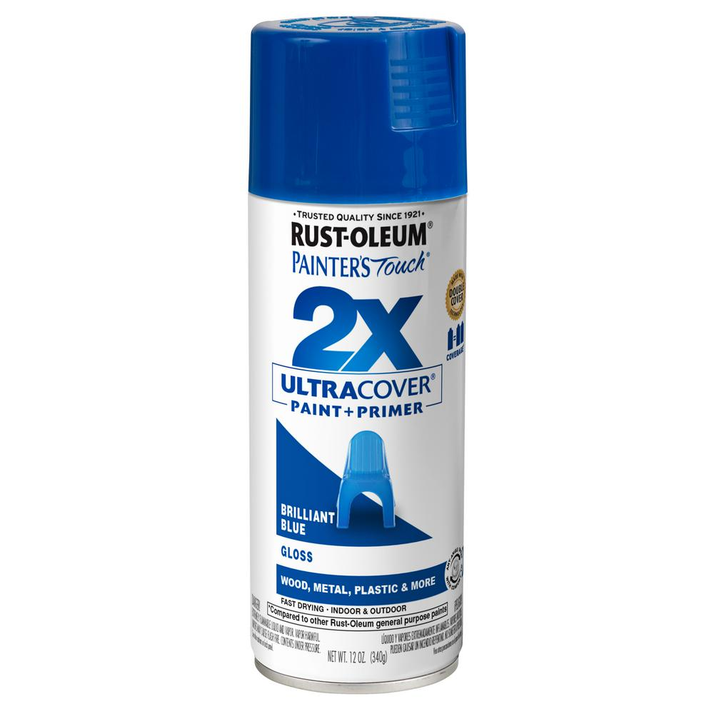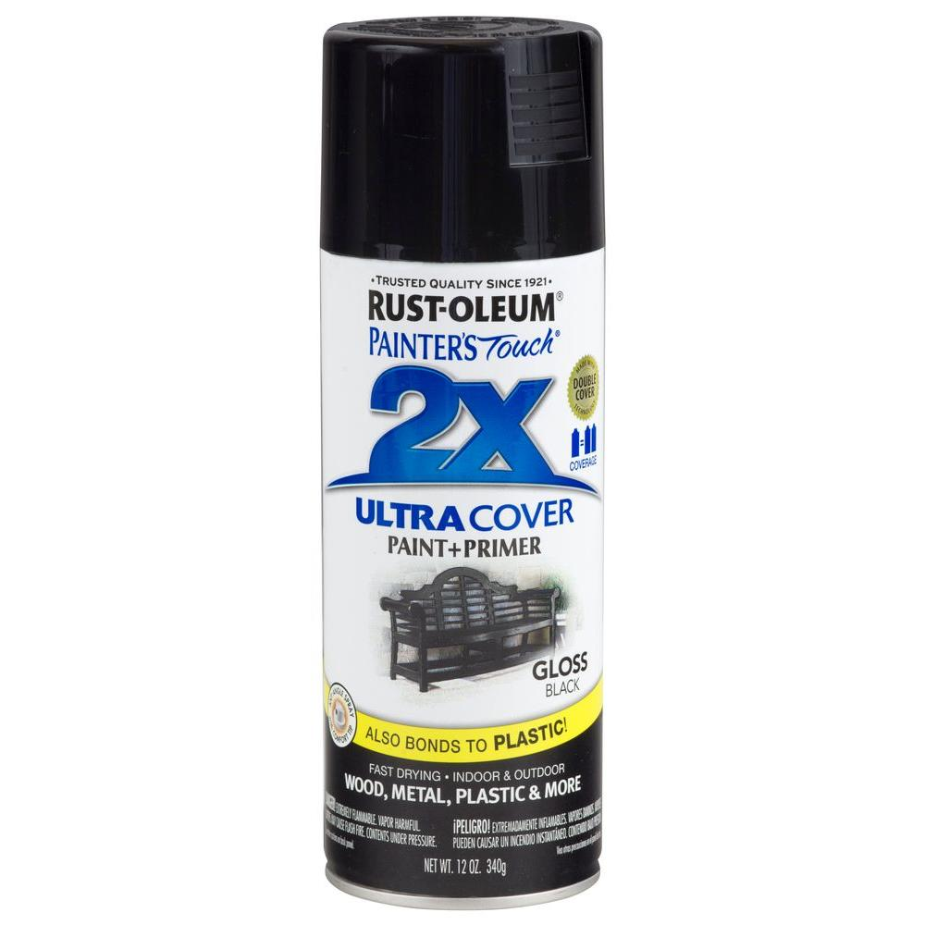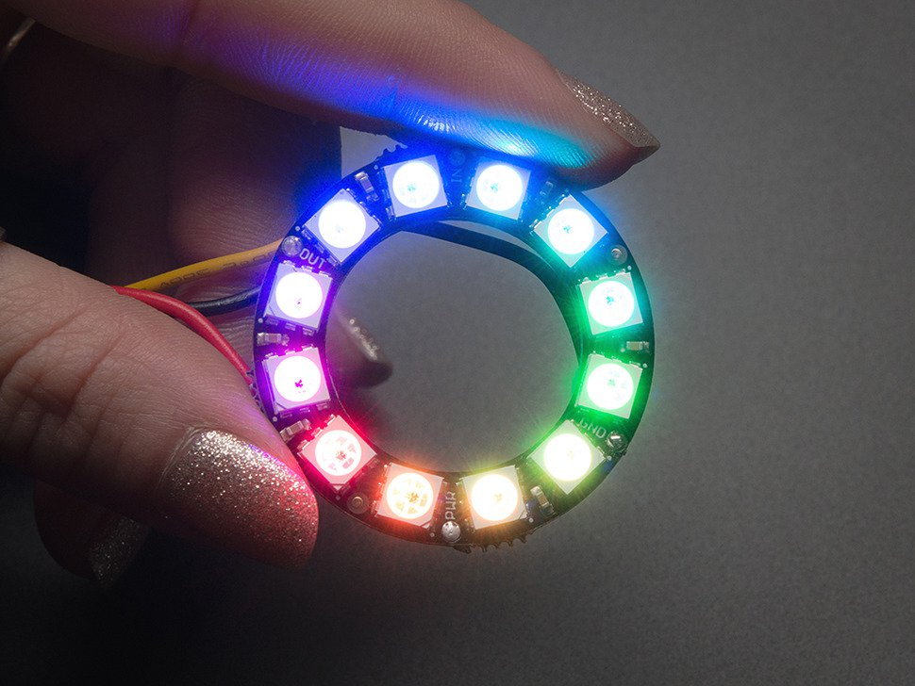 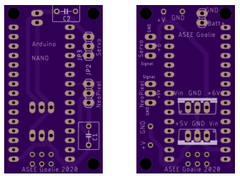

**Construction Procedures:**

**Track**

1. Construct a 4’ x 12’ substructure using 2” x 4” boards spaced 16” on-center.
2. After the substructure is square, fasten the Tile Board using 1.5” finishing nails. Place the nails along the outer edge as well as at each puck location.
3. Attach the 2” x 2” boards used for the outer border of the track using 2” screws
4. Attach the 2” x 2” boards used to form the tops of the goals using 2” screws
5. Draw light construction lines on the tile board to mark the centerlines for the tape as indicated in Figure 2.
6. Apply the 3/4” wide black vinyl tape to the plywood. Be sure not to stretch the tape during application or else the tape will lose adherence to the track over time.
7. Paint 2 dowels (1” x 2” diameter) with the red paint specified. Place the pucks in the locations indicated in Figure 2.
8. Paint 2 dowels (1” x 2” diameter) with the blue paint specified. Place the pucks in the locations indicated in Figure 2.
9. Paint 1 dowel (1” x 2” diameter) with the black paint specified. Place the puck in the location indicated in Figure 2.

#### Goalie Circuit (x2)

1. Upload the code (see Website) to the Arduino or Arduino Clone board
2. Prepare any necessary components by adding wire (recommend 9-12” of wire for the Neopixel ring)
3. Insert LM7806 (U1) and LM7805 (U2) into the breadboard.
4. Wire the servo to the LM7806
5. Wire the Arduino to the LM7805
6. Wire the Neopixel to the LM7805
7. Wire the inputs and grounds of U1 and U2 together.

#### Goalie Body (x2)

1. Slip the servo mount over the servo and mount to the 2x2 perimeter so it is flush with the goal edge.
2. Mount the servo using two 1” wood screws
3. Mount the servo horn inside the goalie wall using an M3 screw
4. When the correct orientation of the goalie wall is found, attach the goalie wall to the servo through the center mounting screw
5. Mount the Neopixel ring in the center of the front of the wall using a tack of hot glue or double sided tape.
   1. There is an optional hole for routing the wires

**Robot Specifications:**

**Allowable Energy Sources:**

Any energy source is allowed as long as it is completely contained within the robot and does not create or emit any gaseous, liquid, or solid emissions. Energy sources must not present any safety hazards to participants or spectators.

**Prohibition Against Flying Robots:**

Since the competition is held in a crowded Exhibition Hall with hundreds of spectators, flying robots (such as quad copters) are prohibited.

**Maximum Robot Size:**

The robot must fit inside a box with vertical sides having inside dimensions of 8.0” X 12.0” and have a maximum height of 10.0”. The robot may expand to any size after the start of a trial.

If a robot exceeds the size constraints the judges will assess a one-time penalty that will be deducted from their exhibit session score. The amount of this penalty will be commensurate with the degree of the oversize and the advantage this infraction would permit. Past penalties for ¼” oversize were 20pts. Entries with dimensions greater than 1” beyond those allowed will be disqualified and not able to compete in the robot time trials.

**Components, Fabrication, and Cost:**

Team members using materials which are commonly available to the general public must perform all fabrication. Use of commercially available vehicles, robots, or entire kits such as RC cars, Legos, K-nex, Fischer-Technics, Parallax or erector sets may not be used. The use of **Lego Mindstorm microcontroller bricks are prohibited.** Individual components from these cars, robots, or kits (except the Mindstorm Brick) may be integrated into a team’s robot as long as the majority of the robot’s components are not from the same car, robot, or kit source. The cost of purchasing all components must not exceed **$400.**

**Robot Time Trial Rules:**

1. It is the responsibility of the team to inspect the condition of the track before starting their robot to be certain that everything is in order. Once a team presses or pulls the start mechanism, the run counts as an official trial and may not be done over.
2. The order of testing will be determined by random draw. Teams will alternate on the two competition tracks making 2 rounds on each track during the complete 4 rounds of competition. For example: if during round 1 a team competes on track A, then for round 2 that team will compete on track B. Teams will be assigned their track and are not free to choose which track they run on.
3. While the preceding team is on the opposite track for a trial, the on-deck team must have their robot on the other track ready to run immediately after the previous team completes their trial. Each team will have one minute to begin a trial after being called.
4. All teams will be called for a trial in a current round before any teams begin the next round of testing.
5. Robot sizes will be tested with the measuring box prior to each team’s first run and in subsequent runs if requested by the competition officials (judges). Team members will be responsible for placing the measuring box over their robots. If a robot fails to meet the size constraints the judges will assess a penalty proportional to the severity of the violation (See Robot Specifications).
6. The pucks will be provided by the competition officials and will be placed on the track positions indicated in Figures 1-2. Each team should inspect the placement of the pucks to be sure that they are satisfied with their position before each trial.
7. The robot must start **with** **some portion of the robot** within the vertical plane of the blue center faceoff circle. The robot may be placed over the black puck however the black puck shall not be moved from its original location as placed by the competition officials.

1. Once the robot is placed on the track, a coin will be flipped by a competition official to determine which color puck shall be delivered first to obtain the optional bonus. Heads will indicate that the red pucks must be delivered first and tails will indicate that the blue pucks must be delivered first. The order of the black puck is irrelevant with regards to the bonus.

1. The robot may extend beyond the perimeter of the track during the trial as long as the robot is fully supported by the plywood track surface or the perimeter boards.
2. The time for a trial will begin when the judge gives the team the command to start. Once this start command is given, a team may only activate a single switch or mechanism to start the robot. The team may communicate the outcome of the coin toss to the robot. For instance if the red pucks are to be delivered first then a team member would press the red button, otherwise a blue button would be pressed. Once the robot begins to move in any way, team members may not touch the robot or send commands to control it with any remote control device.
3. If a robot fails to move once the judge’s start command is given, the team members may work on their robot to get it moving but the time will continue to run from the time when the start command was given. If the robot has not moved within 120 seconds of the start command, a score of zero will be assigned for that trial.
4. A trial will end when any of the following actions occur:

a. The robot becomes disabled or shows no evidence of being able to continue.

b. The robot has successfully achieved a total of five goals using the two red, two blue and single black pucks on the track.

c. The team chooses to end their run.

d. 120 seconds elapses from the start command.

1. Teams may make changes or repairs to their robots between trials but they must be ready within one minute of being called to the track.
2. Teams may not make practice runs during the Exhibit Session or after the start of the Robot Time Trials.
3. Note that no trials will be allowed on the last three missions since the time trials will have begun.

**Robot Time Trial Scoring:**

Robots will earn points by successfully achieving goals with the five pucks contained on the track.

A goal is considered successfully achieved when the following criteria are met

* The puck passed within the 6” wide opening
* The puck passed under the “goalie wall” as it is raised (regardless of puck orientation)
* The puck has fully left the surface of the track

1. **Points earned for successfully achieving goals with the blue pucks:** **50 Points** will be awarded each time a successful goal is achieved with a blue puck in the goal identified by the red goalie.
2. **Points earned for successfully achieving goals with the red pucks:** **50 Points** will be awarded each time a successful goal is achieved with a red puck in the goal identified by the blue goalie.
3. **Points earned for successfully achieving a goal with the black puck:** **50 Points** will be awarded if a successful goal is achieved with a black puck in either goal identified by the red or the blue goalie.
4. **Points earned for successfully achieving a goal with the incorrect puck color:** **25 Points** will be *awarded for each goal* successfully achieved with the incorrect color puck.
5. **Points deducted for entering the goal crease:** **10 Points** will be ***deducted*** ***each time*** the robot breaks the vertical plane of the goal crease. The goal crease is identified by the blue border surrounding the goal. See **Figure 3** for more detail.
6. **Bonus points:** There are two opportunities for bonus points:
   1. If all five pucks are successfully delivered in the correct order per the coin toss and **no penalties** have been applied **for any reason**, a perfect run bonus of (120 - trial time) will be applied.
   2. An additional 50 point bonus can be achieved if a successful goal is achieved with the black puck from any position in the neutral zone (the center area of the track between and including the blue lines). The robot may break into the vertical plane of the blue neutral zone lines while making the goal however, the robot cannot break past the vertical plane of the blue neutral zone lines while making the goal. See **Figure 5** for more detail.

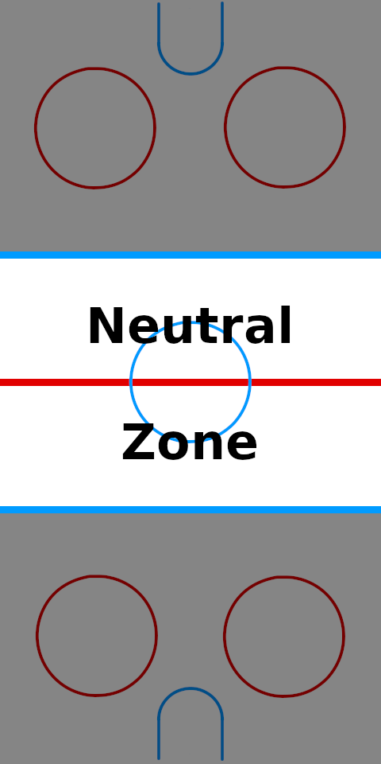

**Figure 5:** Neutral Zone

**Exhibit Session Scoring:**

A maximum score of 120 points may be earned in the Exhibit Session. Scoring details are described below.

**Overall Scoring:**

The overall score for a team will be equal to the sum of the scores for the Exhibition Session and the four Robot Time Trials. A team will be disqualified from the competition if they fail to participate in the entire Exhibition Session.

**Overall Score = Sum of the Points from all four Robot Time Trials + Exhibition Session Point Total**

**Exhibit Session**:

Prior to the Robot Time Trials, each team must participate in an exhibit session where they will create a booth to promote their project to judges, other students, and conference attendees. Each team will be supplied with a 6’ long table, a board behind the table suitable for mounting poster boards, and electrical power. The entire session is scheduled to last approximately 2 hours during the grand opening of the Exhibition Hall on Monday, June 22nd.

All participants must be present during the entire exhibit session. Teams may use posters, written documents, physical prototypes, multimedia displays, and other visual aids at their booths. In addition, each team’s robot must remain on display at their booth for the entire duration of the exhibit session. **Team members may neither work on, nor test their robots during this session.** The number of entries from a given school will be limited by the available space during the exhibit session.

Students from each team are required to visit the exhibits from all other schools. A captain from each school will score each team from other schools on a scale from 0-20 (20 being best) based upon the criteria that the judges will use. Each school will designate a single captain even if that school has multiple teams. The captains’ score will be computed by deleting the highest and lowest scores from the captains and then computing the average of the remaining scores.

The judges will visit each booth for approximately 10 minutes depending on the number of teams competing. During this visit, team members will guide the judges through their display for the first five minutes. In the second 5 minute period, the judges will ask the team questions. Each judge will score teams on a scale of 0 to 20 (20 being best) on the first five items below. The score in each category will be computed by deleting the highest and lowest scores from the judges, and then computing the average of the remaining scores.

1. Design Development:

Guide the judges through the design process that your team followed from the initial ideas to the final solution. Describe your rationale for making design decisions.

2. Robot Operation:

Discuss how your robot works.

3. Fabrication Methods:

Explain how you fabricated your robot.

4. Design Analysis:

Convince the judges that your design is optimal based upon its performance, cost, and environmental impact.

5. Exhibit Quality:

Your exhibit quality will be judged on the following items: team and exhibit appearance, technical expertise displayed, communication skills, and effectiveness of visual aids.

6. Captain Scoring:

The score from the captains will be added to the judges’ scores from the five categories above.

**Schedule of Events on the day of the competition:**

The exact schedule may vary as the competition is subject to the scheduling needs of ASEE. A typical schedule might be as follows (but look for emails from the competition organizers for any possible time changes):

6:45 am: Report to the Exhibition Hall

* Set up your team’s table
* Draw for the order of the presentations and time trials

7:00 – 9:00 am: Exhibit Session

* Judges will visit each table in the order determined by the drawing
* Team captains will visit the table of all other teams
* The track is closed during the Exhibit Session. Teams may not work on robots or test robots at this time.

9:30 am – 1:00 pm: Robot Time Trials

* Trial 1: Each team will compete in the order determined by the drawing.
* Trial 2: Each team will compete in the order determined by the drawing.
* Trial 3: Each team will compete in the order determined by the drawing.
* Trial 4: Each team will compete in the order determined by the drawing.

1:00 pm (or when the time trials end): Awards and Team Photos

**Rule Interpretation Questions:**

**Prior** to the date of the competition direct your inquiries to either of the following:

Paul Gordy Geoff Berl Clint Kohl

Tidewater Community College Monroe Community College Cedarville University

1700 College Crescent 1000 E. Henrietta Road 251 N. Main St.

Virginia Beach, VA 23453 Rochester, NY 14623 Cedarville, OH 45314

Email: [PGordy@tcc.edu](mailto:PGordy@tcc.edu) Email: [gberl001@monroecc.edu](mailto:gberl001@monroecc.edu) Email: [KOHLC@cedarville.edu](mailto:KOHLC@cedarville.edu)

**On the date of the competition:**

The judges will interpret the intent of the rules and make all decisions. If the judges determine that a team is in violation of the intent of any rule or specification, they will deduct points in proportion to the severity of the violation. All decisions by the judges are final and may not be appealed. Teams have shown respect for the judges, participants, and spectators in the past, and this positive attitude is expected from each participant this year.

**Competition Registration Questions:**

Questions related to registering for the competition should be directed to:

Paul Gordy

Tidewater Community College

1700 College Crescent

Virginia Beach, VA 23453

Phone: 757-822-7175

Email: [pgordy@tcc.edu](mailto:pgordy@tcc.edu)

Please find the entry forms on the following pages. The Interest Form should be received no later than April 1, 2020. A Registration Form for each model design team must be received no later than June 1, 2020.

**PROJECT TEAM / ENTRY LIMITATIONS:**

Each team must have at least one faculty advisor and at least 2 student members but no more than 10 student members. Each team member must primarily be enrolled in freshman or sophomore level classes. The number of entries from each school will be limited by the space available in the Exhibit Session. If a school has more than one entry then each team must represent a unique solution to the design problem. Multiple copies of the same solution are prohibited.

**ASEE ANNUAL CONVENTION PASSES:**

It is not required that student team members or faculty advisors be registered for the ASEE Annual Convention. Passes will be provided for all team members and advisors so that they can enter the conference area and exhibition area on the day of the competition. Details for obtaining passes will be made available a couple of weeks prior to the competition.

**PRACTICE SESSION:**

It is expected that two tracks will be ready for teams to practice on by Sunday morning, June 23rd. Teams should be considerate and only use the tracks for brief periods if other teams are waiting to use the tracks.

On the day of the competition the tracks will be available in the Exhibition Hall for teams to practice on prior to and following the Exhibit Session. No practice runs may be made during the Exhibit Session or after the Robot Time Trials have begun.

**AWARDS:**

First, second, and third-place teams will receive plaques.

**Revision History:**

6-11-19: First publication of the rules.

8-21-19: Results and pictures from 2019 competition added.

9-5-19: Details of goalie changed after a prototype was built by Clint Kohl at Cedarville University.

2-10-20: Correction to Figure 2 (Track Dimensions) on p. 4 – 12.5” changed to 12.375” on bottom of image.

**2020 ASEE Model Design Competition Registration Form**

Name of college/university: _______________________________________________________________

Team Name: ________________________________________________________________________

Name of faculty advisor(s): _______________________________________________________________

Mailing Address: _______________________________________________________________________

Phone: ______________________________________

Email (print clearly): _____________________________________________________________________

Student team captain: ____________________________________________________________________

Other student team members:

1. __________________________ 2. __________________________ 3. __________________________

4. __________________________ 5. __________________________ 6. __________________________

7. __________________________ 8. __________________________ 9. __________________________

Which students/advisors need badges for the convention center? (Badges are needed if you are not registered for the convention).

Circle one: **All need badges None need badges Only those listed below need badges**

Will your team require electrical power at your Exhibition Table? Circle one: **YES NO**

Please submit this form to: Paul E. Gordy

Tidewater Community College

1700 College Crescent

Virginia Beach, VA 23453

Phone: 757-822-7175

Fax: 757-822-7334

Email: [PGordy@tcc.edu](mailto:PGordy@tcc.edu)

**Return one copy of this form for each team entered by**

**June 1, 2020 (by US mail , fax, or email)**

**2020 ASEE Model Design Competition Interest Form**

Name of college/university: _______________________________________________________________

Name of faculty advisor(s): _______________________________________________________________

Mailing Address: _______________________________________________________________________

Phone: ______________________________________

Email (print clearly): _____________________________________________________________________

Number of model entries desired : _________________

Please submit this form to: Paul E. Gordy

Tidewater Community College

1700 College Crescent

Virginia Beach, VA 23453

Phone: 757-822-7175

Fax: 757-822-7334

Email: [PGordy@tcc.edu](mailto:PGordy@tcc.edu)

**Return this form by April 1, 2020 (by US mail , fax, or email)**