**ASEE 2019 Model Design Competition Printing resources:**

Print in Color on Card Stock

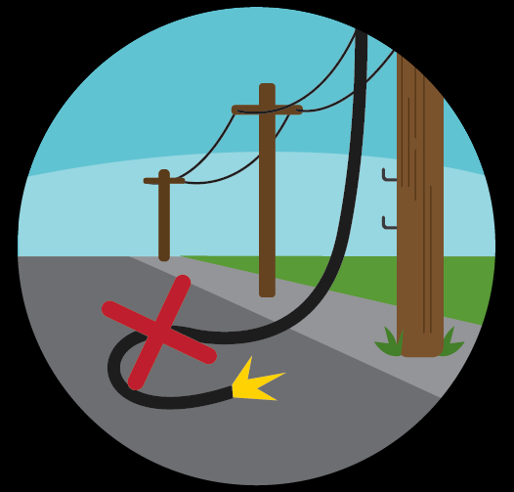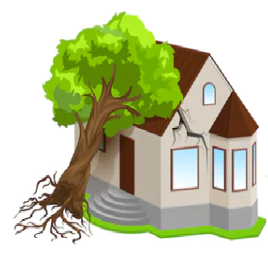

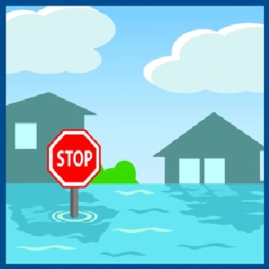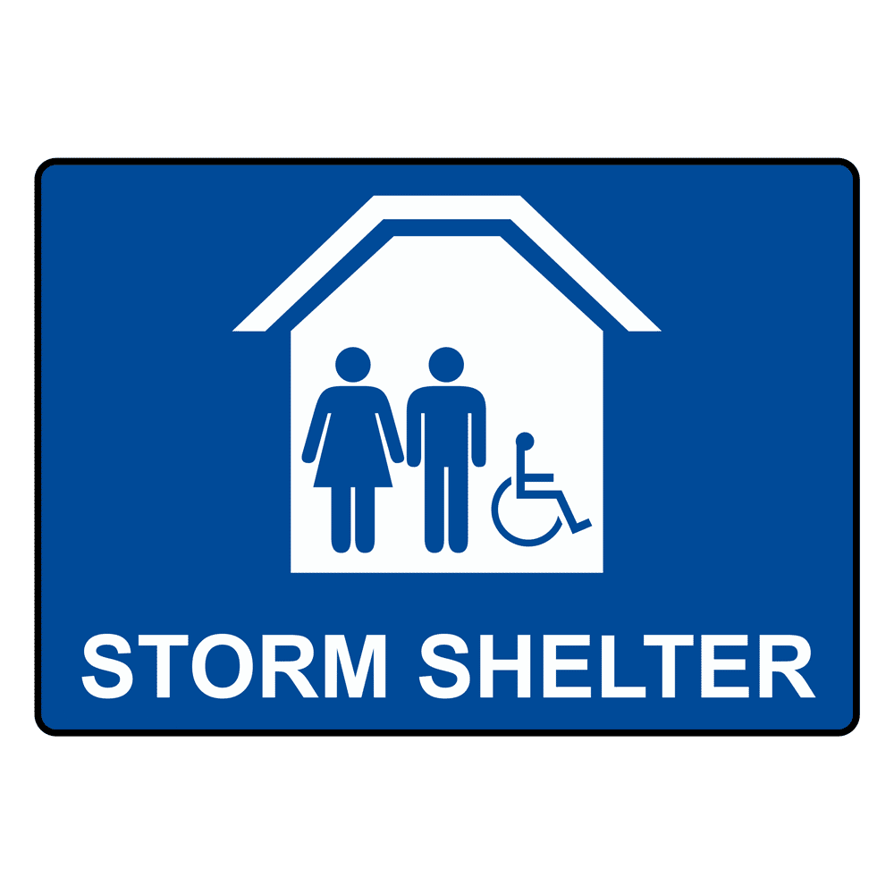

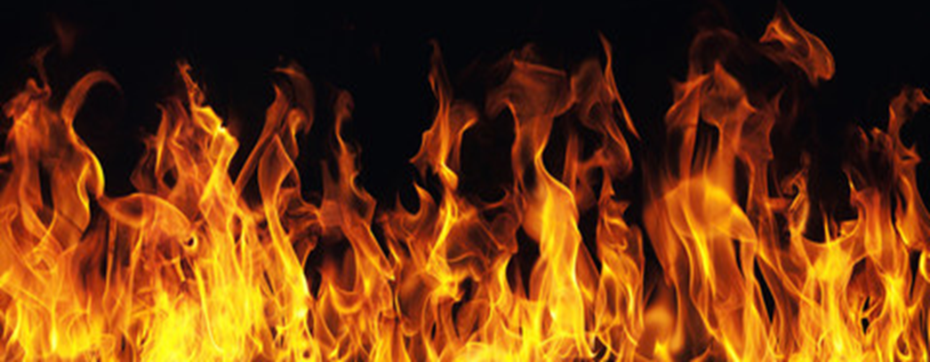



Labels to attach to the 2” x 2” boards surrounding the Field

|  |  |  |  |
| --- | --- | --- | --- |
| **A** | **B** | **C** | **D** |
| **1** | **2** | **3** | **4** |
| **5** | **6** | **7** | **8** |