2019 ASEE MODEL DESIGN COMPETITION
Sponsored by the Two Year College Division of ASEE

Date: June 20, 2018

Dear Colleague,

On behalf of the American Society for Engineering Education (ASEE) - Two Year College Division (TYCD), we invite you to encourage the submission of student design projects for the 21st Annual ASEE Lower Division MODEL DESIGN COMPETITION. This event will be held in conjunction with the 2019 ASEE Annual Convention, Tampa, Florida, June 17, 2019. This competition is open to 1st and 2nd year students at two-year and four-year colleges and universities.

As this year’s competition will be held in the Florida which has been struck by hurricanes, each student team will design and build an autonomous robot that will rescue stranded and injured residents from random locations and return them to either the hospital or storm shelter while avoiding obstacles. The robot must adhere to the rules of the model design competition (attached). An Exhibition session is included as part of the competition.

The main reason for this competition is for students to gain a better understanding of the design process from start to finish. Designing and building something from an idea is probably why they chose engineering in the first place. Use this design competition as a platform to reinforce their ideas and have some engineering fun! We hope to see you and your students' entries in Tampa.

Please find enclosed the guidelines and registration forms for this event. The interest and registration forms are on the back of this letter.

Sincerely,

Paul E. Gordy
Phone: 757-822-7175
Fax: 757-427-0327
Email: pgordy@tcc.edu

Geoff Berl
Phone: 585-502-8484
Email: gberl001@monroecc.edu

Clint Kohl
Phone: 937-766-7672
Email: KOHLC@cedarville.edu

Results from the
20th Annual ASEE Model Design Competition
June 25, 2018 - Salt Lake City, UT

The recent competition in Salt Lake City required teams to design and build an autonomous robot that can transport honey and pollen (orange and white ping pong balls) from the hive (track) to the corner pockets on the track.

10 teams competed and the results were as follows:
- 1st Place: Bumble Bee – Tidewater Community College
- 2nd Place: Buzz - Cedarville University
- 3rd Place: R2 “Bee” 2 – The Apprentice School TCC
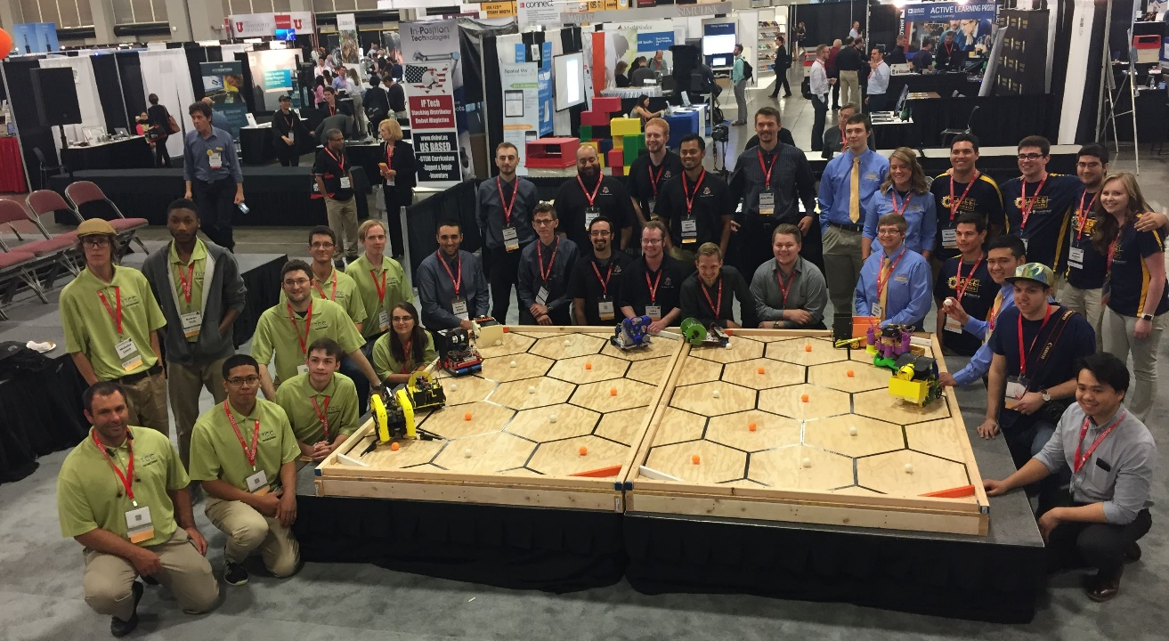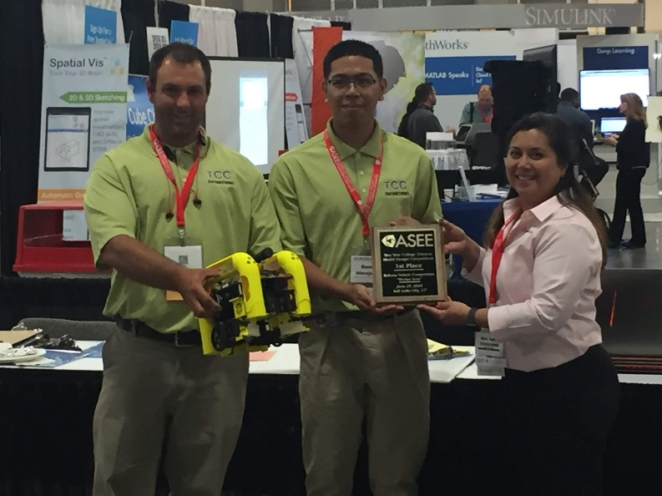
For complete results, including scores, pictures, videos, and more, visit the competition websites at
http://faculty.tcc.edu/PGordy/ASEE/index.html and at https://www.facebook.com/MCCELC .

Consider bringing a team from your college to next year’s competition on June 17, 2019 in Tampa, FL. For more information or a copy of next year’s rules, please contact Paul Gordy, pgordy@tcc.edu , 757-822-7175) or Geoff Berl, gberl001@monroecc.edu, 585-502-8484 or Clint Kohl, KOHLC@cedarville.edu (937-766-7672).
2019 ASEE TYCD MODEL DESIGN COMPETITION RULES (Revised 9-6-18)
Tampa Florida
June 17, 2019

The 21th Annual American Society for Engineering Education (ASEE) Two-Year College Division (TYCD), Model Design Competition will be held Monday, June 17, 2019 in conjunction with the ASEE Annual Convention in Tampa Florida.

Event Name: Hurricane Rescue-bots

Objective:
To design and build an autonomous robot that can rescue stranded and injured victims of a hurricane (wood peg toys) from random locations and return them to either the hospital or storm shelter while avoiding obstacles. Extinguishing a simulated fire caused by down power lines also earns bonus points. The robots will have a maximum time of 120 seconds in each of their four allotted trials. The robot must begin within an 8” X 12” X 10” high size limit but may expand to any size during a trial. An Exhibit Session will precede the robot trials.

Track Specifications:
Figure 1: First Mission Isometric View of the Track
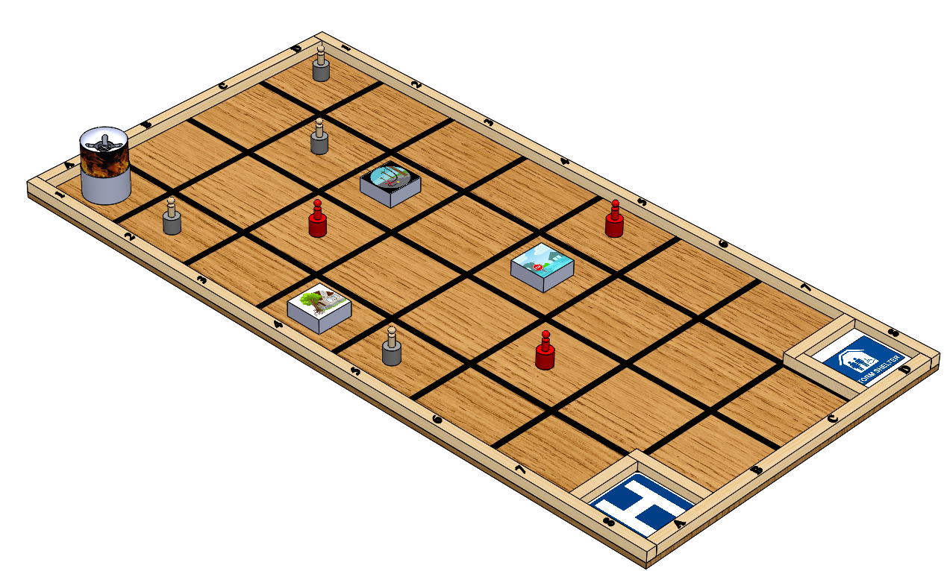

- The 3 red (injured) and 4 natural wood colored people will be placed on a 2” high by 2” diameter gray painted dowel in the center of a randomly selected coordinate square, along with 3 randomly placed obstacles and a simulated fire which is always placed in square A1.
- The robot must start anywhere completely within the two squares between the Hospital and Storm Shelter B8 or C8.

- All tape dimensions are to the centerlines of the tape.
- Each square should have fine pencil lines connecting the diagonal corners with a 2 inch circle made with a protractor in the very center. These lines help center each obstacle or pedestal.
- Although effort will be made to build the competition tracks according to specifications, participants should allow for some minor variation in dimensions due to practical construction limitations.
Figure 2: Track Dimensions

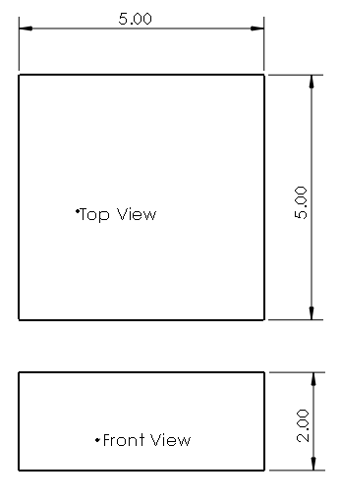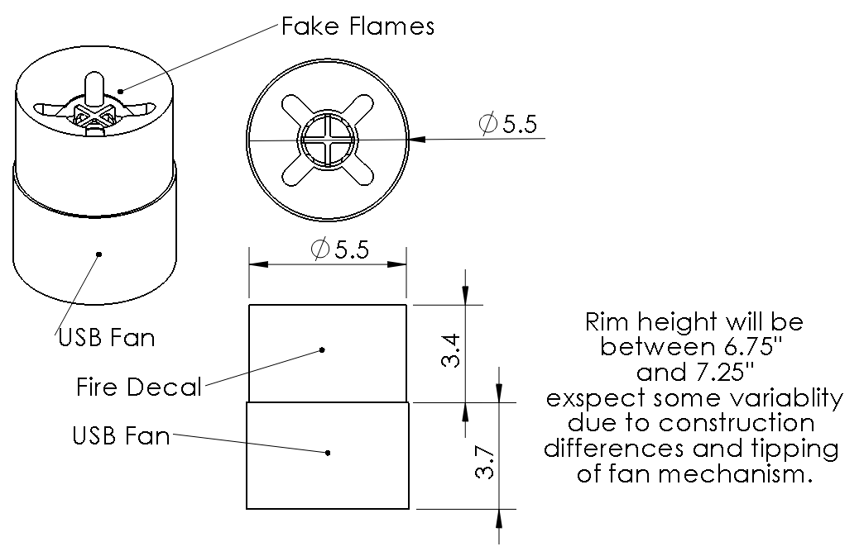

Figure 3: Styrofoam Obstacle Size Details Fake Fire Obstacle Details

Required Materials:

- One 4’ X 8’ X 3/4” sheet of BC or better grade plywood
- Seven 2” x 4” x 96” boards for the substructure (not shown)
- Three 2” x 2” x 96” boards (actual size 1.5” x 1.5” x 96”) to be cut into the following lengths:
  - 96” (2 boards for 8’ sides)
  - 45” (2 boards for 4’ ends)
- One Roll of 3/4” Wide Black Vinyl Electrical Tape
- Seven 2” dowels cut 2” in length, these will be act as pedestals.
- Three 5” x 5” by 2” thick Styrofoam insulation obstacles.
- At least 7 unfinished male shaped wooden peg dolls 2cm diameter by 6.2cm high.
- One blue standard sized Racquetball. This will be used to extinguish the fire obstacle.
- One USB Fan –Comfort Zone 4” dual powered desk fan used for fire hazard.
- Access to 3D printer – Print fire hazard parts from .stl files provided. Since the fire hazard is for show at the competition, a team could practice placing a ball in a cylinder approximately 5.5 inches Diameter and 7.1 inches high.
- One Can of Rust-Oleum Painter’s Touch 2X Gloss Spray Paint in the following color: Apple Red
- One Can of Rust-Oleum Painter’s Touch 2X Gloss Spray Paint in the following color: Dark Gray
- One Box of 2.5” or 3.0” Wood Screws (or deck screws) for substructure framing

One Box of 2” Wood Screws (or deck screws) for attaching 2x2 barriers
- One Box of 1.5” Finishing Nails for attaching the plywood to the substructure
- One container of light pine colored Sandable Wood Filler
- One package of 150 grit sandpaper
- One package of tack cloths
- One tape measure with decimal inch values (easier than working with fractions for this track)
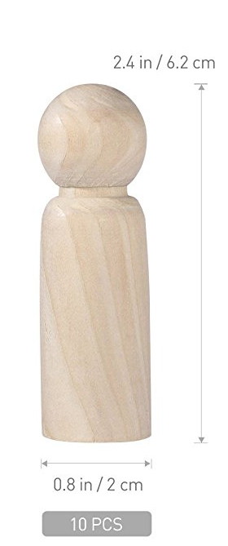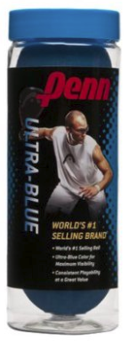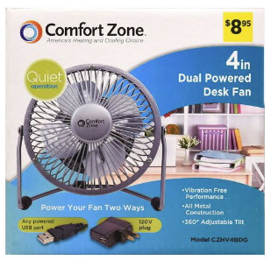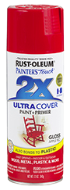
https://www.amazon.com/gp/product/B077Z3LY46/ref=ox_sc_act_title_3?smid=A1DDJSDI7E1MOJ&psc=1
https://www.amazon.com/gp/product/B002LGF9L6/ref=ox_sc_act_title_2?smid=A3K90JHFOGRITA&psc=1
https://www.dollargeneral.com/comfort-zone-dual-powered-desk-fan-4-in-assorted.html
https://www.rustoleum.com/product-catalog/consumer-brands/painters-touch-2x-ultra-cover/gloss/

Dark Orange, Light Orange and Yellow Tissue paper flames.

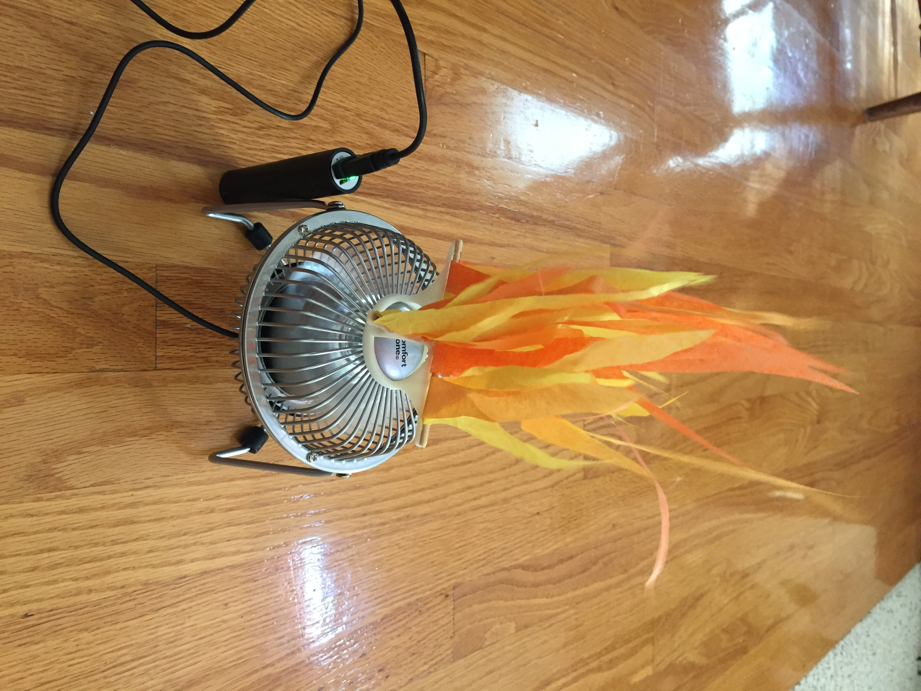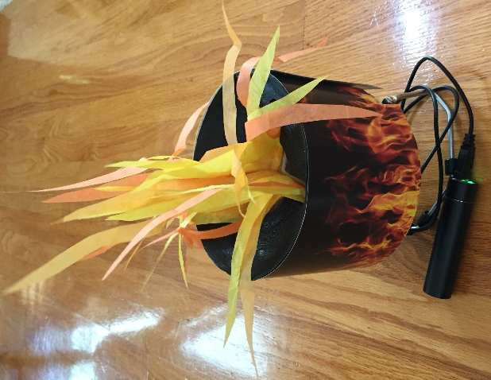
Flames on fan with support Shroud added Flames extinguished with racquetball

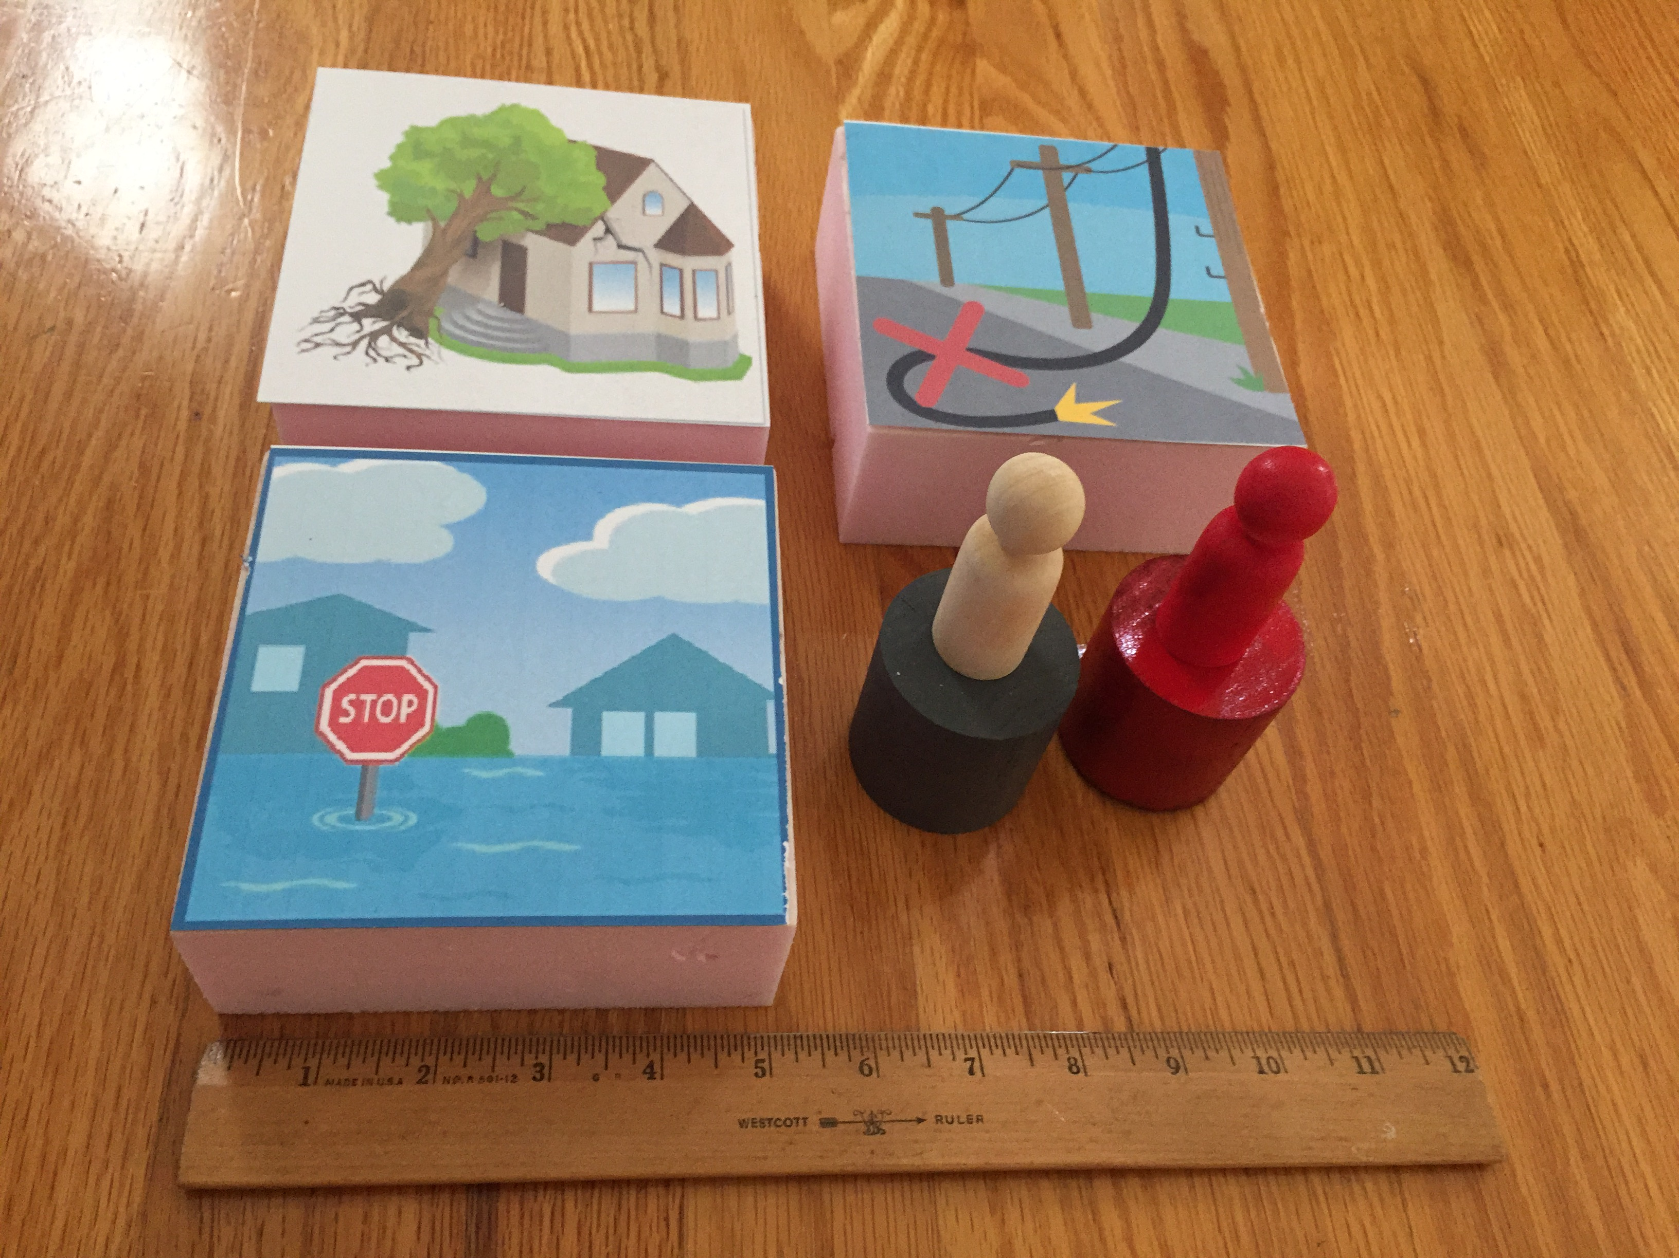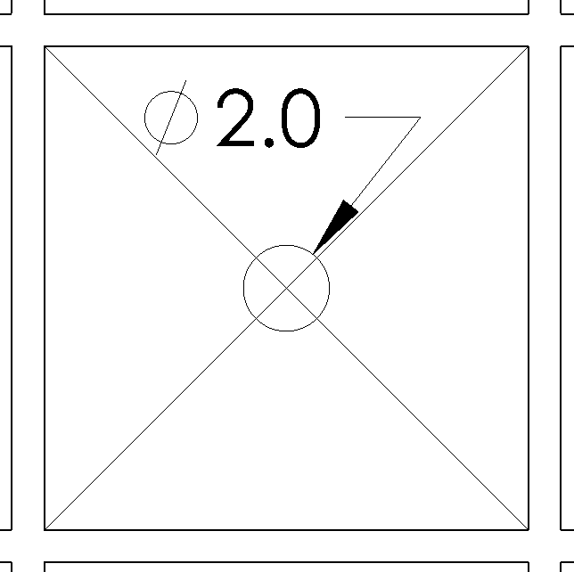
Obstacles with decals and people on 2” pedestals Light Pencil lines to help placements

Construction Procedures:

- Construct a 48” x 96” substructure using 2” x 4” boards spaced on approximately 16” centers.
- After the substructure is square, fasten the 3/4” thick plywood using 1.5” finishing nails. Set the nails and fill the holes with putty. Once the putty has dried, sand it flat.
- Do not attach the 2” x 2” boards yet as part of the black tape will be under these boards!
- Draw horizontal and vertical lines on the track according to Figure 2. With a fine mechanical pencil draw a line connecting each squares diagonal corners. At the center crossing of these diagonals use a protractor to make a center circle 2” in diameter. These lines will be used to center the pedestals and obstacles during competition.
- Apply the 3/4” wide black vinyl tape to the plywood to form each square. Note that the lines on the track correspond to the centerlines of the black tape and that no tape should be applied on the perimeter since these will be covered. Be sure not to stretch the tape during application or else the tape will lose adherence to the track over time.
- Attach the 2” x 2” boards used for the outer border of the track using 2” screws. Note that the 2” x 2” boards cover some edges of black tape.
- Use the 2” x 2” (two 10.5” and two 9”) boards to make the corner squares for the Hospital and Storm Shelter. The outside edge should be on the 12” center lines for the tape. Note ½ of the tape will be covered by these boards.
- Color print decals for all hazards on card stock and attach to the Styrofoam using double sided tape.
- Sand off any stray marks on the plywood and then dust the plywood with tack cloths.
- Assemble Fire hazard. Cut out flames from red, orange and yellow tissue paper. Use Elmer’s glue, attach dark orange, light orange and yellow tissue paper flames to a small dowel or bamboo skewer. Hot glue dowels with flames to the flame support. Place on top of fan. Cut out wrap around Flames and attach to 3-D printed Flame shroud printed in black or spray painted black. Place shroud on Fan facing straight up while carefully aligning the flame support structure under the slots in the shroud. Place Fire hazard in the center of square A1.
- Spray-paint four 2” by 2” dowels with Rust-Oleum Painter’s Touch 2X Gloss Paint in Dark Gray
- Spray-paint three 2” by 2” dowels with Rust-Oleum Painter’s Touch 2X Gloss Paint in Apple Red
- Spray-paint three of the male shaped wooden peg dolls with Rust-Oleum Painter’s Touch 2X Gloss Spray Paint in Apple Red

Robot Specifications:

Allowable Energy Sources:
Any energy source is allowed as long as it is completely contained within the robot and does not create or emit any gaseous, liquid, or solid emissions. Energy sources must not present any safety hazards to participants or spectators.

Prohibition Against Flying Robots:
Since the competition is held in a crowded Exhibition Hall with hundreds of spectators, flying robots (such as quad copters) are prohibited.

Maximum Robot Size:
The robot must fit inside a box with vertical sides having inside dimensions of 8.0” X 12.0” and have a maximum height of 10.0”. The robot may expand to any size after the start of a trial.
If a robot exceeds the size constraints the judges will assess a one-time penalty that will be deducted from their exhibit session score. The amount of this penalty will be commensurate with the degree of the oversize and the advantage this infraction would permit. Past penalties for ¼” oversize were 20pts. Entries with dimensions greater than 1” beyond those allowed will be disqualified and not able to compete in the robot time trials.

Components, Fabrication, and Cost:
Team members using materials which are commonly available to the general public must perform all fabrication. Use of commercially available vehicles, robots, or entire kits such as RC cars, Legos, K-nex, Fischer-Technics, Parallax or erector sets may not be used. The use of Lego Mindstorm microcontroller bricks are prohibited. Individual components from these cars, robots, or kits (except the Mindstorm Brick) may be integrated into a team’s robot as long as the majority of the robot’s components are not from the same car, robot, or kit source. The cost of purchasing all components must not exceed $400.

Robot Time Trial Rules:

- It is the responsibility of the team to inspect the condition of the track before starting their robot to be certain that everything is in order. Once a team presses or pulls the start mechanism, the run counts as an official trial and may not be done over.
- The order of testing will be determined by random draw. Teams will alternate on the two competition tracks making 2 rounds on each track during the complete 4 rounds of competition. For example: if during round 1 a team competes on track A, then for round 2 that team will compete on track B. Teams will be assigned their track and are not free to choose which track they run on.
- While the preceding team is on the opposite track for a trial, the on-deck team must have their robot on the other track ready to run immediately after the previous team completes their trial. Each team will have one minute to begin a trial after being called.
- All teams will be called for a trial in a current round before any teams begin the next round of testing.
- Robot sizes will be tested with the measuring box prior to each team’s first run and in subsequent runs if requested by the competition officials (judges). Team members will be responsible for placing the measuring box over their robots. If a robot fails to meet the size constraint the judges will assess a penalty proportional to the severity of the violation.

- The robot must start somewhere within squares B8 and C8. The robot may be over or touching the tape between B8 and C8 but may not be over or touching the tape bordering B7 or C7.

- A random mission will be selected using the following procedure. Using the table at the end of these instructions containing the values A1-D6, printed on card stock and cut out, and referred to as the deck of options will be placed in a container and shook. Since the fire challenge is always placed at A1, this value is removed from the deck of options. The first card randomly selected will be the position of the Tree obstacle. If the value selected is within any square touching the fire obstacle in A1 (in this case values B1, B2 or A2) this card will be returned to the container and shook again. Another card is drawn until a non-touching value is drawn. Once the tree obstacle is determined the flood and downed power line obstacles will be determined. No obstacles can be placed in adjacent squares to another obstacle to avoid a trapping situation. If this occurs the card is returned to the deck and re-drawn. Once the three random obstacles have been determined, the three red (injured) people pegs will be randomly drawn, followed by the four natural wood (stranded) people will be drawn and placed. Note that the placement of the people are drawn at random without any other considerations (they can be next to each other or next to any obstacle) and no person card is ever returned to the deck. See example missions included at the end of these rules.

- The first mission will be the one shown in Figure 1. The contest officials will use these rules to generate three additional missions prior to the completion of the poster judging session. All three missions will then be given to the team captains after the poster judging is completed and at least 30 minutes prior to the running of the first known mission.

- The robot may extend beyond the perimeter of the track during the trial as long as the robot is fully supported by the plywood track surface or the perimeter boards.

- The time for a trial will begin when the judge gives the team the command to start. Once this start command is given, a team may only activate a single switch or mechanism to start the robot. Once the robot begins to move in any way, team members may not touch the robot or send commands to control it with any remote control device.

- If a robot fails to move once the judge’s start command is given, the team members may work on their robot to get it moving but the time will continue to run from the time when the start command was given. If the robot has not moved within 120 seconds of the start command, a score of zero will be assigned for that trial.

- A trial will end when any of the following actions occur:
a. The robot becomes disabled or shows no evidence of being able to continue.
b. The robot has deposited all 3 red people to the hospital square A8 and the 4 natural wood people to the Storm Shelter D8 and has extinguished the Fire in A1. A person is considered to have been validly placed in the hospital or storm shelter if they are touching the floor and if some portion of each person is within the 4 vertical planes formed by the inside vertical walls of their respective square A8 or D8.
c. The team chooses to end their run.
d. 120 seconds elapses from the start command.

- Teams may make changes or repairs to their robots between trials but they must be ready within one minute of being called to the track.
- Teams may not make practice runs during the Exhibit Session or after the start of the Robot Time Trials.
- Note that no trials will be allowed on the last three missions since the time trials will have begun.

Robot Time Trial Scoring:

Robots will earn points by returning people to the hospital or storm shelter and extinguishing the fire in A1. In particular:

- Points earned for People in hospital and storm shelter:
  - 20 Points will be awarded for each person delivered to the storm shelter (D8) regardless of color.
  - 25 Points will be awarded only for red colored people delivered to the hospital. Natural colored people will not earn any points if delivered to the hospital square (A8).
  - Note that a maximum of 155 points can be earned if all people are properly delivered to their respective positions.

- Points earned for extinguishing the fire in A1:
- 50 points will be awarded if a blue racquetball (representing water) is deposited and remains in the fire ring obstacle.
- Penalty for moving obstacles:
- 25 points will be deducted if any obstacle including the fire is moved from its location. An obstacle will be considered moved if it is displaced more than ½” in any direction and is at the discretion of the judges to determine.
- 10 points will be deducted if a pedestal is moved from its location. A pedestal will be considered moved if the center of the square it was placed on top of is visible. The pedestals are centered on the square and therefore some displacement is permitted but if this displacement exceeds 1” thus exposing the center of the square a 10 point penalty will be given.

- Bonus points: Time Bonus Points can be earned for delivering all 3 red people to the hospital as soon as possible.
  - Time Bonus for delivering all 3 red people to the Hospital square.
Points earned = (120 – Time in seconds to deliver all 3 injured people to the hospital)
Note: There is no time bonus for un-injured people or extinguishing the fire, but these tasks must be completed before 120 seconds expire to score points.
Note that time will be rounded up to the nearest whole second for the purpose of bonus points.

Example1: All three red people were delivered to the hospital after 44.02 seconds.
Bonus points = (120-45) = 75 points.

Example 2: Two red people were delivered to the hospital after 65 seconds but the 3rd was never rescued. Since not all 3 injured people were rescued no time bonus would be awarded.

Exhibit Session Scoring:
A maximum score of 120 points may be earned in the Exhibit Session. Scoring details are described below.

Overall Scoring:
The overall score for a team will be equal to the sum of the scores for the Exhibition Session and the four Robot Time Trials. A team will be disqualified from the competition if they fail to participate in the entire Exhibition Session.

Overall Score = Sum of the Points from all four Robot Time Trials + Exhibition Session Point Total

Exhibit Session:
Prior to the Robot Time Trials, each team must participate in an exhibit session where they will create a booth to promote their project to judges, other students, and conference attendees. Each team will be supplied with a 6’ long table, a board behind the table suitable for mounting poster boards, and electrical power. The entire session is scheduled to last approximately 2 hours during the grand opening of the Exhibition Hall on Monday, June 17th.

All participants must be present during the entire exhibit session. Teams may use posters, written documents, physical prototypes, multimedia displays, and other visual aids at their booths. In addition, each team’s robot must remain on display at their booth for the entire duration of the exhibit session. Team members may neither work on, nor test their robots during this session. The number of entries from a given school will be limited by the available space during the exhibit session.

Students from each team are required to visit the exhibits from all other schools. A captain from each school will score each team from other schools on a scale from 0-20 (20 being best) based upon the criteria that the judges will use. Each school will designate a single captain even if that school has multiple teams. The captains’ score will be computed by deleting the highest and lowest scores from the captains and then computing the average of the remaining scores.

The judges will visit each booth for approximately 10 minutes depending on the number of teams competing. During this visit, team members will guide the judges through their display for the first five minutes. In the second 5 minute period, the judges will ask the team questions. Each judge will score teams on a scale of 0 to 20 (20 being best) on the first five items below. The score in each category will be computed by deleting the highest and lowest scores from the judges, and then computing the average of the remaining scores.

1. Design Development:
Guide the judges through the design process that your team followed from the initial ideas to the final solution. Describe your rationale for making design decisions.

2. Robot Operation:
Discuss how your robot works.

3. Fabrication Methods:
Explain how you fabricated your robot.

4. Design Analysis:
Convince the judges that your design is optimal based upon its performance, cost, and environmental impact.

5. Exhibit Quality:
Your exhibit quality will be judged on the following items: team and exhibit appearance, technical expertise displayed, communication skills, and effectiveness of visual aids.

6. Captain Scoring:
The score from the captains will be added to the judges’ scores from the five categories above.

Schedule of Events on the day of the competition:
The exact schedule may vary as the competition is subject to the scheduling needs of ASEE. A typical schedule might be as follows (but look for emails from the competition organizers for any possible time changes):
6:45 am: Report to the Exhibition Hall
- Set up your team’s table
- Draw for the order of the presentations and time trials
7:00 – 9:00 am: Exhibit Session
- Judges will visit each table in the order determined by the drawing
- Team captains will visit the table of all other teams
- The track is closed during the Exhibit Session. Teams may not work on robots or test robots at this time.
9:30 am – 1:00 pm: Robot Time Trials
- Trial 1: Each team will compete in the order determined by the drawing.
- Trial 2: Each team will compete in the order determined by the drawing.
- Trial 3: Each team will compete in the order determined by the drawing.
- Trial 4: Each team will compete in the order determined by the drawing.
1:00 pm (or when the time trials end): Awards and Team Photos

Rule Interpretation Questions:

Prior to the date of the competition direct your inquiries to either of the following:
Paul Gordy Geoff Berl Clint Kohl
Tidewater Community College Monroe Community College Cedarville University
1700 College Crescent 1000 E. Henrietta Road 251 N. Main St.
Virginia Beach, VA 23453 Rochester, NY 14623 Cedarville, OH 45314
Email: PGordy@tcc.edu Email: gberl001@monroecc.edu Email: KOHLC@cedarville.edu

On the date of the competition:
The judges will interpret the intent of the rules and make all decisions. If the judges determine that a team is in violation of the intent of any rule or specification, they will deduct points in proportion to the severity of the violation. All decisions by the judges are final and may not be appealed. Teams have shown respect for the judges, participants, and spectators in the past, and this positive attitude is expected from each participant this year.

Competition Registration Questions:

Questions related to registering for the competition should be directed to:

Paul Gordy
Tidewater Community College
1700 College Crescent
Virginia Beach, VA 23453
Phone: 757-822-7175
Email: pgordy@tcc.edu

Please find the entry forms on the following pages. The Interest Form should be received no later than April 1, 2019. A Registration Form for each model design team must be received no later than June 1, 2019.

PROJECT TEAM / ENTRY LIMITATIONS:

Each team must have at least one faculty advisor and at least 2 student members but no more than 10 student members. Each team member must primarily be enrolled in freshmen or sophomore level classes. The number of entries from each school will be limited by the space available in the Exhibit Session. If a school has more than one entry then each team must represent a unique solution to the design problem. Multiple copies of the same solution are prohibited.

ASEE ANNUAL CONVENTION PASSES:

It is not required that student team members or faculty advisors be registered for the ASEE Annual Convention. Passes will be provided for all team members and advisors so that they can enter the conference area and exhibition area on the day of the competition. Details for obtaining passes will be made available a couple of weeks prior to the competition.
PRACTICE SESSION:

It is expected that two tracks will be ready for teams to practice on by Sunday morning, June 16th. Teams should be considerate and only use the tracks for brief periods if other teams are waiting to use the tracks.

On the day of the competition the tracks will be available in the Exhibition Hall for teams to practice on prior to and following the Exhibit Session. No practice runs may be made during the Exhibit Session or after the Robot Time Trials have begun.

AWARDS:

First, second, and third-place teams will receive plaques.

SUNY TYESA COMPETITION

The State University of New York Two Year Engineering Science Association (SUNY TYESA) will host a design-build competition on at the end of April 2019. SUNY TYESA will use the same rules and project as the 2019 ASEE Design Competition. Teams interested in participating in the SUNY TYESA competition should contact Mark Courtney mcourtne@sunydutchess.edu or visit the SUNY TYESA website at: tyesa.org

Revision History:
6-20-18: First publication of the rules
8-24-18 2018 results added – Maximum Robot Size penalty added

2019 ASEE Model Design Competition Registration Form

Name of college/university: _______________________________________________________________

Team Name: ________________________________________________________________________

Name of faculty advisor(s): _______________________________________________________________

Mailing Address: _______________________________________________________________________

Phone: ______________________________________

Email (print clearly): _____________________________________________________________________

Student team captain: ____________________________________________________________________

Other student team members:

1. __________________________ 2. __________________________ 3. __________________________

4. __________________________ 5. __________________________ 6. __________________________

7. __________________________ 8. __________________________ 9. __________________________

Which students/advisors need badges for the convention center? (Badges are needed if you are not registered for the convention).
Circle one: All need badges None need badges Only those listed below need badges

Will your team require electrical power at your Exhibition Table? Circle one: YES NO

Please submit this form to: Paul E. Gordy
Tidewater Community College
1700 College Crescent
Virginia Beach, VA 23453
Phone: 757-822-7175
Fax: 757-822-7334
Email: PGordy@tcc.edu

Return one copy of this form for each team entered by
June 1, 2019 (by US mail , fax, or email)
2019 ASEE Model Design Competition Interest Form

Name of college/university: _______________________________________________________________

Name of faculty advisor(s): _______________________________________________________________

Mailing Address: _______________________________________________________________________

Phone: ______________________________________

Email (print clearly): _____________________________________________________________________

Number of model entries desired : _________________

Please submit this form to: Paul E. Gordy
Tidewater Community College
1700 College Crescent
Virginia Beach, VA 23453
Phone: 757-822-7175
Fax: 757-822-7334
Email: PGordy@tcc.edu

Return this form by April 1, 2019 (by US mail , fax, or email)

How first Mission was determined: Note this setup will be the first mission of the competition

Draw # | Position Drawn | Result
1 | A4 | Tree Obstacle placed at A4
2 | C5 | Flood Obstacle Placed at C5
3 | B2 | B2 is too close to Fire Obstacle and returned to deck
4 | B6 | B6 is too close to the Flood Obstacle and returned to deck
5 | C3 | Downed Power Line Obstacle Placed at C3
6 | B3 | Red person placed at B3
7 | B6 | Red person placed at B6
8 | D5 | Red person placed at D5
9 | A5 | Unpainted natural wood person placed at A5
10 | D1 | Unpainted natural wood person placed at D1
11 | C2 | Unpainted natural wood person placed at C2
12 | A2 | Unpainted natural wood person placed at A2

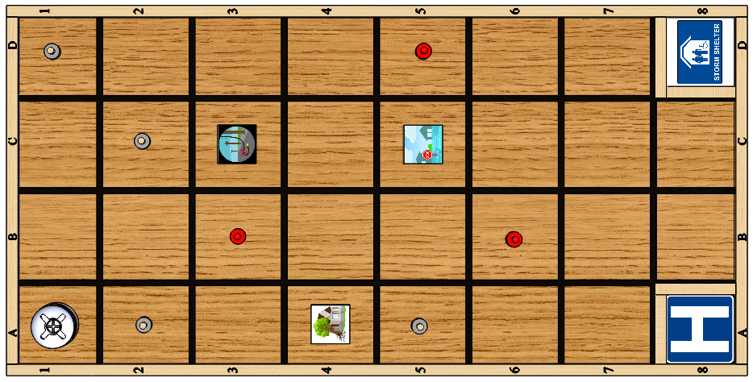
First Mission Setup

Example Random Mission Note: Three random missions will be created at the competition in Tampa.

Draw # | Position Drawn | Result
1 | D6 | Tree Obstacle placed at D6
2 | C5 | C5 is too close to the Tree Obstacle at D6 and is returned to deck
3 | A5 | Flood Obstacle Placed at A5
4 | C1 | Downed Power Line Obstacle Placed at C1
5 | D2 | Red person placed at D2
6 | B5 | Red person placed at B5
7 | D1 | Red person placed at D1
8 | C4 | Unpainted natural wood person placed at C4
9 | B3 | Unpainted natural wood person placed atB3
10 | C5 | Unpainted natural wood person placed at C5
11 | A2 | Unpainted natural wood person placed at A2

