2018 ASEE MODEL DESIGN COMPETITION
Sponsored by the Two Year College Division of ASEE

Date: June 21, 2017

Dear Colleague,

On behalf of the American Society for Engineering Education (ASEE) - Two Year College Division (TYCD), we invite you to encourage the submission of student design projects for the 20th Annual ASEE Lower Division MODEL DESIGN COMPETITION. This event will be held in conjunction with the 2018 ASEE Annual Convention, Salt Lake City, UT, June 24-27, 2018. This competition is open to 1st and 2nd year students at two-year and four-year colleges and universities.

As this year’s competition will be held in the Beehive State, each student team will design and build an autonomous robot that collects honey (orange and white ping pong balls) from the track (hive) and deliver them to specified locations. The robot must adhere to the rules of the model design competition (attached). An Exhibition session is included as part of the competition.

The main reason for this competition is for students to gain a better understanding of the design process from start to finish. Designing and building something from an idea is probably why they chose engineering in the first place. Use this design competition as a platform to reinforce their ideas and have some engineering fun! We hope to see you and your students' entries in Salt Lake City.

Please find enclosed the guidelines and registration forms for this event. The interest and registration forms are on the back of this letter.

Sincerely,

Paul E. Gordy
Phone: 757-822-7175
Fax: 757-427-0327
Email: pgordy@tcc.edu

Geoff Berl
Phone: 585-502-8484
Email: gberl001@monroecc.edu

Results from the
19th Annual ASEE Model Design Competition
June 26, 2017 - Columbus, OH

The recent competition in Columbus required teams to design and build an autonomous robot that can transport one blue barrel from Spain to each of 6 islands visited by Christopher Columbus and return one red barrel from each island to Spain on a specified track within 90 seconds.

xx teams competed and the results were as follows:
- 1st Place: xxxxxxxxxxxxxxxx
- 2nd Place: xxxxxxxxxxxxxxxx
- 3rd Place: xxxxxxxxxxxxxxxx

(Add photos)

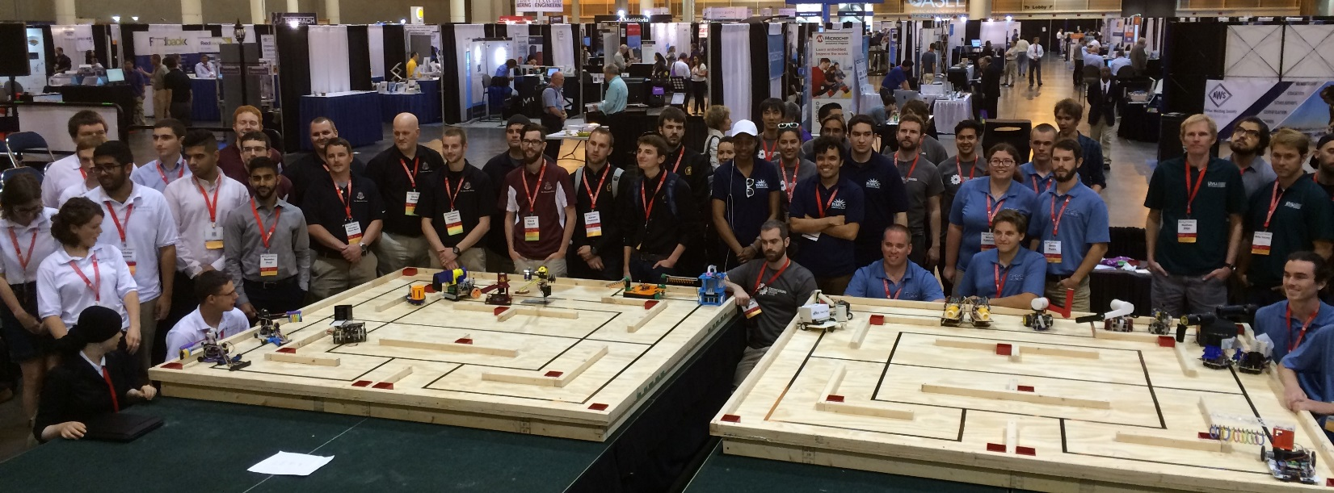

For complete results, including scores, pictures, videos, and more, visit the competition websites at
http://faculty.tcc.edu/PGordy/ASEE/index.html and at https://www.facebook.com/MCCELC .

Consider bringing a team from your college to next year’s competition on June 25, 2018 in Salt Lake City, UT. For more information or a copy of next year’s rules, please contact Paul Gordy, pgordy@tcc.edu ,
757-822-7175) or Geoff Berl, gberl001@monroecc.edu, 585-502-8484.
2018 ASEE TYCD MODEL DESIGN COMPETITION RULES (Revised 6-21-17)
Salt Lake City, UT
June 25, 2018

The 20th Annual American Society for Engineering Education (ASEE) Two-Year College Division (TYCD), Model Design Competition will be held Monday, June 25, 2018 in conjunction with the ASEE Annual Convention in Salt Lake City, UT.

Event Name: Worker Bots

Objective:
To design and build an autonomous robot that can transport honey (orange and white ping pong balls) from the hive (track) to the corner pockets on the track. The robots will have a maximum time of 120 seconds in each of their four allotted trials. The robot must begin within an 8” X 12” X 10” high size limit but may expand to any size during a trial. An Exhibit Session will precede the robot trials.

Track Specifications:
Figure 1: Isometric View of the Track
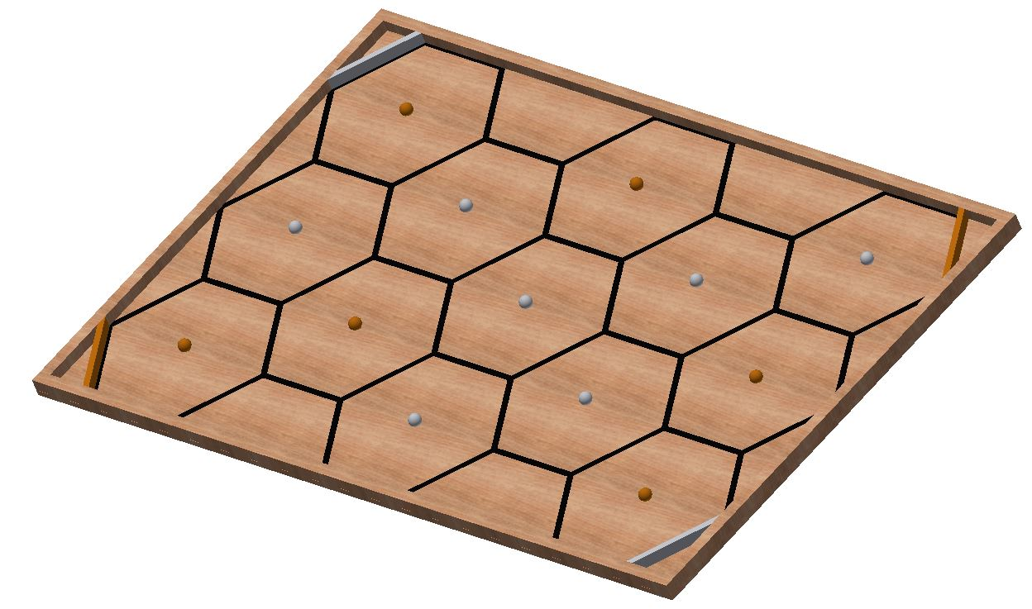
- The 7 white ping pong balls and the 6 orange ping pong balls will be placed randomly in the center of each of the 13 hexagons on the track just before each trial begins.
- The robot may start in any location as long as it is touching an outer wall (including the white and orange pocket borders.
- The orange and white pocket borders must be arranged as shown.

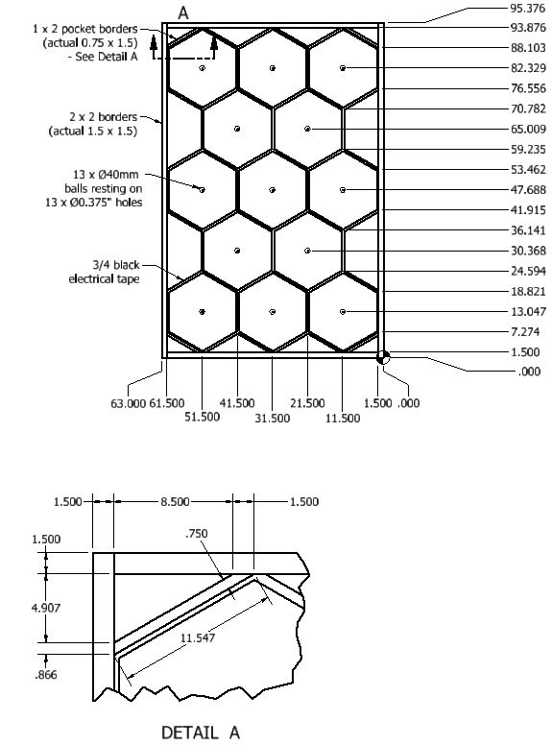
Figure 2: Track Dimensions

- All tape dimensions are to the centerlines of the tape.
- The 13 holes (0.375” diameter) are centered within each hexagon. The holes may be drilled partially or completely through the track.
- When the orange and white pocket borders are painted, care should be taken that they are arranged as shown in Figure 1.
- Although effort will be made to build competition tracks according to specifications, participants should allow for some minor variation in dimensions due to practical construction limitations.
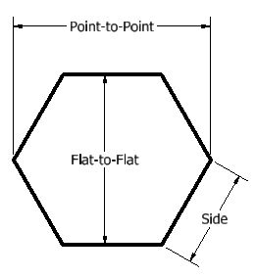
Figure 3: (Hexagon geometry)

Figure 4: Pictures of ping pong balls in a corner pocket
The pictures below illustrate that 7 ping pong balls can fit it the bottom of a corner pocket. It would be challenging to put all 13 ping pong balls in one pocket, but it is possible.

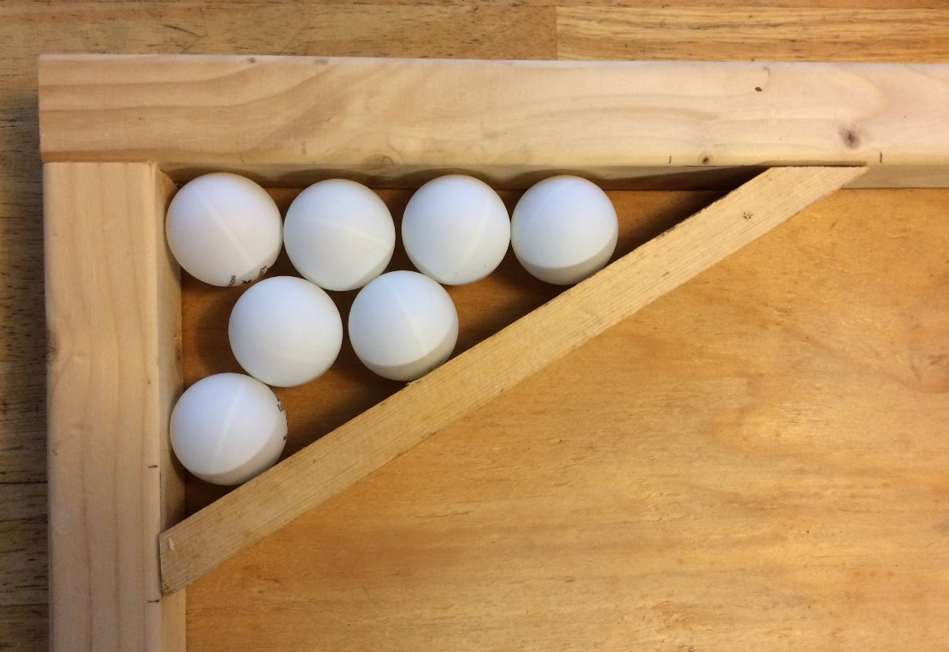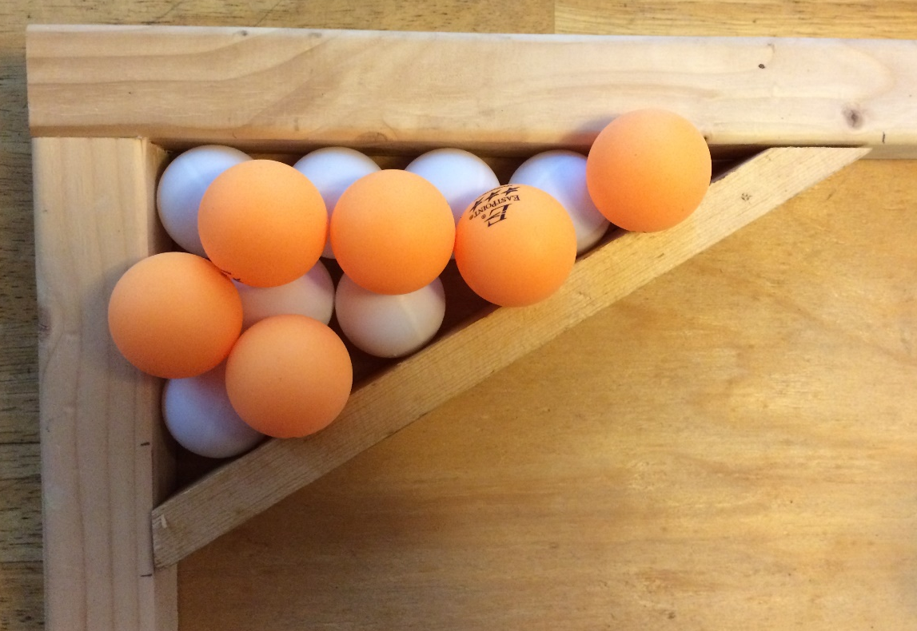

Required Materials:

- Two 4’ X 8’ X 3/4” sheets of BC or better grade plywood to be cut into the following lengths:
  - 48” x 95.376” (1 board)
  - 15” x 95.376” (1 board)
- Two 2” x 4” x 96” boards for the substructure (not shown)
- Five 2” x 4” x 93” boards for the substructure (not shown) to be cut into the following lengths:
  - 93” (3 boards)
  - 60” (2 boards)
- Four 2” x 2” x 96” boards (actual size 1.5” x 1.5” x 96”) to be cut into the following lengths:
  - 96” (2 boards)
  - 60” (2 boards)
- Four 1” x 2” x 96” boards (actual size 0.75” x 1.5” x 96”) to be cut into the following lengths:
  - 11.547” (4 boards cut at angle for corner pockets)
- One Roll of 3/4” Wide Black Vinyl Tape
- One box of 6 orange table tennis balls (Eastpoint 3-Star 40mm) from Walmart. See image below.
- Two boxes of 6 white table tennis balls (Eastpoint 3-Star 40mm) from Walmart.
Note: Earlier, the ping pong ball use to be 38 mm in diameter which has now been revised and standardized to 40 mm. A 3-star rating for the ball indicates that its bounce and roundness are consistent. The weight of a ping pong ball should be 2.7 g. http://www.ibuzzle.com/articles/ping-pong-table-size.html
- One Can of Rust-Oleum Painter’s Touch 2X Gloss Spray Paint in the following color: Real Orange
- One Can of Rust-Oleum Painter’s Touch 2X Gloss Spray Paint in the following color: White
- One Box of 2.5” or 3.0” Wood Screws (or deck screws) for substructure framing

One Box of 2” Wood Screws (or deck screws) for attaching 2x2 barriers
- One Box of 1.5” Finishing Nails for attaching the plywood to the substructure
- One container of light pine colored Sandable Wood Filler
- One package of 150 grit sandpaper
- One package of tack cloths
- One tape measure with decimal inch values (easier than working with fractions for this track)
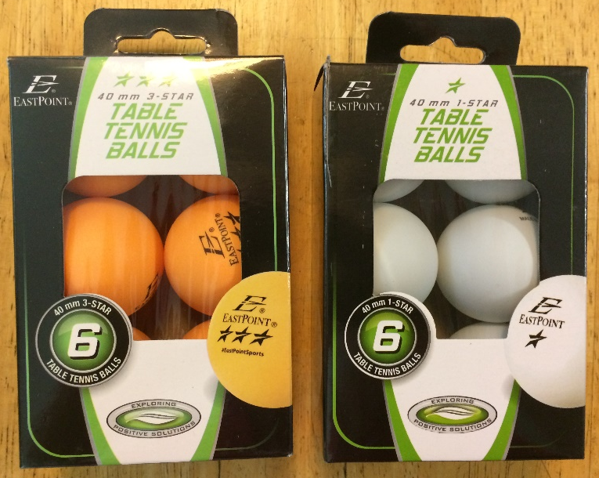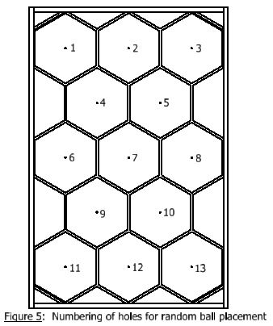
Construction Procedures:

- Construct a 63” x 95.376” substructure using 2” x 4” boards spaced approximately 16” centers (or use 63” x 96” and let the substructure extend the extra amount). Be sure that one of the 2x4’s will be under the seam between the two pieces of plywood.
- Cut two pieces of plywood to 48” x 95.376” and 15” x 95.376” (or use 48” x 96” and 15” x 96”) and let the plywood extend by a small amount past one of the track outer 2x2 barriers.
- After the substructure is square, fasten the 3/4” thick plywood using 1.5” finishing nails. Set the nails and fill the holes with putty. Once the putty has dried, sand it flat.
- Do not attach the 2” x 2” boards yet as part of the black tape will be under these boards!
- Draw horizontal and vertical lines on the track according to Figure 2. Use the intersections of these lines to draw each hexagon. Using a decimal-inch tape measure is recommended.
- Apply the 3/4” wide black vinyl tape to the plywood to form the black hexagons. Note that the lines on the track correspond to the centerlines of the black tape. Be sure not to stretch the tape during application or else the tape will lose adherence to the track over time.
- Drill one 0.375” hole in the center of each hexagon. The hole may go partially or all the way through the plywood.
- Attach the 2” x 2” boards used for the outer border of the track using 2” screws. Note that the 2” x 2” boards cover half of the black tape in many cases.
- Use Detail A on Figure 2 to mark where the 1” x 2” pocket border boards will intersect the 2” x 2” border. Lay the 1” x 2” boards on top of the border using the marks made and then mark where to make the angled cuts in the 1” x 2” board. Cut one board and test it for fit. Once the fit is correct, use it as a template for the remaining 3 pocket borders.
- Paint two of the pocket board boards white and the other two orange using the specified paint.
- Attach the 1” x 2” pocket corner boards using 2” screws. Be sure to attach them based on the order shown in Figure 1. The order is critical.
- Sand off any stray marks on the plywood and then dust the plywood with tack cloths.

Robot Specifications:

Allowable Energy Sources:
Any energy source is allowed as long as it is completely contained within the robot and does not create or emit any gaseous, liquid, or solid emissions. Energy sources must not present any safety hazards to participants or spectators.

Prohibition Against Flying Robots:
Since the competition is held in a crowded Exhibition Hall with hundreds of spectators, flying robots (such as quad copters) are prohibited.

Maximum Robot Size:
The robot must fit inside a box with vertical sides having inside dimensions of 8.0” X 12.0” and have a maximum height of 10.0”. The robot may expand to any size after the start of a trial.

Components, Fabrication, and Cost:
Team members using materials which are commonly available to the general public must perform all fabrication. Use of commercially available vehicles, robots, or entire kits such as RC cars, Legos, K-nex, Fischer-Technics, Parallax or erector sets may not be used. The use of Lego Mindstorm microcontroller bricks are prohibited. Individual components from these cars, robots, or kits (except the Mindstorm Brick) may be integrated into a team’s robot as long as the majority of the robot’s components are not from the same car, robot, or kit source. The cost of purchasing all components must not exceed $400.

Robot Time Trial Rules:

- It is the responsibility of the team to inspect the condition of the track before starting their robot to be certain that everything is in order. Once a team presses or pulls the start mechanism, the run counts as an official trial and may not be done over.
- The order of testing will be determined by random draw.
- While the preceding team is on the track for a trial, the on-deck team must have their robot on the on-deck table ready to run immediately after the previous team completes their trial. Each team will have one minute to begin a trial after being called.
- All teams will be called for a trial in a current round before any teams begin the next round of testing.
- Robot sizes will be tested with the measuring box prior to each team’s first run and in subsequent runs if requested by the competition officials (judges). Team members will be responsible for placing the measuring box over their robots. If a robot fails to meet the size constraint the judges will assess a penalty proportional to the severity of the violation.

- The team must place their robot on the track before the judges place the balls on the track in random order. The robot may be placed anywhere on the track so that it is touching one of the 1” x 2” or 2”x2” borders.

- The 6 orange balls and the 7 white balls will be provided by the judges. The judges will draw the balls one at a time randomly from a bag or box and place them on the track in order on holes 1-13 shown in Figure 5. Each team should inspect the placement of the balls to be sure that they are satisfied with their position on the holes before each trial. The team is not allowed to convey the color distribution of the orange and white balls through any mechanical, electrical, wireless, or other means to the robot. The robot must not know the color distribution of the balls before the trial begins.

- The ping pong balls or the track cannot be damaged or modified in any way by the team or the robot.

- The robot cannot deposit anything into any corner pocket or on top of any corner pocket except ping pong balls or else no points will be earned for the balls in that pocket.

- The robot may extend beyond the perimeter of the track during the trial as long as the robot is fully supported by the plywood track surface or the perimeter boards.

- The time for a trial will begin when the judge gives the team the command to start. Once this start command is given, a team may only activate a single switch or mechanism to start the robot. Once the robot begins to move in any way, team members may not touch the robot or communicate with it with any remote control device.

- If a robot fails to move once the judge’s start command is given, the team members may work on their robot to get it moving but the time will continue to run from the time when the start command was given. If the robot has not moved within 120 seconds of the start command, a score of zero will be assigned for that trial.

- A trial will end when any of the following actions occur:
a. The robot becomes disabled or shows no evidence of being able to continue.
b. The robot has deposited all 13 balls in any of the 4 corner pockets. A ball is considered to have been validly placed in a pocket if all balls are at rest and if some portion of each ball is within the 3 vertical planes formed by the inside vertical walls of one of the pockets. As an example, note that the 13 balls shown in Figure 4 are valid.
c. 120 seconds elapses from the start command.

- Teams may make changes or repairs to their robots between trials but they must be ready within one minute of being called to the track.
- Teams may not make practice runs during the Exhibit Session or after the start of the Robot Time Trials.

Robot Time Trial Scoring:

Robots will earn points by depositing ping pong balls in corner pockets on the track. In particular:

- Points earned for balls to pockets:
  - 10 Points will be awarded for each ball delivered to a pocket of the same color (a white ball to a white pocket or an orange ball to an orange pocket).
  - 5 Points will be awarded for each ball delivered to a pocket of the wrong color (a white ball to an orange pocket or an orange ball to a white pocket).
  - Note that a maximum of 130 points can be earned if all 13 balls are delivered to a pocket of the correct color.

- Bonus points: Time Bonus Points can be earned for delivering all 13 balls to pockets in under 120 seconds as follows:
  - Time Bonus for delivering all 13 balls to correct colored pockets:
Points earned = (120 – Time in seconds to complete the run)
  - Time Bonus for delivering all 13 balls with 1 or more balls not in a correct colored pocket:
Points earned = (120 – Time in seconds to complete the run)/2
Note that time will be rounded up to the nearest whole second for the purpose of bonus points.
Example: A time of 66.02 s will be rounded up to 67 s.

Exhibit Session Scoring:
A maximum score of 120 points may be earned in the Exhibit Session. Scoring details are described below.

Overall Scoring:
The overall score for a team will be equal to the sum of the scores for the Exhibition Session and the four Robot Time Trials. A team will be disqualified from the competition if they fail to participate in the entire Exhibition Session.

Overall Score = Sum of the Points from all four Robot Time Trials + Exhibition Session Point Total

Exhibit Session:
Prior to the Robot Time Trials, each team must participate in an exhibit session where they will create a booth to promote their project to judges, other students, and conference attendees. Each team will be supplied with a 6’ long table, a board behind the table suitable for mounting poster boards, and electrical power. The entire session is scheduled to last approximately 2 hours during the grand opening of the Exhibition Hall on Monday, June 25th.

All participants must be present during the entire exhibit session. Teams may use posters, written documents, physical prototypes, multimedia displays, and other visual aids at their booths. In addition, each team’s robot must remain on display at their booth for the entire duration of the exhibit session. Team members may neither work on, nor test their robots during this session. The number of entries from a given school will be limited by the available space during the exhibit session.

Students from each team are required to visit the exhibits from all other schools. A captain from each school will score each team from other schools on a scale from 0-20 (20 being best) based upon the criteria that the judges will use. Each school will designate a single captain even if that school has multiple teams. The captains’ score will be computed by deleting the highest and lowest scores from the captains and then computing the average of the remaining scores.

The judges will visit each booth for approximately 10 minutes depending on the number of teams competing. During this visit, team members will guide the judges through their display for the first five minutes. In the second 5 minute period, the judges will ask the team questions. Each judge will score teams on a scale of 0 to 20 (20 being best) on the first five items below. The score in each category will be computed by deleting the highest and lowest scores from the judges, and then computing the average of the remaining scores.

1. Design Evolution:
Guide the judges through the design process that your team followed from the initial ideas to the final solution. Describe your rationale for making design decisions.

2. Robot Operation:
Discuss how your robot works.

3. Fabrication Methods:
Explain how you fabricated your robot.

4. Design Analysis:
Convince the judges that your design is optimal based upon its performance, cost, and environmental impact.

5. Exhibit Quality:
Your exhibit quality will be judged on the following items: team and exhibit appearance, technical expertise displayed, communication skills, and effectiveness of visual aids.

6. Captain Scoring:
The score from the captains will be added to the judges’ scores from the five categories above.

Schedule of Events on the day of the competition:
The exact schedule may vary as the competition is subject to the scheduling needs of ASEE. A typical schedule might be as follows (but look for emails from the competition organizers for any possible time changes):
6:45 am: Report to the Exhibition Hall
- Set up your team’s table
- Draw for the order of the presentations and time trials
7:00 – 9:00 am: Exhibit Session
- Judges will visit each table in the order determined by the drawing
- Team captains will visit the table of all other teams
- The track is closed during the Exhibit Session. Teams may not work on robots or test robots at this time.
9:30 am – 1:00 pm: Robot Time Trials
- Trial 1: Each team will compete in the order determined by the drawing.
- Trial 2: Each team will compete in the order determined by the drawing.
- Trial 3: Each team will compete in the order determined by the drawing.
- Trial 4: Each team will compete in the order determined by the drawing.
1:00 pm (or when the time trials end): Awards and Team Photos

Rule Interpretation Questions:

Prior to the date of the competition direct your inquiries to either of the following:
Paul Gordy Geoff Berl
Tidewater Community College Monroe Community College
1700 College Crescent 1000 E. Henrietta Road
Virginia Beach, VA 23453 Rochester, NY 14623
Email: PGordy@tcc.edu Email: gberl001@monroecc.edu

On the date of the competition:
The judges will interpret the intent of the rules and make all decisions. If the judges determine that a team is in violation of the intent of any rule or specification, they will deduct points in proportion to the severity of the violation. All decisions by the judges are final and may not be appealed. Teams have shown respect for the judges, participants, and spectators in the past, and this positive attitude is expected from each participant this year.

Competition Registration Questions:

Questions related to registering for the competition should be directed to:

Paul Gordy
Tidewater Community College
1700 College Crescent
Virginia Beach, VA 23453
Phone: 757-822-7175
Email: pgordy@tcc.edu

Please find the entry forms on pages 11 and 12. The Interest Form should be received no later than April 1, 2018. A Registration Form for each model design team must be received no later than June 1, 2018.

PROJECT TEAM / ENTRY LIMITATIONS:

Each team must have at least one faculty advisor and at least 2 student members but no more than 10 student members. Each team member must primarily be enrolled in freshmen or sophomore level classes. The number of entries from each school will be limited by the space available in the Exhibit Session. If a school has more than one entry then each team must represent a unique solution to the design problem. Multiple copies of the same solution are prohibited.

ASEE ANNUAL CONVENTION PASSES:

It is not required that student team members or faculty advisors be registered for the ASEE Annual Convention. Passes will be provided for all team members and advisors so that they can enter the conference area and exhibition area on the day of the competition. Details for obtaining passes will be made available a couple of weeks prior to the competition.
PRACTICE SESSION:

It is expected that two tracks will be ready for teams to practice on by Sunday morning, June 25th. Teams should be considerate and only use the tracks for brief periods if other teams are waiting to use the tracks.

On the day of the competition the tracks will be available in the Exhibition Hall for teams to practice on prior to and following the Exhibit Session. No practice runs may be made during the Exhibit Session or after the Robot Time Trials have begun.

AWARDS:

First, second, and third-place teams will receive plaques.

SUNY TYESA COMPETITION

The State University of New York Two Year Engineering Science Association (SUNY TYESA) will host a design-build competition on at the end of April 2018. SUNY TYESA will use the same rules and project as the 2018 ASEE Design Competition. Teams interested in participating in the SUNY TYESA competition should contact Mark Courtney mcourtne@sunydutchess.edu or visit the SUNY TYESA website at: tyesa.org

Revision History:
6-12-17: First publication of the rules
6-21-17: Items 8 and 9 were added under Robot Time Trial Rules.
Names of competition organizers changed from Paul Gordy and John Wadach to Paul Gordy and Geoff Berl.

2018 ASEE Model Design Competition Registration Form

Name of college/university: _______________________________________________________________

Team Name: ________________________________________________________________________

Name of faculty advisor(s): _______________________________________________________________

Mailing Address: _______________________________________________________________________

Phone: ______________________________________

Email (print clearly): _____________________________________________________________________

Student team captain: ____________________________________________________________________

Other student team members:

1. __________________________ 2. __________________________ 3. __________________________

4. __________________________ 5. __________________________ 6. __________________________

7. __________________________ 8. __________________________ 9. __________________________

Which students/advisors need badges for the convention center? (Badges are needed if you are not registered for the convention).
Circle one: All need badges None need badges Only those listed below need badges

Will your team require electrical power at your Exhibition Table? Circle one: YES NO

Please submit this form to: Paul E. Gordy
Tidewater Community College
1700 College Crescent
Virginia Beach, VA 23453
Phone: 757-822-7175
Fax: 757-822-7334
Email: PGordy@tcc.edu

Return one copy of this form for each team entered by
June 1, 2018 (by US mail , fax, or email)
2018 ASEE Model Design Competition Interest Form

Name of college/university: _______________________________________________________________

Name of faculty advisor(s): _______________________________________________________________

Mailing Address: _______________________________________________________________________

Phone: ______________________________________

Email (print clearly): _____________________________________________________________________

Number of model entries desired : _________________

Please submit this form to: Paul E. Gordy
Tidewater Community College
1700 College Crescent
Virginia Beach, VA 23453
Phone: 757-822-7175
Fax: 757-822-7334
Email: PGordy@tcc.edu

Return this form by April 1, 2018 (by US mail , fax, or email)

