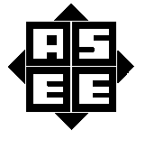
2017 ASEE MODEL DESIGN COMPETITION
Sponsored by the Two Year College Division of ASEE

Date: June 17, 2016

Dear Colleague,

On behalf of the American Society for Engineering Education (ASEE) - Two Year College Division (TYCD), we invite you to encourage the submission of student design projects for the 19th Annual ASEE Lower Division MODEL DESIGN COMPETITION. This event will be held in conjunction with the 2017 ASEE Annual Convention, Columbus, OH, June 25-28, 2017. This competition is open to 1st and 2nd year students at two-year and four-year colleges and universities.

In this year’s competition student teams will design and build an autonomous robot that will follow Columbus’ path from Spain to various Caribbean islands dropping off goods (barrels) and picking up other goods to return to Spain. The robot must adhere to the rules of the model design competition (attached). An Exhibition session is included as part of the competition.

The main reason for this competition is for students to gain a better understanding of the design process from start to finish. Designing and building something from an idea is probably why they chose engineering in the first place. Use this design competition as a platform to reinforce their ideas and have some engineering fun! We hope to see you and your students' entries in Columbus.

Please find enclosed the guidelines and registration forms for this event. The interest and registration forms are on the back of this letter.

Sincerely,

Paul E. Gordy
Phone: 757-822-7175
Fax: 757-427-0327
Email: pgordy@tcc.edu

John Wadach
Phone: 585-292-2488
Email: jwadach@monroecc.edu

Results from the
18th Annual ASEE Model Design Competition
June 27, 2016 - New Orleans, LA

The recent competition in New Orleans required teams to design and build an autonomous robot that can deposit jewelry (rings) to one dozen boxes along the parade route on a specified track within 90 seconds.

16 teams competed and the results were as follows:
- 1st Place: Tidewater Community College – Chesapeake, VA
- 2nd Place: Tidewater Community College – Virginia Beach, VA
- 3rd Place: Cedarville University – Cedarville, OH
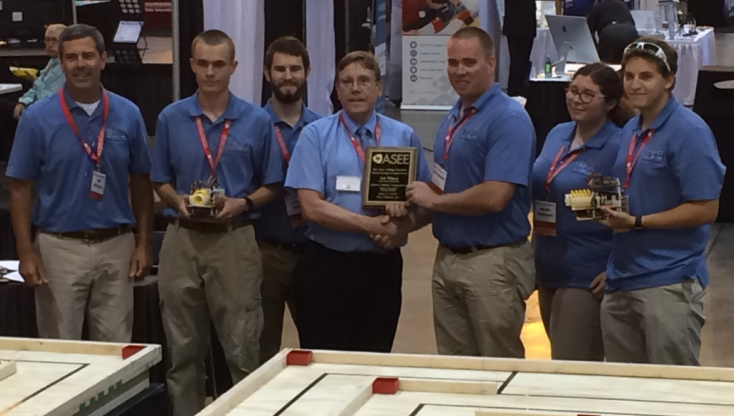

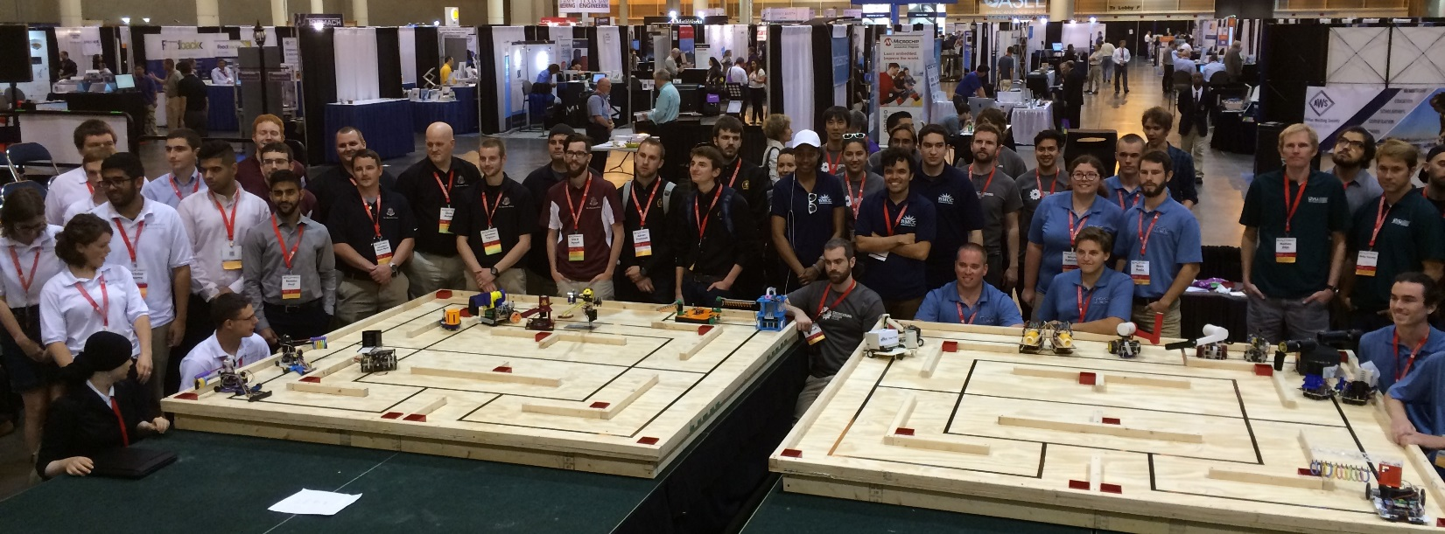

For complete results, including scores, pictures, videos, and more, visit the competition websites at
http://faculty.tcc.edu/PGordy/ASEE/index.html and at https://www.facebook.com/MCCELC .

Consider bringing a team from your college to next year’s competition on June 26, 2017 in Columbus, OH. For more information or a copy of next year’s rules, please contact Paul Gordy, pgordy@tcc.edu ,
757-822-7175) or John Wadach, Jwadach@monroecc.edu , 585-292-2488).
2017 ASEE TYCD MODEL DESIGN COMPETITION RULES (Revised 6-17-16)
Columbus, Ohio
June 26, 2017

The 19th Annual American Society for Engineering Education (ASEE) Two-Year College Division (TYCD), Model Design Competition will be held Monday, June 26, 2017 in conjunction with the ASEE Annual Convention in Columbus, Ohio.

Event Name: Columbots

Objective:
To design and build an autonomous robot that can transport one blue barrel from Spain to each of 6 islands visited by Christopher Columbus and return one red barrel from each island to Spain. The robots will have a maximum time of 90 seconds in each of their four allotted trials. The robot must begin within an 8” X 12” X 10” high size limit but may expand to any size during a trial. An Exhibit Session will precede the robot trials.

Track Specifications:
Figure 1: Isometric View of the Track
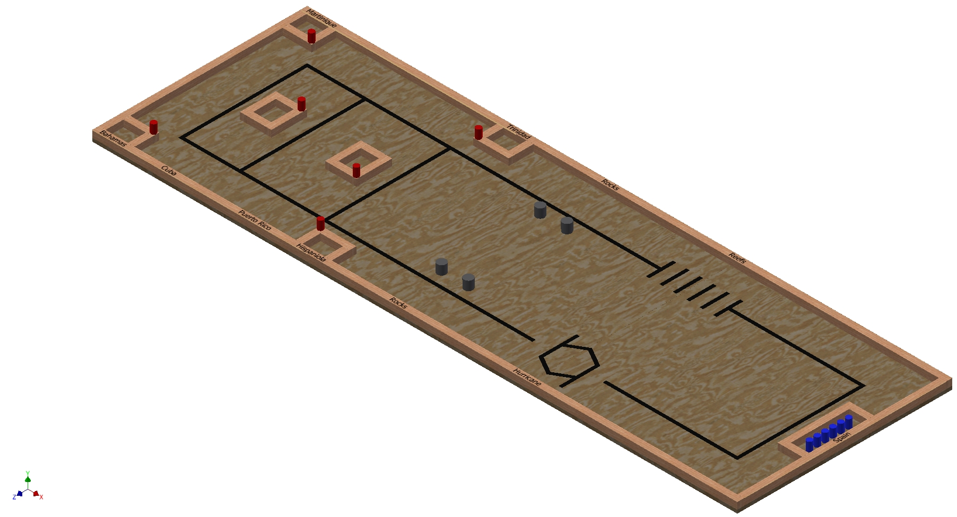
- The red barrels are tangent to the outer edges of the island in the corner indicated.
- Blue barrels are NOT shown in the correct location. They will initially be loaded on your robot.
- Labels for islands, Spain, etc., are not essential, but will be used at the competition to give the audience additional information.
- The labels starting from the upper left and going clockwise are: Martinique, Trinidad, Rocks, Reefs, Spain, Hurricane, Rocks, Hispaniola, Puerto Rico, Cuba, Bahamas.
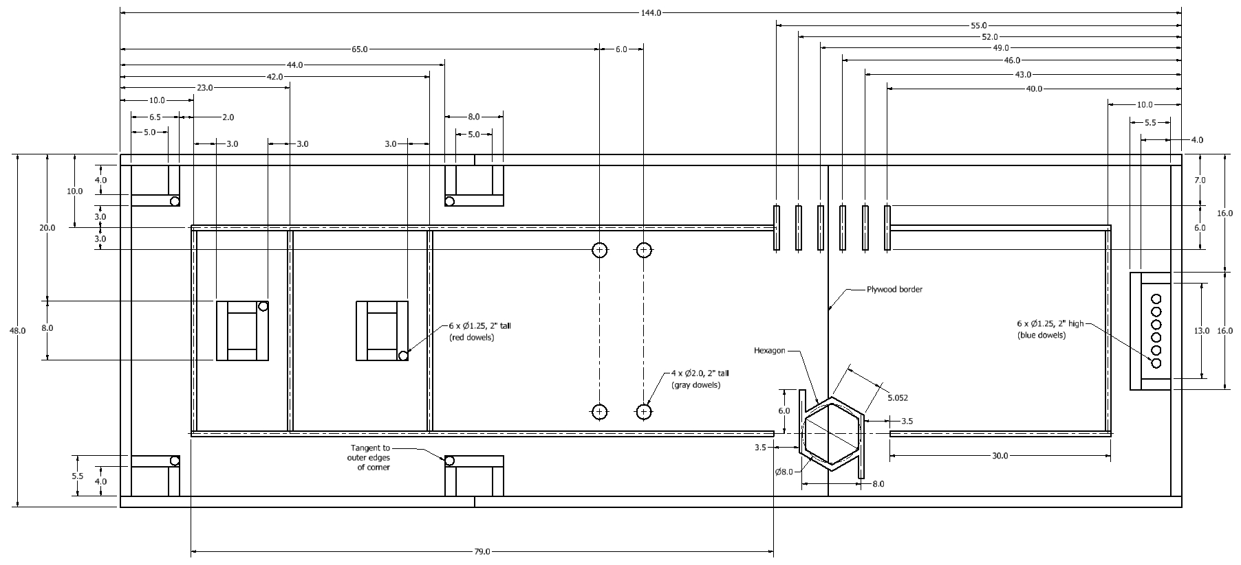
Figure 2: Top View of the Track (all dimensions are in inches)
- ¾” black electrical tape sections are typically located by their centerlines
- Assume symmetry for most features
- The inside dimensions for all islands are 4” x 5”
- All borders and islands are constructed using 2x2 boards (1.5” x 1.5” typical size)
Required Materials:

- One 4’ X 8’ X 3/4” sheet of BC grade or better grade plywood.
- One 4’ X 4’ X 3/4” sheet of BC grade or better grade plywood.
- Two 2” x 4” x 12’ boards for the substructure (not shown)
- Five 2” x 4” x 93” boards for the substructure (not shown) to be cut into the following lengths:
  - 45” (8 boards)
  - 48” (2 boards)
- Five 2” x 2” x 96” boards (actual size 1.5 x 1.5 x 96) to be cut into the following lengths:
  - 96” (2 boards)
  - 45” (2 boards)
  - 16” (1 board)
  - 8” (6 boards)
  - 6.5” (2 boards)
  - 4” (12 boards)
- One Roll of 3/4” Wide Black Vinyl Tape
- One 36” x 1” diameter hardwood dowel to be cut into 2” lengths (12 total)
- One 12” x 2” diameter hardwood dowel to be cut into 2” lengths (4 total)
- One Can of Rust-Oleum Painter’s Touch 2X Gloss Spray Paint in the following color: Apple Red
- One Can of Rust-Oleum Painter’s Touch 2X Gloss Spray Paint in the following color: Brilliant Blue
- One Can of Rust-Oleum Painter’s Touch 2X Gloss Spray Paint in the following color: Dark Gray
- One Box of 2.5” or 3.0” Wood Screws for substructure framing

One Box of 2” Wood Screws for attaching 2x2 barriers
- One Box of 1.5” Finishing Nails for attaching the plywood to the substructure
- Two packs of Permanent Adhesive Vinyl Letters and Numbers 1"-Gothic/Black by Graphic Products (or similar)
- One container of light pine colored Sandable Wood Filler
- One package of 150 grit sandpaper
- One package of tack cloths

Construction Procedures:

- Construct a 4’ x 12’ substructure using 2” x 4” boards spaced 16” on-center.
- After the substructure is square, fasten the 3/4” thick plywood using 1.5” finishing nails. Set the nails and fill the holes with putty. Once the putty has dried, sand it flat.
- Attach the 2” x 2” boards used for the outer border of the track using 2” screws
- Attach the 2” x 2” boards used to form the islands using 2” screws
- Draw light construction lines on the plywood locate the centerlines for the tape as indicated in Figure 2.
- Apply the 3/4” wide black vinyl tape to the plywood. Be sure not to stretch the tape during application or else the tape will lose adherence to the track over time.
- Paint 6 dowels (2” x 1” diameter) with the red paint specified. Place the dowels in the locations indicated in Figure 2.
- Paint 6 dowels (2” x 1” diameter) with the blue paint specified. These dowels will be loaded on your robot at the beginning of each trial.
- Paint 4 dowels (2” x 2” diameter) with the gray pain specified. Mark the centers on the track for each of these dowels (rocks). Place one dowel over each center and carefully draw a circle around the base of the dowel. Each dowel will be placed within its circle at the start of each trial. If the robot knocks over the dowel or moves it so that it is no longer centered within the circle, a penalty will be incurred.
- Label the islands and other features on the track according to Figure 2 using the 1”-tall black letters specified (or similar). The exact location of these labels is not specified.
- Sand off any stray marks on the plywood and then dust the plywood with tack cloths.

Robot Specifications:

Allowable Energy Sources:
Any energy source is allowed as long as it is completely contained within the robot and does not create or emit any gaseous, liquid, or solid emissions. Energy sources must not present any safety hazards to participants or spectators.

Prohibition Against Flying Robots:
Since the competition is held in a crowded Exhibition Hall with hundreds of spectators, flying robots (such as quad copters) are prohibited.

Maximum Robot Size:
The robot (including the 6 blue dowels) must fit inside a box with vertical sides having inside dimensions of 8.0” X 12.0” and have a maximum height of 10.0”. The robot may expand to any size after the start of a trial. The robot cannot contain more than 6 blue dowels.

Components, Fabrication, and Cost:
Team members using materials which are commonly available to the general public must perform all fabrication. Use of commercially available vehicles, robots, or entire kits such as RC cars, Legos, K-nex, Fischer-Technics, Parallax or erector sets may not be used. The use of Lego Mindstorm microcontroller bricks are prohibited. Individual components from these cars, robots, or kits (except the Mindstorm Brick) may be integrated into a team’s robot as long as the majority of the robot’s components are not from the same car, robot, or kit source. The cost of purchasing all components must not exceed $400.

Robot Time Trial Rules:

- It is the responsibility of the team to inspect the condition of the track before starting their robot to be certain that everything is in order. Once a team presses or pulls the start mechanism, the run counts as an official trial and may not be done over.
- The order of testing will be determined by random draw.
- While the preceding team is on the track for a trial, the on-deck team must have their robot on the on-deck table ready to run immediately after the previous team completes their trial. Each team will have one minute to begin a trial after being called.
- All teams will be called for a trial in a current round before any teams begin the next round of testing.
- Robot sizes will be tested with the measuring box prior to each team’s first run and in subsequent runs if requested by the judges. The robot should contain the 6 blue dowels during this test. Team members will be responsible for placing the measuring box over their robots. If a robot fails to meet the size constraint the judges will assess a penalty proportional to the severity of the violation.

- Each team should provide their own set of 6 blue dowels for the competition. The judges may inspect the dowels and may choose to replace the dowels if they do not meet specifications or if the dowels appear to have been modified in any way.
- The 6 red dowels and the 4 gray dowels will be provided by the competition officials and will be placed on the track in the positions indicated in Figures 1-2. Each team should inspect the placement of the dowels to be sure that they are satisfied with their position before each trial.

- The robot may start anywhere on the track as long as part of the robot is touching the 2” x 2” x 16” border for Spain or one of the 2” x 2” x 4” borders for Spain.
- The robot may extend beyond the perimeter of the track during the trial as long as the robot is fully supported by the plywood track surface or the perimeter boards.

- The time for a trial will begin when the judge gives the team the command to start. Once this start command is given, a team may only activate a single switch or mechanism to start the robot. Once the robot begins to move in any way, team members may not touch the robot or communicate with it with any remote control device.

- If a robot fails to move once the judge’s start command is given, the team members may work on their robot to get it moving but the time will continue to run from the time when the start command was given. If the robot has not moved within 90 seconds of the start command, a score of zero will be assigned for that trial.

- A trial will end when any of the following actions occur:
a. The robot becomes disabled or shows no evidence of being able to continue.
b. The robot deposits one blue dowel on each of the 6 islands, collects the 6 red dowels from the islands, and deposits the 6 red dowels in Spain. A blue dowel is considered to be properly deposited on an island if it is touching the plywood within the borders of the island. A red dowel is considered to be properly deposited in Spain if it is touching the plywood within the borders of Spain or if a red dowel is supported by another red dowel which is touching the plywood within the borders of Spain.
c. 90 seconds elapses from the start command.

- Only the dowels may be deposited in each island or in Spain. No other materials may be deposited.
- Teams may make changes or repairs to their robots between trials but they must be ready within one minute of being called to the track.

14) Teams may not make practice runs during the Exhibit Session or after the start of the Robot Time Trials.

Robot Time Trial Scoring:

Robots will earn points by depositing one blue dowel in each island and by collecting red dowels from the islands and delivering the red dowels to Spain. In particular:

- Points earned for delivering blue dowels: 5 Points will be awarded each time a blue dowel is deposited in an island for a maximum of 5 points per island. If two or more blue dowels are deposited in a single island, only 5 points is earned for the island. A blue dowel is considered to be properly deposited on an island if it is touching the plywood within the borders of the island. A maximum of 30 points can be earned for delivering blue dowels to the islands.

- Points earned for collecting and delivering red dowels: 5 Points will be awarded for each red dowel that was collected from an island and is deposited in Spain. A red dowel is considered to be properly deposited in Spain if it is touching the plywood within the borders of Spain or if a dowel is supported by another red dowel which is touching the plywood with the borders of Spain. A maximum of 30 points can be earned for collecting red dowels from the islands and delivering them to Spain.

- Points deducted for moving gray rocks: 5 Points will be deducted if a gray rock on the course is moved by the robot. A gray rock is considered to be moved if it is no longer centered within the circle drawn on the track used to located the rock. A maximum of 20 points can be deducted for moving the gray rocks on the track.

- Bonus points: Time Bonus for Perfect Run = (90 – Time in seconds to complete the perfect run)

Exhibit Session Scoring:

A maximum score of 120 points may be earned in the Exhibit Session. Scoring details are described below.

Overall Scoring:
The overall score for a team will be equal to the sum of the scores for the Poster Session and the four Robot Time Trials. A team will be disqualified from the competition if they fail to participate in the entire Poster Session.

Overall Score = Sum of the Points from all four Robot Time Trials + Exhibition Session Point Total

Exhibit Session:
Prior to the Robot Time Trials, each team must participate in an exhibit session where they will create a booth to promote their project to judges, other students, and conference attendees. Each team will be supplied with a 6’ long table, a tripod display frame, and electrical power. The entire session is scheduled to last approximately 2 hours during the grand opening of the Exhibition Hall on Monday, June 26th.

All participants must be present during the entire exhibit session. Teams may use posters, written documents, physical prototypes, multimedia displays, and other visual aids at their booths. In addition, each team’s robot must remain on display at their booth for the entire duration of the exhibit session. Team members may neither work on, nor test their robots during this session. The number of entries from a given school will be limited by the available space during the exhibit session.

Students from each team are required to visit the exhibits from all other schools. A captain from each school will score each team from other schools on a scale from 0-20 (20 being best) based upon the criteria that the judges will use. Each school will designate a single captain even if that school has multiple teams. The captains’ score will be computed by deleting the highest and lowest scores from the captains and then computing the average of the remaining scores.

The judges will visit each booth for approximately 10 minutes depending on the number of teams competing. During this visit, team members will guide the judges through their display for the first five minutes. In the second 5 minute period, the judges will ask the team questions. Each judge will score teams on a scale of 0 to 20 (20 being best) on the first five items below. The score in each category will be computed by deleting the highest and lowest scores from the judges, and then computing the average of the remaining scores.

1. Design Evolution:
Guide the judges through the design process that your team followed from the initial ideas to the final solution. Describe your rationale for making design decisions.

2. Robot Operation:
Discuss how your robot works.

3. Fabrication Methods:
Explain how you fabricated your robot.

4. Design Analysis:
Convince the judges that your design is optimal based upon its performance, cost, and environmental impact.

5. Exhibit Quality:
Your exhibit quality will be judged on the following items: team and exhibit appearance, technical expertise displayed, communication skills, and effectiveness of visual aids.

6. Captain Scoring:
The score from the captains will be added to the judges’ scores from the five categories above.

Schedule of Events on the day of the competition:
The exact schedule may vary as the competition is subject to the scheduling needs of ASEE. A typical schedule might be as follows (but look for emails from the competition organizers for any possible time changes):
6:45 am: Report to the Exhibition Hall
- Set up your team’s table
- Draw for the order of the presentations and time trials
7:00 – 9:00 am: Exhibit Session
- Judges will visit each table in the order determined by the drawing
- Team captains will visit the table of all other teams
- The track is closed during the Exhibit Session. Teams may not work on robots or test robots at this time.
9:30 am – 1:00 pm: Robot Time Trials
- Trial 1: Each team will compete in the order determined by the drawing.
- Trial 2: Each team will compete in the order determined by the drawing.
- Trial 3: Each team will compete in the order determined by the drawing.
- Trial 4: Each team will compete in the order determined by the drawing.
1:00 pm (or when the time trials end): Awards and Team Photos

Rule Interpretation Questions:

Prior to the date of the competition direct your inquiries to either of the following:
Paul Gordy John Wadach
Tidewater Community College Monroe Community College
1700 College Crescent 1000 E. Henrietta Road
Virginia Beach, VA 23453 Rochester, NY 14623
Email: PGordy@tcc.edu Email: jwadach@monroecc.edu

On the date of the competition:
The judges will interpret the intent of the rules and make all decisions. If the judges determine that a team is in violation of the intent of any rule or specification, they will deduct points in proportion to the severity of the violation. All decisions by the judges are final and may not be appealed. Teams have shown respect for the judges, participants, and spectators in the past, and this positive attitude is expected from each participant this year.

Competition Registration Questions:

Questions related to registering for the competition should be directed to:

Paul Gordy
Tidewater Community College
1700 College Crescent
Virginia Beach, VA 23453
Phone: 757-822-7175
Email: pgordy@tcc.edu

Please find the entry forms on pages 11 and 12. The Interest Form should be received no later than April 1, 2017. A Registration Form for each model design team must be received no later than June 1, 2017.

PROJECT TEAM / ENTRY LIMITATIONS:

Each team must have at least one faculty advisor and at least 2 student members but no more than 10 student members. Each team member must primarily be enrolled in freshmen or sophomore level classes. The number of entries from each school will be limited by the space available in the Exhibit Session. If a school has more than one entry then each team must represent a unique solution to the design problem. Multiple copies of the same solution are prohibited.

ASEE ANNUAL CONVENTION PASSES:

It is not required that student team members or faculty advisors be registered for the ASEE Annual Convention. Passes will be provided for all team members and advisors so that they can enter the conference area and exhibition area on the day of the competition. Details for obtaining passes will be made available a couple of weeks prior to the competition.
PRACTICE SESSION:

It is expected that two tracks will be ready for teams to practice on by Sunday morning, June 25th. Teams should be considerate and only use the tracks for brief periods if other teams are waiting to use the tracks.

On the day of the competition the tracks will be available in the Exhibition Hall for teams to practice on prior to and following the Exhibit Session. No practice runs may be made during the Exhibit Session or after the Robot Time Trials have begun.

AWARDS:

First, second, and third-place teams will receive plaques.

SUNY TYESA COMPETITION

The State University of New York Two Year Engineering Science Association (SUNY TYESA) will host a design-build competition on at the end of April 2017. SUNY TYESA will use the same rules and project as the 2017 ASEE Design Competition. Teams interested in participating in the SUNY TYESA competition should contact Mark Courtney mcourtne@sunydutchess.edu or visit the SUNY TYESA website at: tyesa.org

Revision History:
6-12-16: First publication of the rules
10-14-16: Hurricane symbol changed from a circle to a hexagon (to make it easier to construct with tape). (Figures 1 and 2).
Length of wood for substructure changed from 2’ x 4’ x 96” to 2’ x 4’ x 12’
Results and pictures from 2016 competition added
Other minor editing.

2017 ASEE Model Design Competition Registration Form

Name of college/university: _______________________________________________________________

Team Name: ________________________________________________________________________

Name of faculty advisor(s): _______________________________________________________________

Mailing Address: _______________________________________________________________________

Phone: ______________________________________

Email (print clearly): _____________________________________________________________________

Student team captain: ____________________________________________________________________

Other student team members:

1. __________________________ 2. __________________________ 3. __________________________

4. __________________________ 5. __________________________ 6. __________________________

7. __________________________ 8. __________________________ 9. __________________________

Which students/advisors need badges for the convention center? (Badges are needed if you are not registered for the convention).
Circle one: All need badges None need badges Only those listed below need badges

Will your team require electrical power at your Exhibition Table? Circle one: YES NO

Please submit this form to: Paul E. Gordy
Tidewater Community College
1700 College Crescent
Virginia Beach, VA 23453
Phone: 757-822-7175
Fax: 757-822-7334
Email: PGordy@tcc.edu

Return one copy of this form for each team entered by
June 1, 2017 (by US mail , fax, or email)
2017 ASEE Model Design Competition Interest Form

Name of college/university: _______________________________________________________________

Name of faculty advisor(s): _______________________________________________________________

Mailing Address: _______________________________________________________________________

Phone: ______________________________________

Email (print clearly): _____________________________________________________________________

Number of model entries desired : _________________

Please submit this form to: Paul E. Gordy
Tidewater Community College
1700 College Crescent
Virginia Beach, VA 23453
Phone: 757-822-7175
Fax: 757-822-7334
Email: PGordy@tcc.edu

Return this form by April 1, 2017 (by US mail , fax, or email)

