

**2016 ASEE MODEL DESIGN COMPETITION**

**Sponsored by the Two Year College Division of ASEE**

Date: June 10, 2015

Dear Colleague,

On behalf of the American Society for Engineering Education (ASEE) - Two Year College Division (TYCD), we invite you to encourage the submission of student design projects for the 18th Annual ASEE Lower Division MODEL DESIGN COMPETITION. This event will be held in conjunction with the 2016 ASEE Annual Convention, New Orleans, LA, June 26-29, 2016. This competition is open to 1st and 2nd year students at two-year and four-year colleges and universities.

In this year’s competition student teams will design and build an autonomous robot that can deposit jewelry (rings) to one dozen boxes along the parade route on a specified track. The robot must adhere to the rules of the model design competition (attached). An Exhibition session is included as part of the competition.

The main reason for this competition is for students to gain a better understanding of the design process from start to finish. Designing and building something from an idea is probably why they chose engineering in the first place. Use this design competition as a platform to reinforce their ideas and have some *engineering fun!* We hope to see you and your students' entries in New Orleans.

Please find enclosed the guidelines and registration forms for this event. The interest and registration forms are on the back of this letter.

Sincerely,

Paul E. Gordy

Phone: 757-822-7175

Fax: 757-427-0327

Email: [pgordy@tcc.edu](mailto:pgordy@tcc.edu)

John Wadach

Phone: 585-292-2488

Email: [jwadach@monroecc.edu](mailto:jwadach@monroecc.edu)

Results from the

**17th Annual ASEE Model Design Competition**

June 15, 2015 - Seattle, Washington

The recent competition in Seattle required teams to design and build an autonomous robot that could collect as many colored fish cutouts and then deposit them in corresponding colored fish tanks within 120 seconds.

15 teams competed and the results were as follows:

* 1st Place: Cedarville University, Cedarville, OH (team pictures provided below)
* 2nd Place: Monroe Community College, Rochester, NY
* 3rd Place: Tidewater Community College, Virginia Beach, VA

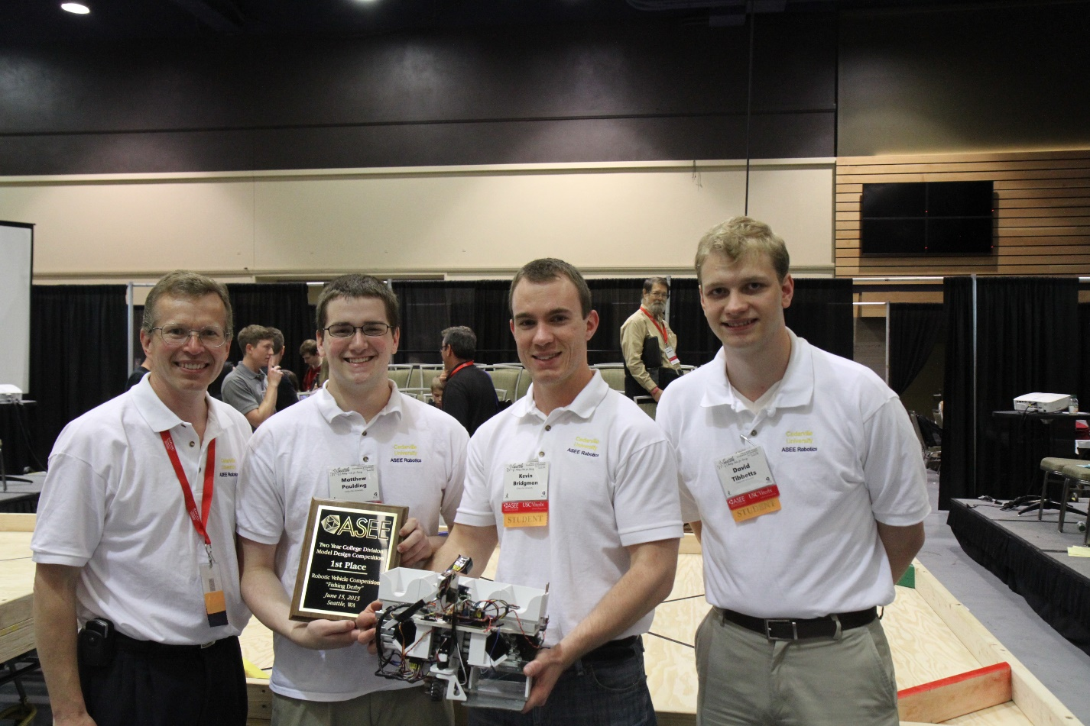

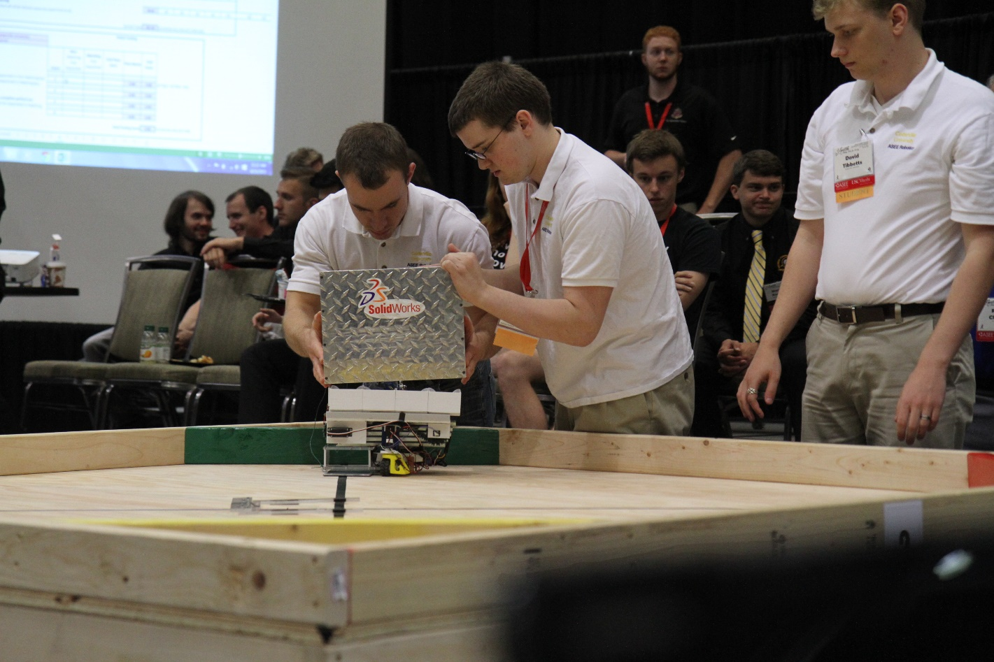 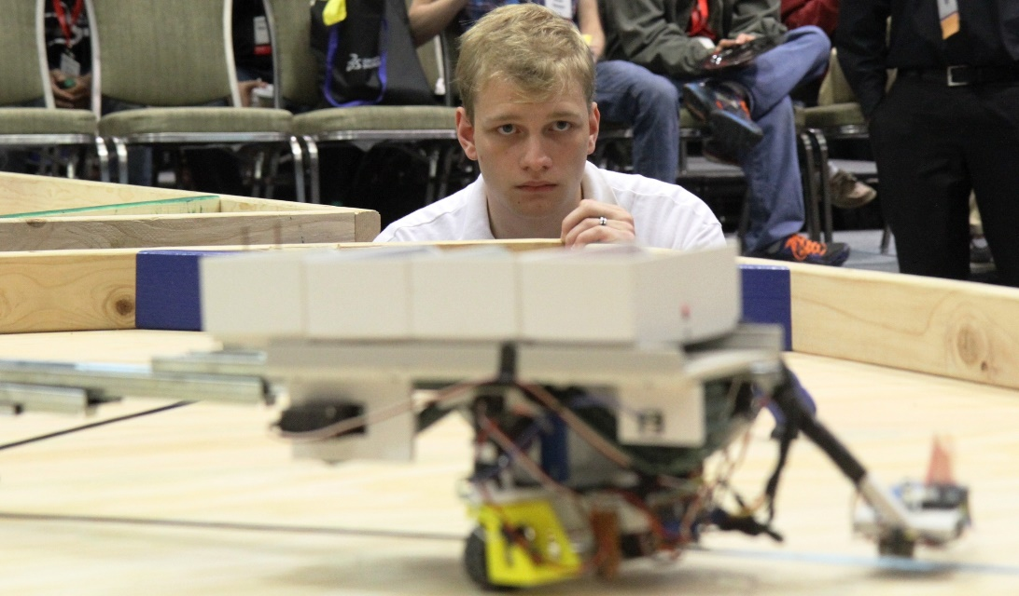

For complete results, including scores, pictures, videos, and more, visit the competition websites at

<http://faculty.tcc.edu/PGordy/ASEE/index.html> and at <https://www.facebook.com/MCCELC> .

Consider bringing a team from your college to next year’s competition on June 27, 2016 in New Orleans, LA. For more information or a copy of next year’s rules, please contact Paul Gordy, [pgordy@tcc.edu](mailto:pgordy@tcc.edu) ,

757-822-7175) or John Wadach, [Jwadach@monroecc.edu](mailto:Jwadach@monroecc.edu) , 585-292-2488).

**2016 ASEE TYCD MODEL DESIGN COMPETITION RULES (Revised 8-26-15)**

**New Orleans, Louisiana**

**June 27, 2016**

The 18th Annual American Society for Engineering Education (ASEE) Two-Year College Division (TYCD), Model Design Competition will be held Monday, June 27, 2016 in conjunction with the ASEE Annual Convention in New Orleans, Louisiana.

**Event Name:** Robot Parade

**Objective:**

To design and build an autonomous robot that can deposit one ring in each of 12 boxes located along the “parade route” on the track. Robots will have a maximum time of 90 seconds in each of their four allotted trials. The robot must begin within an 8” X 12” X 10” high size limit but may expand to any size during a trial. An Exhibit Session will precede the robot trials.

**Track Specifications:**

Figure 1: Isometric View of the Track showing the location of the 12 boxes and the Start/Stop area.

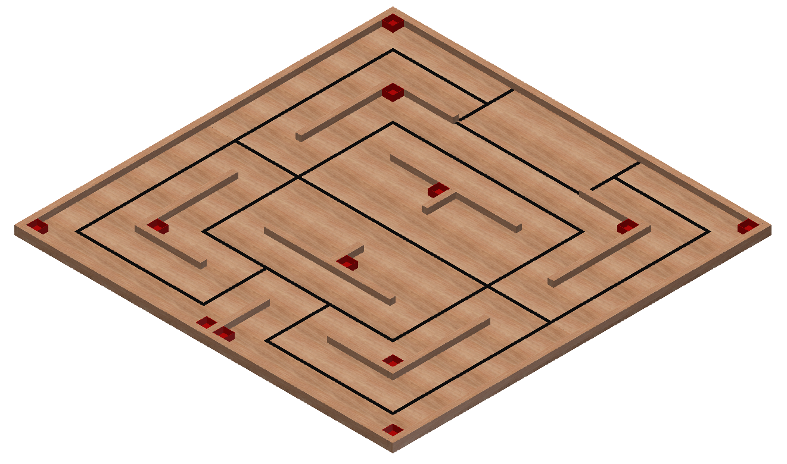**Figure 2: Top View of the Track (all dimensions are in inches)**

* **All ¾” black electrical tape on 8” centers**
* **All 2x2 boards on 16” centers**

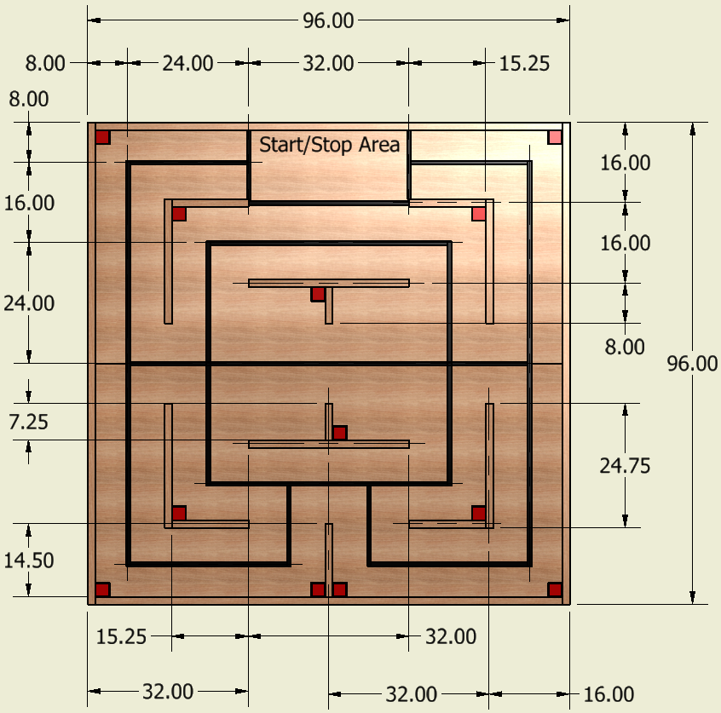

**Figure 3: Box – 12 boxes will be placed in precise locations on the track. Each box will have the lid removed and will be painted red using the specified paint.**

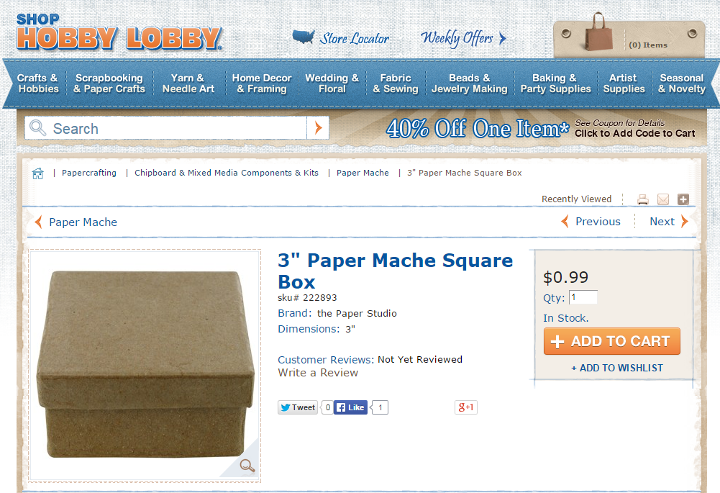

**Figure 4: Rings – One ring is to be deposited into each box (12 rings total - any colors can be used)**



**Figure 5: 2-sided mounting tape: used to secure the boxes to the track**

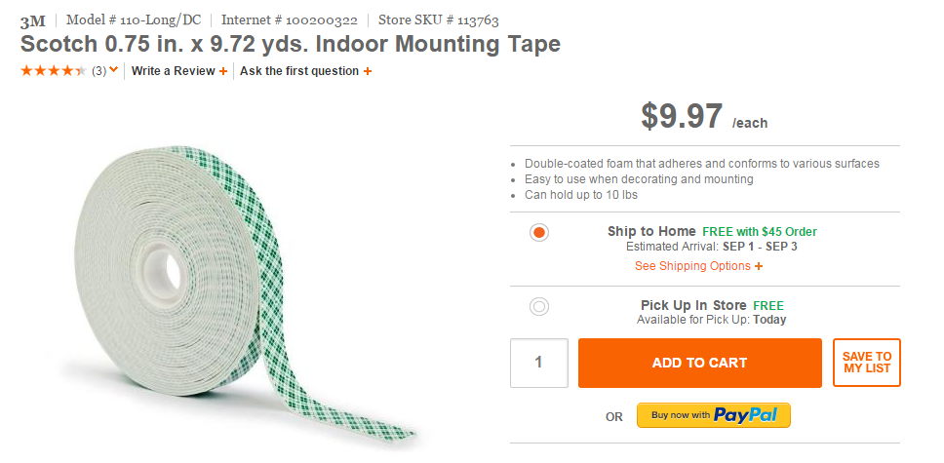

**Required Materials:**

1. **Two** 4’ X 8’ X 3/4” sheets of BC grade or better grade plywood.

2. **Two** 2” x 4” x 96” boards for the substructure

3. **Seven** 2” x 4” x 93” boards for the substructure

4. **Seven** 2” x 2” x 96” boards (actual size 1.5 x 1.5 x 96) to be cut into the following lengths:

* 96” (2 boards)
* 93” (2 boards)
* 32” (2 boards)
* 24.75” (4 boards)
* 15.25” (4 boards)
* 14.5” (1 board)
* 7.25” (2 boards)

5. **One** Roll of 3/4” Wide Black Vinyl Tape

6. **Twelve** 3 inch Paper Mache Square Boxes (typical outer dimensions with lid removed: 2.8 x 2.8 x 1.5”), SKU # 222893 from [www.hobbylobby.com](http://www.hobbylobby.com)- See image on previous page

Cut and Paste link: <http://shop.hobbylobby.com/products/3-paper-mache-square-box-222893/>

7. **Twelve** 2-inch plastic rings (outside diameter 2”, inside diameter 1.5”) from [www.noahsarkandnovelty.com/](http://www.noahsarkandnovelty.com/) - See image on previous page

Cut and Paste Link: <http://www.noahsarkandnovelty.com/2quot-pearlized-marbella-rin2.html>

8. **One** Can of Rust-Oleum Painter’s Touch 2X **Gloss** Spray Paint in the following color: **Apple Red**

9. **One** roll of Scotch Permanent Mounting Tape: 3/4” x 350” (9.72 yd)

10. **One** Box of 2.5” or 3.0” Wood Screws for substructure framing

## 11. One Box of 2” Wood Screws for attaching 2x2 barriers

12. **One** Box of 1.5” Finishing Nails for attaching the plywood to the substructure

13. **One** container of light pine colored Sandable Wood Filler

14. **One** package of 150 grit sandpaper

15. **One** package of tack cloths

**Construction Procedures:**

1. Construct an 8’ x 8’ substructure using 2” x 4” boards spaced 16” on-center.

2. After the substructure is square, fasten the 3/4” thick plywood using 1.5” finishing nails. Set the nails and fill the holes with putty. Once the putty has dried, sand it flat.

3. Draw light construction lines on the plywood as shown in figure 2 to locate the 8” centerlines and the 16” centerlines.

4. Apply the 3/4” wide black vinyl tape to the plywood. Be sure not to stretch the tape during application or else the tape will lose adherence to the track over time.

5. Attach the perimeter boards to the track using 2” screws.

6. Paint the 12 boxes (2 coats) with the red paint specified. Place the boxes in the locations indicated in Figure 2. Use the 2-sided tape specified to secure the bottoms of the boxes to the track. No part of the tape should extend beyond the boundaries of the bottom edge of each box.

7. Sand off any stray marks on the plywood and then dust the plywood with tack cloths.

**Robot Specifications:**

**Allowable Energy Sources:**

Any energy source is allowed as long as it is completely contained within the robot and does not create or emit any gaseous, liquid, or solid emissions. Energy sources must not present any safety hazards to participants or spectators.

**Maximum Robot Size:**

The robot must fit inside a box with vertical sides having inside dimensions of 8.0” X 12.0” and have a maximum height of 10.0”. The robot may expand to any size after the start of a trial.

**Components, Fabrication, and Cost:**

Team members using materials which are commonly available to the general public must perform all fabrication. Use of commercially available vehicles, robots, or entire kits such as RC cars, Legos, K-nex, Fischer-Technics, Parallax or erector sets may not be used. The use of **Lego Mindstorm microcontroller bricks are prohibited.** Individual components from these cars, robots, or kits (except the Mindstrorm Brick) may be integrated into a team’s robot as long as the majority of the robot’s components are not from the same car, robot, or kit source. The cost of purchasing all components must not exceed **$400.**

**Robot Time Trial Rules:**

1. It is the responsibility of the team to inspect the condition of the track before starting their robot to be certain that everything is in order. Once a team presses or pulls the start mechanism, the run counts as an official trial and may not be done over.
2. The order of testing will be determined by random draw.
3. While the preceding team is on the track for a trial, the on-deck team must have their robot on the on-deck table ready to run immediately after the previous team completes their trial. Each team will have one minute to begin a trial after being called.
4. All teams will be called for a trial in a current round before any teams begin the next round of testing.
5. Robot sizes will be tested with the measuring box prior to each team’s first run and in subsequent runs if requested by the judges. Team members will be responsible for placing the measuring box over their robots. If a robot fails to meet the size constraint the judges will assess a penalty proportional to the severity of the violation.
6. Each team should provide their own set of 12 rings for the competition. The judges may inspect the rings and may choose to replace the rings if the rings appear to have been modified in any way.
7. The 12 red boxes will be provided by the competition officials and will be inspected by the judges before each trial to be sure that they are in the specified locations.
8. The robot may start anywhere within the Start/Stop area of the track. No part of the robot may be over the tape bordering the Start/Stop area.
9. The robot may extend beyond the perimeter of the track during the trial as long as the robot is fully supported by the plywood track surface or the perimeter boards.
10. The time for a trial will begin when the judge gives the team the command to start. Once this start command is given, a team may only activate a single switch or mechanism to start the robot. Once the robot begins to move in any way, team members may not touch the robot or communicate with it with any remote control device.
11. If a robot fails to move once the judge’s start command is given, the team members may work on their robot to get it moving but the time will continue to run from the time when the start command was given. If the robot has not moved within 90 seconds of the start command, a score of zero will be assigned for that trial.
12. Robots may touch the boxes on the track, but they are not allowed to damage the boxes. If a box is damaged by a robot, the official judges will assess a penalty proportional to the severity of the violation. The judges may elect to replace a damaged box.
13. A trial will end when any of the following actions occur:

a. The robot becomes disabled or shows no evidence of being able to deposit additional rings into the boxes or being able to return to the Start/Stop area.

b. The robot deposits one ring into each of the 12 boxes and then returns to Start/Stop area (the robot must be completely within the Start/Stop area and come to a stop before the trial ends. No part of the robot may be over the tape bordering the Start/Stop area once the robot has stopped.)

c. 90 seconds elapses from the start command.

13) Teams may make changes or repairs to their robots between trials but they must be ready within one minute of being called to the track.

14) **Teams may not make practice runs during the Exhibit Session or after the start of the Robot Time Trials.**

**Robot Time Trial Scoring:**

Robots will earn points by depositing rings into the red boxes on the track. No other items except the specified rings may be placed in the boxes. The boxes may not be moved (other than incidental movement) or damaged by the robot.

1. **5 Points** will be awarded for each box into which one ring was deposited. A ring is considered to be deposited in a box if any part of the ring is touching the inside bottom of the box. No points are awarded if 2 or more rings are deposited into a single box. A maximum of 60 points can be earned one ring in each of the 12 boxes.
2. **20 Points** will be awarded if the robot returns to the Start/Stop area after depositing one ring into each of at least 6 boxes.
3. If a robot deposits one ring into each of the 12 boxes and returns to the Stop/Start area and thus earns 80 points (a perfect run) a time bonus will be added using the formula below if the time for the run is less than 90 seconds.  
     
   Time Bonus for Perfect Run = (90 – Time in seconds to complete the perfect run)

**Exhibit Session Scoring:**

A maximum score of 120 points may be earned in the Exhibit Session. Scoring details are described below.

**Overall Scoring:**

The overall score for a team will be equal to the sum of the scores for the Poster Session and the four Robot Time Trials. A team will be disqualified from the competition if they fail to participate in the entire Poster Session.

**Overall Score = Sum of the Points from all four Robot Time Trials + Exhibition Session Point Total**

**Exhibit Session**:

Prior to the Robot Time Trials, each team must participate in an exhibit session where they will create a booth to promote their project to judges, other students, and conference attendees. Each team will be supplied with a 6’ long table, a tripod display frame, and electrical power. The entire session is scheduled to last approximately 2 hours during the grand opening of the Exhibition Hall on Monday, June 27th.

All participants must be present during the entire exhibit session. Teams may use posters, written documents, physical prototypes, multimedia displays, and other visual aids at their booths. In addition, each team’s robot must remain on display at their booth for the entire duration of the exhibit session. **Team members may neither work on, nor test their robots during this session.** The number of entries from a given school will be limited by the available space during the exhibit session.

Students from each team are required to visit the exhibits from all other schools. A captain from each school will score each team from other schools on a scale from 0-20 (20 being best) based upon the criteria that the judges will use. Each school will designate a single captain even if that school has multiple teams. The captains’ score will be computed by deleting the highest and lowest scores from the captains and then computing the average of the remaining scores.

The judges will visit each booth for approximately 10 minutes depending on the number of teams competing. During this visit, team members will guide the judges through their display for the first five minutes. In the second 5 minute period, the judges will ask the team questions. Each judge will score teams on a scale of 0 to 20 (20 being best) on the first five items below. The score in each category will be computed by deleting the highest and lowest scores from the judges, and then computing the average of the remaining scores.

1. Design Evolution:

Guide the judges through the design process that your team followed from the initial ideas to the final solution. Describe your rationale for making design decisions.

2. Robot Operation:

Discuss how your robot works.

3. Fabrication Methods:

Explain how you fabricated your robot.

4. Design Analysis:

Convince the judges that your design is optimal based upon its performance, cost, and environmental impact.

5. Exhibit Quality:

Your exhibit quality will be judged on the following items: team and exhibit appearance, technical expertise displayed, communication skills, and effectiveness of visual aids.

6. Captain Scoring:

The score from the captains will be added to the judges’ scores from the five categories above.

**Rule Interpretation Questions:**

**Prior** to the date of the competition direct your inquiries to either of the following:

Paul Gordy John Wadach

Tidewater Community College Monroe Community College

1700 College Crescent 1000 E. Henrietta Road

Virginia Beach, VA 23453 Rochester, NY 14623

Email: [PGordy@tcc.edu](mailto:PGordy@tcc.edu) Email: [jwadach@monroecc.edu](mailto:jwadach@monroecc.edu)

**On the date of the competition:**

The judges will interpret the intent of the rules and make all decisions. If the judges determine that a team is in violation of the intent of any rule or specification, they will deduct points in proportion to the severity of the violation. All decisions by the judges are final and may not be appealed. Teams have shown respect for the judges, participants, and spectators in the past, and this positive attitude is expected from each participant this year.

**Competition Registration Questions:**

Questions related to registering for the competition should be directed to:

Paul Gordy

Tidewater Community College

1700 College Crescent

Virginia Beach, VA 23453

Phone: 757-822-7175

Email: [pgordy@tcc.edu](mailto:pgordy@tcc.edu)

Please find the entry forms on pages 11 and 12. The Interest Form should be received no later than April 1, 2016. A Registration Form for each model design team must be received no later than June 1, 2016.

**PROJECT TEAM / ENTRY LIMITATIONS:**

Each team must have at least one faculty advisor and at least 2 student members but no more than 10 student members. Each team member must primarily be enrolled in freshmen or sophomore level classes. The number of entries from each school will be limited by the space available in the Exhibit Session. If a school has more than one entry then each team must represent a unique solution to the design problem. Multiple copies of the same solution are prohibited.

**ASEE ANNUAL CONVENTION PASSES:**

It is not required that student team members or faculty advisors be registered for the ASEE Annual Convention. Passes will be provided for all team members and advisors so that they can enter the conference area and exhibition area on the day of the competition. Details for obtaining passes will be made available a couple of weeks prior to the competition.

**COMPETITION TIMELINE:**

The specific time and location of the Exhibit Session and Robot Testing will be sent to all teams and published in the ASEE Final Program and Proceedings booklet. The overall format of the competition is given below.

# Morning: Exhibit Session

## Afternoon: Robot Testing Session and Awards

**PRACTICE SESSION:**

It is expected that two tracks will be ready for teams to practice on by Sunday morning, June 26th. Teams should be considerate and only use the tracks for brief periods if other teams are waiting to use the tracks.

On the day of the competition the tracks will be available in the Exhibition Hall for teams to practice on prior to and following the Exhibit Session. No practice runs may be made during the Exhibit Session or after the Robot Time Trials have begun.

**AWARDS:**

First, second, and third-place teams will receive plaques.

# SUNY TYESA COMPETITION

The State University of New York Two Year Engineering Science Association (SUNY TYESA) will host a design-build competition on at the end of April 2016. SUNY TYESA will use the same rules and project as the 2016 ASEE Design Competition. Teams interested in participating in the SUNY TYESA competition should contact Mark Courtney [mcourtne@sunydutchess.edu](mailto:mcourtne@sunydutchess.edu) or visit the SUNY TYESA website at: [tyesa.org](http://www.tc.cc.va.us/studorgs/vbeng/)

**Revision History:**

6-10-15: First publication of the rules

8-26-15: Rules modified to specify a different vendor for the rings (Figure 4 on page 4). The inner diameter of the rings has changed as well.

9-23-15: 1) Size of boards on Materials List (page 6) changed from 7.5” to 7.25” to agree with the track dimensions shown on page 4.

2) This Revision History was added.

3) Figure 5 added to page 4 to specify 2-sided tape to be used to secure the bottoms of the boxes to the track.

4) The specified 2-sided tape was also added to the Materials List (item 9 on page 6).

5) The Construction Procedures (Step 6 on page 7) were modified to specify the use of the 2-sided tape to secure the boxes to the track.

6) Step 12 was added to the Robot Time Trial Rules on page 8 concerning possible damage to the boxes on the track by robots.

1. The winning teams and some pictures were added to page 2.
2. The links for the competition website and Facebook page on page 2 were updated.

**2016 ASEE Model Design Competition Registration Form**

Name of college/university: _______________________________________________________________

Team Name: ________________________________________________________________________

Name of faculty advisor(s): _______________________________________________________________

Mailing Address: _______________________________________________________________________

Phone: ______________________________________

Email (print clearly): _____________________________________________________________________

Student team captain: ____________________________________________________________________

Other student team members:

1. __________________________ 2. __________________________ 3. __________________________

4. __________________________ 5. __________________________ 6. __________________________

7. __________________________ 8. __________________________ 9. __________________________

Which students/advisors need badges for the convention center? (Badges are needed if you are not registered for the convention).

Circle one: **All need badges None need badges Only those listed below need badges**

Will your team require electrical power at your Exhibition Table? Circle one: **YES NO**

Please submit this form to: Paul E. Gordy

Tidewater Community College

1700 College Crescent

Virginia Beach, VA 23453

Phone: 757-822-7175

Fax: 757-822-7334

Email: [PGordy@tcc.edu](mailto:PGordy@tcc.edu)

**Return one copy of this form for each team entered by**

**June 1, 2016 (by US mail , fax, or email)**

**2016 ASEE Model Design Competition Interest Form**

Name of college/university: _______________________________________________________________

Name of faculty advisor(s): _______________________________________________________________

Mailing Address: _______________________________________________________________________

Phone: ______________________________________

Email (print clearly): _____________________________________________________________________

Number of model entries desired : _________________

Please submit this form to: Paul E. Gordy

Tidewater Community College

1700 College Crescent

Virginia Beach, VA 23453

Phone: 757-822-7175

Fax: 757-822-7334

Email: [PGordy@tcc.edu](mailto:PGordy@tcc.edu)

**Return this form by April 1, 2016 (by US mail , fax, or email)**